MAT120_SUMMER_2024_SKY
To share this document to anyone- USE the following link:
https://shorturl.at/hCDaT
or
SCAN the following QR Code:

You can share this link with the following foreword to anyone or Keep it confidential before end of this semester.

FOREWORD

"These resources are only for BRACU students of MAT 120 course instructed by me, some of these are my personal comments and not a universal and complete guide for
INTEGRAL CALCULUS AND DIFFERENTIAL EQUATION.
The reference books are better to refer to anyone for a complete view."
-
Sakal Roy
Adjunct (Contractual) Faculty,
MNS, BRACU,
Academic Counselor,
BdMOC,
Former Senior Math Olympiad Consultant,
PEDP4, DPE, MoPME,
Author, Primary and Secondary Mathematics Textbook,
NCTB

INDEX

FOREWORD 2
COURSE INFO 6
% Class Info: 7
% My Consultation Info: 7
# Student Tutor(ST): 8
* Lecture Note: https://shorturl.at/ensGI 9
* Resources (Textbooks, Exercise Sheets with Practice Problems): https://shorturl.at/htyV9 9
% Group Communication: 10
* The mark distribution for MAT 120 in this semester: 11
%Tentative dates and topics of Quiz and Assignment: 12
* Mid-term Exam Modality: Central 13
* Final Exam Modality: Central 15
%FURTHER RESOURCES: 17
● BEFORE INTEGRATION 20
● Integration using Riemann Sums, Integration and Antiderivatives, Indefinite & Definite integrals, Integrals with variable limits, Infinite Integral, Integration by Substitution 21
Integration using Riemann Sums 21
Integration and Antiderivatives, Indefinite & Definite integrals, Integrals with variable limits, Integration by Substitution 35
Indefinite Integral 35
Integration by Substitution 40
The Definite Integral 53
Evaluating Definite Integral by Substitution 65
● Improper Integrals, Integration by parts, Reduction formula, Integration by Trigonometric Substitution, Integration of Rational Function 76
Integration by parts, Reduction formula, Improper Integrals, Infinite integrals 76
Integration By Parts 83
Integrating Trigonometric functions (Reduction Formula) 101
Improper Integrals 118
Integration by Trigonometric Substitution, Integration of Rational Function 136
Integration by Trigonometric Substitution 136
Integration of Rational Function by partial fractions 145
● Beta and Gamma Function 168
● Length of a curve, Surface area of revolution 172
Length of a curve 172
Surface Area of revolution 178
● Basic concept of Double integral, Double integral in Cartesian and Polar Coordinate system 182
Prerequisite 182
Double Integrals 183
Double Integrals over non rectangular regions 201
Double Integrals in polar Coordinates 226
Surface Area; Parametric Surfaces 232
● Concept of Triple Integral, Triple integral in Cartesian, Cylindrical and Spherical Coordinate system. 235
Triple Integrals 235
Triple Integrals in Cylindrical and Spherical Coordinates 238
Change of Variables in Multiple Integrals, Jacobians 242
● Introduction to Differential Equation, Separable Variables, Linear Equations, Integrating Factor 247
Introduction to Differential Equation 247
Separable Variables 248
Linear Equations 261
● Exact Equation, A non-Exact DE made Exact. 278
Exact Equations 278
A non-Exact DE made Exact 291
● Higher order DE, homogeneous and inhomogeneous cases. 300
Homogeneous linear equations with constant coefficients 300
Undetermined Coefficients-Superposition Approach 315
● Modeling with 1st and 2nd order DE 334
Linear Models 334

COURSE INFO
% Will be provided by Course Teacher
* Will be finalized by Course Coordinator
# Will be provided by Course Teacher and assessed by Student Tutor

Course ID: MAT 120 Course Name: Integral Calculus & Differential Equations
Faculty Name: SAKAL ROY Initial: SKY
Semester: SUMMER-2024 Section: 5, 6
Email: Official: ext.sakal.roy@bracu.ac.bd Personal: sakalroy10@gmail.com

% Class Info:

Section | Day | Class Time 🕑 | Room No
5 | SAT & THU | 2:00 PM - 3:20 PM | 10H-37C
6 | SAT & THU | 3:30 PM - 4:50 PM | 10-H37C

% My Consultation Info:
Consultation Room No:
4th Floor, MNS, Cubicle/Open Space for faculties (1 st Row, Check My NAME and INITIAL:SKY)
Consultation Hour:
🕑 SAT : 11:30 AM - 1:00 PM
🕑 MON : 12:30 PM - 2:00 PM

Contact in my personal/official email in if: 

# Student Tutor(ST):
Sec: 5 : Name: MALIHA MUSSARRAT, Email: maliha.mussarrat@g.bracu.ac.bd
ST Consultation Info: (This info is from previous semester, this years has not been announced yet, that’s why it's yellow marked, will be updated when ST lets you know)
Consultation Room No: UB 60601 (Building 6)
Consultation Hour:
🕑 SUN : 3:30 PM - 4:50 PM
🕑 TUE : 3:30 PM - 4:50 PM
🕑 WED : 11:00 AM - 12:20 PM
🕑 WED : 2:00 PM - 3:20 PM
🕑 THU : 8:00 AM - 9:20 AM

Sec: 6 : Name: Sajida Hossain, Email: sajida.hossain@g.bracu.ac.bd
ST Consultation Info: (This info is from previous semester, this years has not been announced yet, that’s why it's yellow marked, will be updated when ST lets you know)
Consultation Room No: UB 60601 (Building 6)
Consultation Hour:
🕑 SUN : 3:30 PM - 4:50 PM
🕑 TUE : 3:30 PM - 4:50 PM
🕑 WED : 11:00 AM - 12:20 PM
🕑 WED : 2:00 PM - 3:20 PM
🕑 THU : 8:00 AM - 9:20 AM

* Lecture Note: https://shorturl.at/ensGI

* Resources (Textbooks, Exercise Sheets with Practice Problems): https://shorturl.at/htyV9

% The links will lead to a Google Drive. The content of these Google Drive will be referred for ASSIGNMENT, QUIZ because they are important for MID and FINAL EXAM also. Let me know if you have any problem accessing any of the material provided here.
Among the reference text books provided in the G-drive, I’ll personally recommend “CALCULUS: EARLY TRANSCENDENTALS by Anton, Bivens, Davis 10th Edition ''.
ANSWERS CAN BE FOUND HERE: calculus-early-transcendentals-10th-ed-howard-anton-iril-bivens-stephen-davis-solution2.pdf
Surprisingly, I found the authors of this book share quite similar tastes with me in terms of explaining. So if you enjoy my class lectures, you can follow this reference book. I hope you can connect with this book easily and enjoy it while preparing.

% Group Communication:
The slack channel links are given below. Find your section and join only there accordingly.
Use your personal mail in case you have a problem accessing your BRACU g-suite email address.

- Section 5 : Join using the link:
https://join.slack.com/t/mat120sec05/shared_invite/zt-2ksm5a74w-zwPoa8trwm9CMSjz~W1HdQ
- Section 6 : Join using the link:
https://join.slack.com/t/mat120sec06/shared_invite/zt-2kjbqa9ys-BIdGcFPkmeP8qB6RMHLqzQ

* The mark distribution for MAT 120 in this semester:

Attendance | 5%
Assignment | 10%
Quiz | 15%
Midterm | 20%
Final | 30%
Lab | 20%
Total | 100%

%Tentative dates and topics of Quiz and Assignment:
% Number of Quiz: 3 ( best 2 will be counted) # Number of Assignment: 4 ( best 3 will be counted)

Quiz/ Assignment | Quiz Date & Time/  Assignment Submission Deadline | Instruction
Assignment 1 | Submission Deadline:  TBA | Topics: Mathematical Reasoning  Submission Method: Group Presentation
Assignment 2 | Submission Deadline:  TBA | Topics: TBA  Submission Method: TBA
Assignment 3 | Submission Deadline:  TBA | Topics: TBA  Submission Method: TBA
Assignment 4 | Submission Deadline:  TBA | Topics: TBA  Submission Method: TBA
Quiz 1 | Date: TBA  Time: Class Time | Topics: Mathematical Reasoning  Submission Method: Oral Presentation
Quiz 2 | Date: TBA  Time: TBA | Topics: TBA  Submission Method: TBA
Quiz 3 | Date: TBA  Time: TBA | Topics: TBA  Submission Method: TBA

* Mid-term Exam Modality: Central
Total marks: 40 Time: 1 hour 20 minutes
There'll be 6 questions from the 6 topics given below.
You’ve to answer any 5 questions.
Each Question will have 8 Marks. So in total 5 x 8 = 40 Marks.
Your Obtained Marks will be Converted into 20 marks later.
Topics:
- Integration using Riemann Sums
- Integration and Antiderivatives, Indefinite & Definite integrals, Integrals with variable limits, Integration by Substitution
- Integration by parts, Reduction formula, Improper Integrals, Infinite integrals
- Integration by Trigonometric Substitution, Integration of Rational Function
- Beta and Gamma Function
- Length of a curve, Surface area of revolution
*Points to be noted for MID-TERM Preparation:
- 1 question will contain/focus on 1 set of topics only, that means there’ll be no question which consists of multiple set of topics.
- You can use the theorems and definitions noted in Reference Books/Lecture Note Directly for corresponding question/topic. No need to prove any theorem unless specifically asked in the question. There’ll be no question in which you need to prove any mathematical theorem.
- Practise all the problems of the Practice Sheets. If you’re stuck in some problem see Reference Textbook (HOWARD ANTON will be enough in most cases). Use my given online solvers if needed.
- Use my given further resources and reference Book by HOWARD ANTON if you need to revisit the topics since they’re mostly related to my class lectures.
- You may use the lecture notes only to get a list of the basic formulas which you can directly use and to find at least 1 worked out example for techniques needed for Practice Sheet Problems.
- DON’T try to go through everything from the Lecture Note or reference Book which are not needed to solve problems mentioned from Reference Text Books and problems in the Practice Sheets. Everything will not appear in the MID-TERM exam so focus only which parts you need. If you’ve confusion about any specific topics, feel free to DM me in Slack (or post it in general channel in Slack ). You can email me in my official/personal email for any kind of query regarding the exam. But first go through my provided Further resources, they’ll solve your problems easily and make you confident.
- I’ll take 1 or 2 EXTRA ONLINE SESSION before your exam to clear any confusion. I’ll announce the time/date in GOOGLE CLASSROOM/SLACK.
- Last but not the least DON’T MISS THE CLASSES. Best wishes.
- Here are a few resources that might help in last moment preparation:
Choosing what integration methods to use - Part I
Choosing what integration methods to use - Challenging Example!
MATH PROF vs TRICKY INTEGRALS

* Final Exam Modality: Central
Total marks: 30 Time: 1 hour 20 minutes
There'll be 6 questions from the 6 topics given below.
You’ve to answer any 5 questions.
Each Question will have 6 Marks. So in total 5 x 6 = 30 Marks.
No conversion will happen to the FINAL EXAM marks.
Topics:
- Basic concept of Double integral, Double integral in Cartesian and Polar Coordinate system
- Concept of Triple Integral, Triple integral in Cartesian, Cylindrical and Spherical Coordinate system.
- Introduction to Differential Equation, Separable Variables, Linear Equations, Integrating Factor
- Exact Equation, A non-Exact DE made Exact.
- Higher order DE, homogeneous and inhomogeneous cases.
- Modeling with 1st and 2nd order DE
*Points to be noted for FINAL Preparation:

%FURTHER RESOURCES:
Calculus Index:
Calculus
Calculus I
MAT137 - YouTube
Dr. Trefor Bazett - YouTube
Calculus I (Limits, Derivative, Integrals) **Full Course** - YouTube
Calculus II (Integration Methods, Series, Parametric/Polar, Vectors) **Full Course** - YouTube
Multivariable Calculus (Vectors, Curves, Partial Derivatives, Multiple Integrals, Optimization, etc) **Full Course ** - YouTube
Calculus IV: Vector Calculus (Line Integrals, Surface Integrals, Vector Fields, Greens' Thm, Divergence Thm, Stokes Thm, etc) **Full Course** - YouTube
Ordinary Differential Equations (ODEs) - YouTube

Prof Ghrist Math - YouTube
Calculus BLUE Vol 1 : Vectors & Matrices (MULTIVARIABLE) - YouTube
Calculus GREEN Vol 2 : Integration (SINGLE VARIABLE) - YouTube
Calculus BLUE Vol 3 : Integrals (MULTIVARIABLE) - YouTube

Multivariable Calculus Theory - YouTube
CALCULUS 3 CH 1 DOUBLE INTEGRALS - YouTube
NiLTime - YouTube
ClearMath - YouTube
Essence of calculus - YouTube
blackpenredpen - YouTube
Exact Equations (Nagle Sect2.4) - YouTube
Differential Equations: Special Integrating Factors (Nagle Sect2.5) - YouTube
Calculus 1 - Ximera
7. The definition of integral - YouTube
8. The Fundamental Theorem of Calculus - YouTube
9. Integration methods - YouTube
12. Improper integrals - YouTube
Calculus -- The foundation of modern science
This Is the Calculus They Won't Teach You
Mathematics in Movies

Online Solver:
Math Calculators on eMathHelp
Calculators - Calculus I - eMathHelp
Calculators - Calculus II - eMathHelp
Calculators - Calculus III - eMathHelp
Calculators - Differential Equations - eMathHelp
Free online calculators to solve mathematical tasks
Graphing Calculator - GeoGebra
3D Calculator - GeoGebra

MathDF

Integral Calculator

BEFORE INTEGRATION
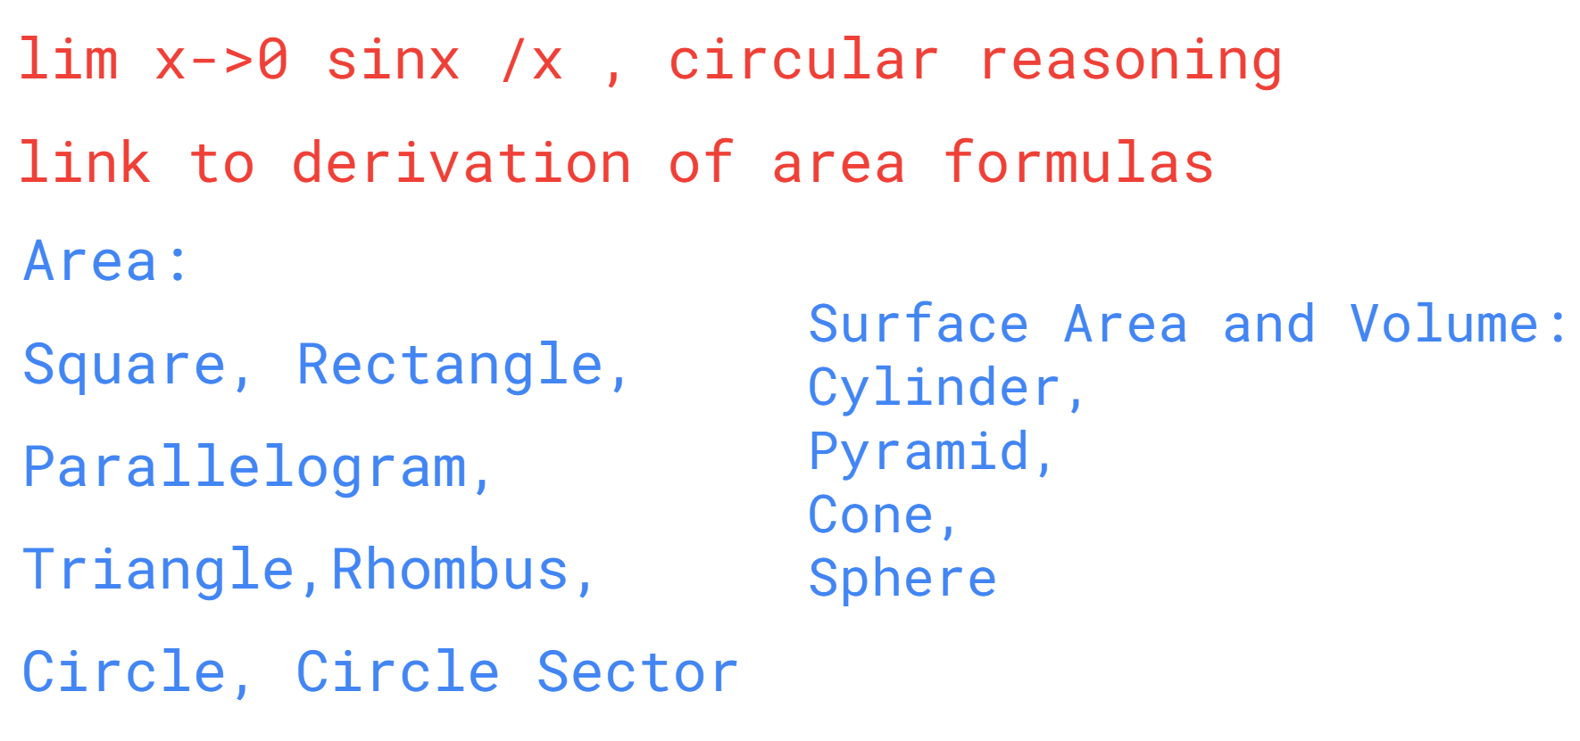
READ:
Geometry
Metric Volume
Conversion of Volume
https://www.mathsisfun.com/search/search.html?submit=&query=volume&search=1#ff

Integration using Riemann Sums, Integration and Antiderivatives, Indefinite & Definite integrals, Integrals with variable limits, Infinite Integral, Integration by Substitution

Integration using Riemann Sums
READ:
Integral Approximations
Integral Approximations Calculator and Graph
Sigma Notation
Partial Sums
Riemann Sums
Calculus I - Summation Notation
Calculus I - Area Problem
How to calculate sum of series:sum_(n=0)^oor^nsin(nx) and sum_(n=0)^oor^ncos(nx)? (i don't have specifications for r). | Socratic

READ:
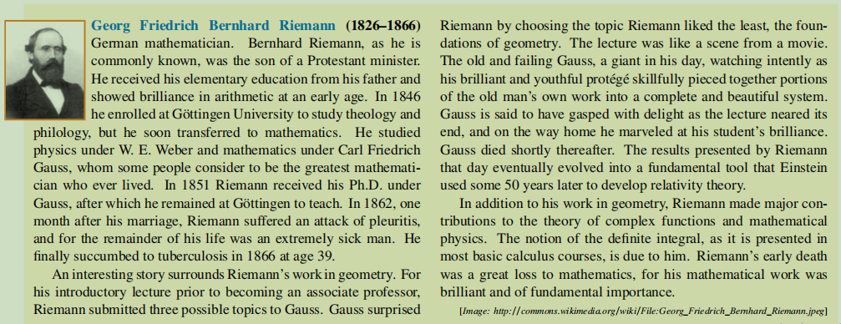
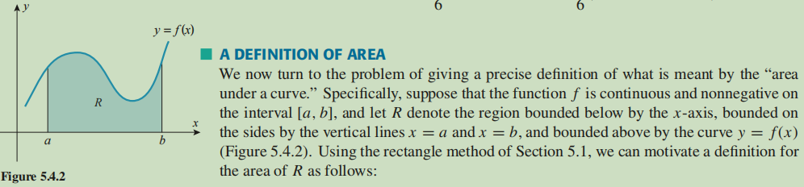
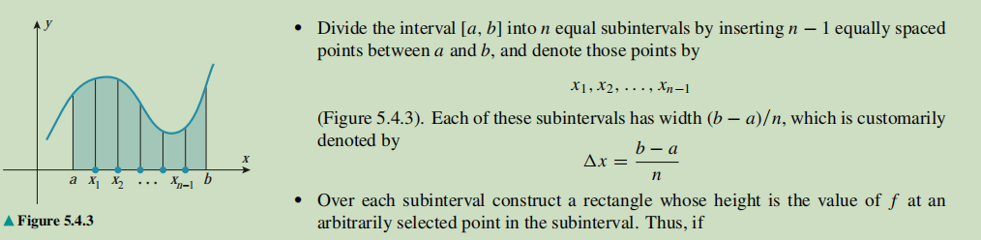
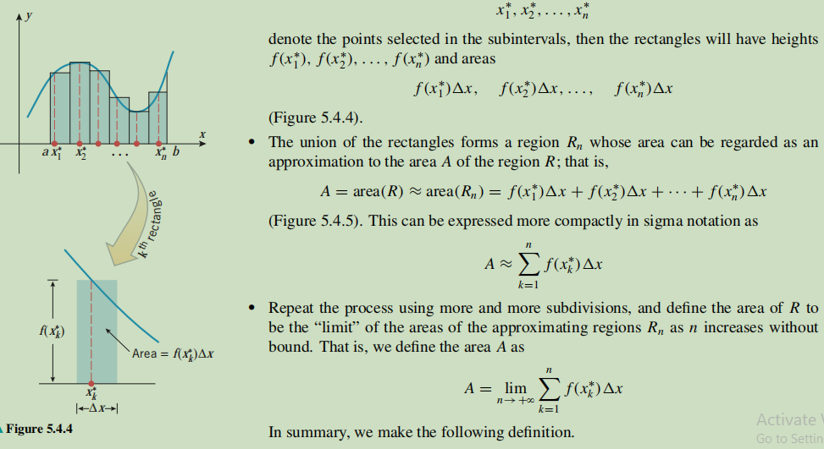
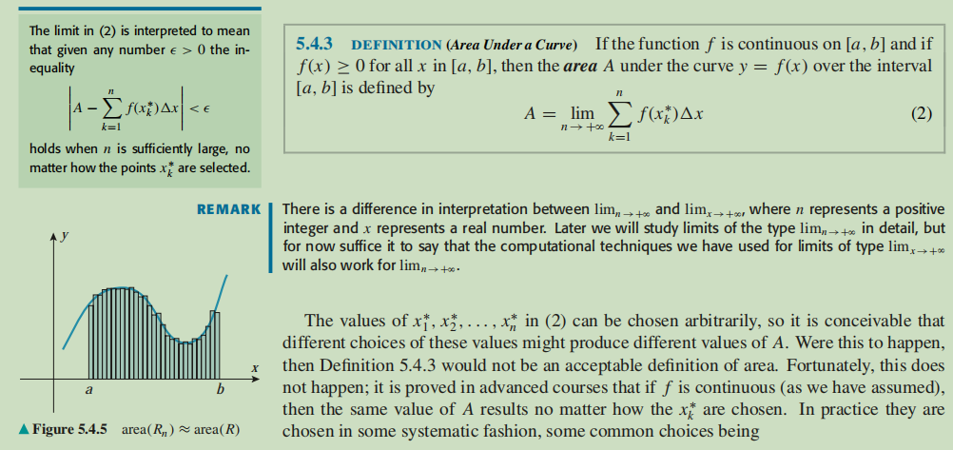
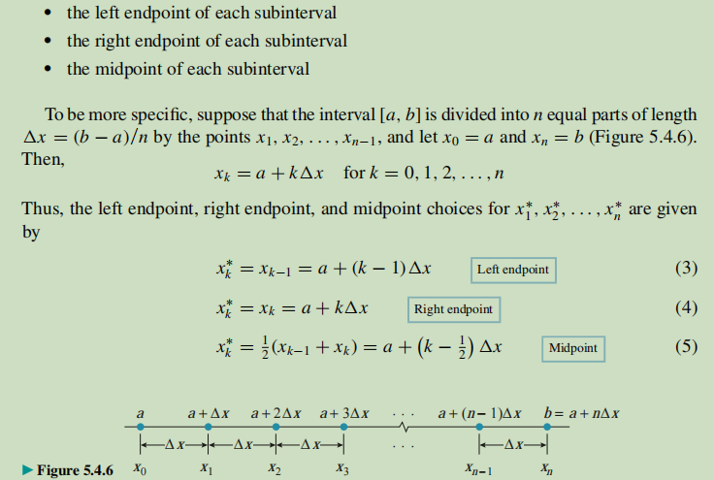
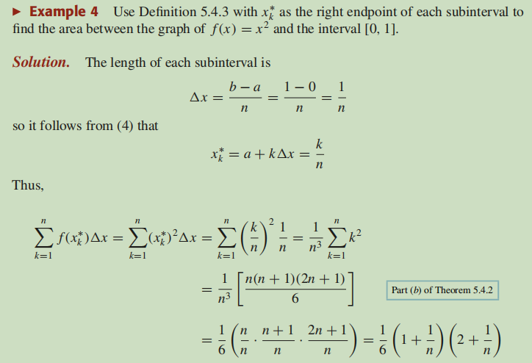
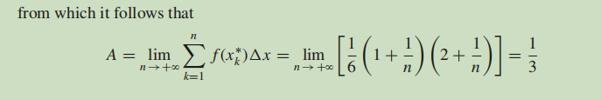
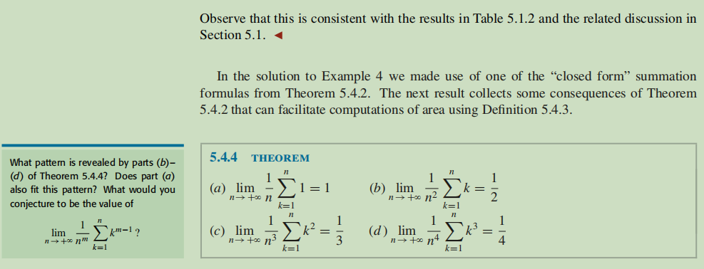
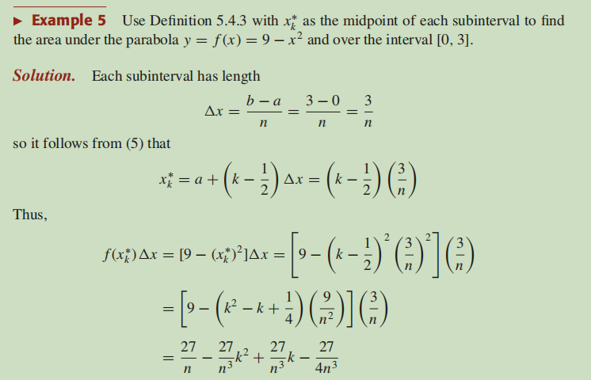
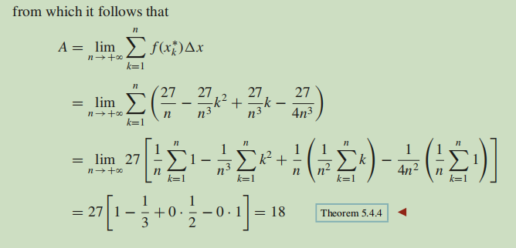
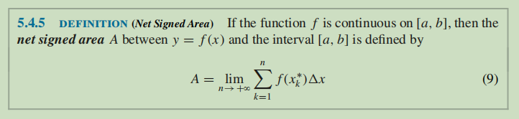
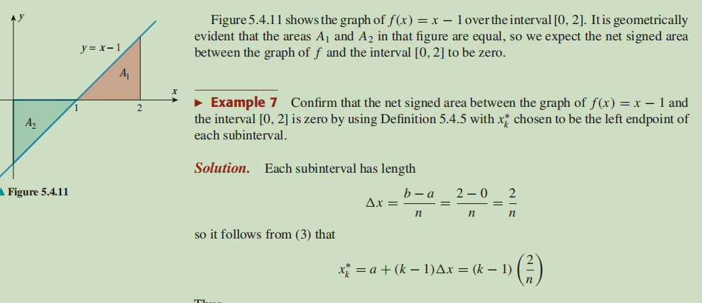
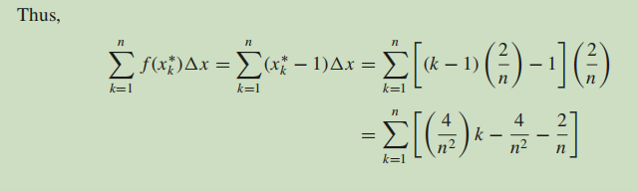
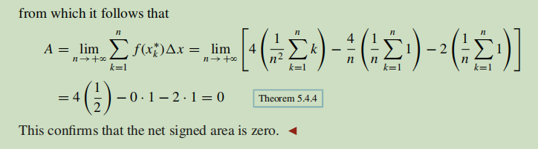
WATCH:
7.1 Preview of the definition of integral
7.2 "Sigma notation" for sums
7.10 Riemann sums
The Definite Integral Part I: Approximating Areas with rectangles
The Definite Integral Part II: Using Summation Notation to Define the Definite Integral
The Definite Integral Part III: Evaluating From The Definition
"Reverse" Riemann Sums | Finding the Definite Integral Given a Sumচলো ছবিতে অনুভব করি প্রথম n সংখ্যক স্বাভাবিক সংখ্যার বর্গ, ঘন এর যোগফলের সূত্র | চমক হাসানঅসীম গুণোত্তর ধারার আনন্দ - ১ | The Joy of Geometric Series -1/2 | Chamok Hasan
Proof of Sum Cos(kx) | Two Methods
READ: Limits to Infinity

Use the following online solver:
Riemann Sum Calculator for a Function - eMathHelp
PRACTISE: HOWARD ANTON: 5.4: Riemann Sum: 27-30, 35-40, 41-44, 45-48
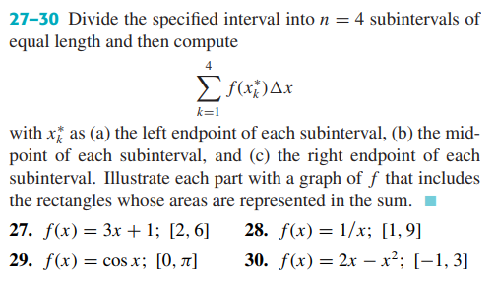
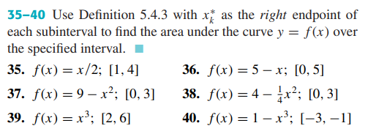
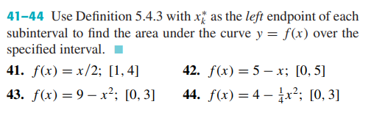
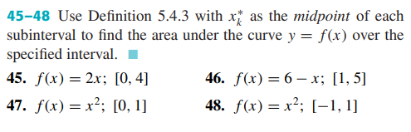

Integration and Antiderivatives, Indefinite & Definite integrals, Integrals with variable limits, Integration by Substitution

Indefinite Integral
READ:
Introduction to Integration
Calculus I - Constant of Integration
Graphical Intro to Derivatives and Integrals
Integration Rules
Calculus I - Computing Indefinite Integrals

READ:
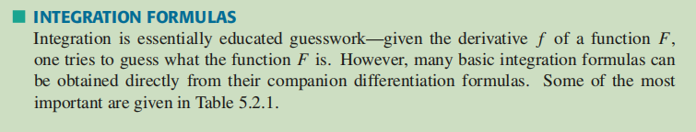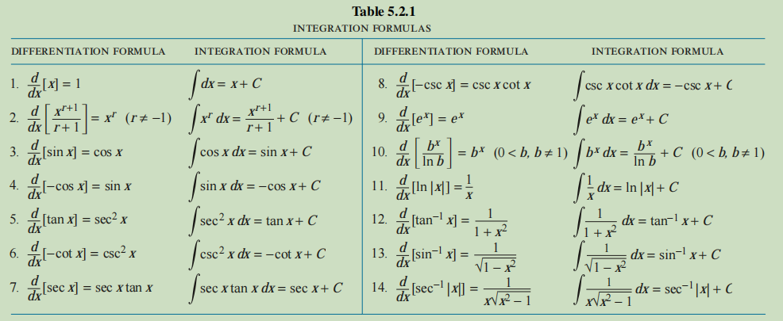
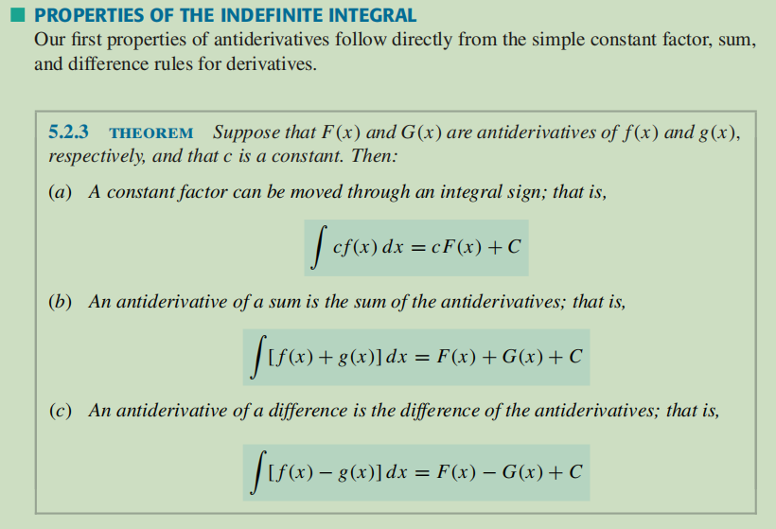
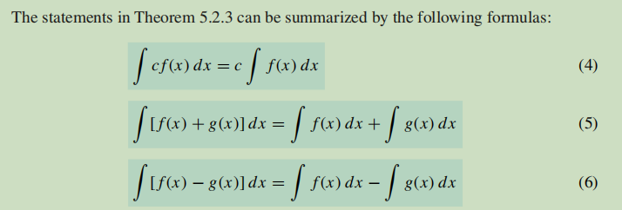
WATCH:
8.1 Antiderivatives
What's an anti-derivative?
Solving for the constant in the general anti-derivative
Use the following online solver:
Integral Calculator
Integral Calculator - eMathHelp
Integral Calculator

PRACTISE: HOWARD ANTON: 5.2 :Indefinite Integral: 15-22, 25, 27-31
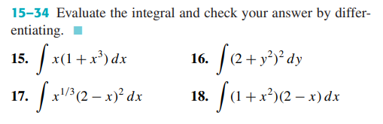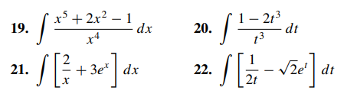
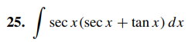
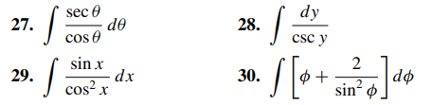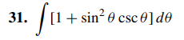

Integration by Substitution

READ:
Integration by Substitution
Calculus I - Substitution Rule for Indefinite Integrals
Calculus I - More Substitution Rule

READ:
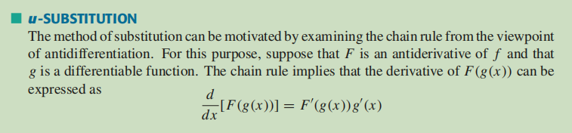
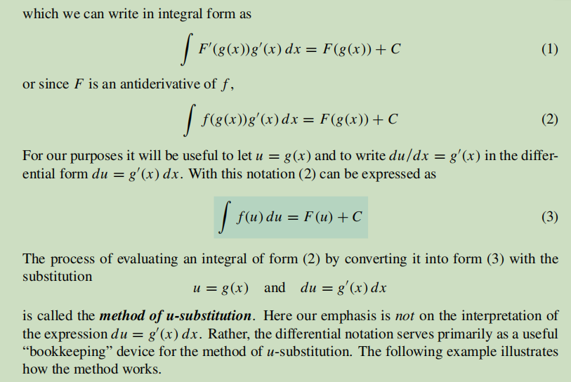
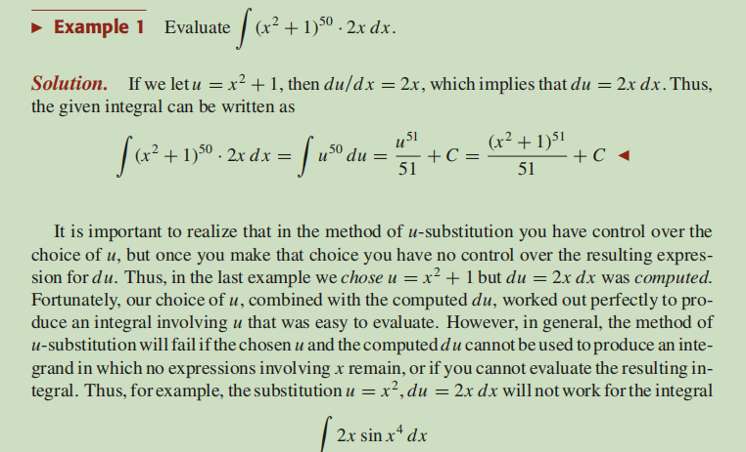
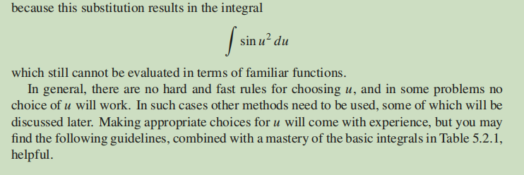
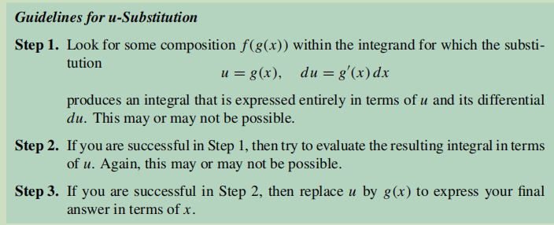
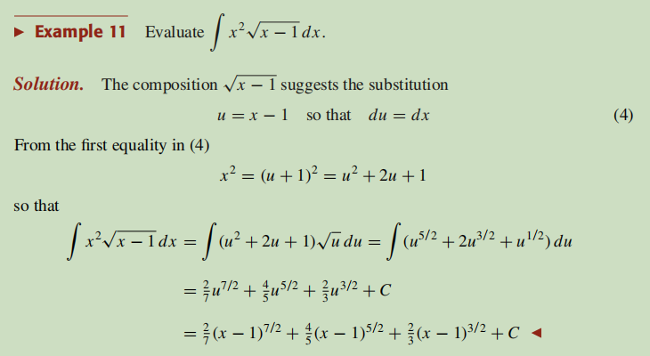
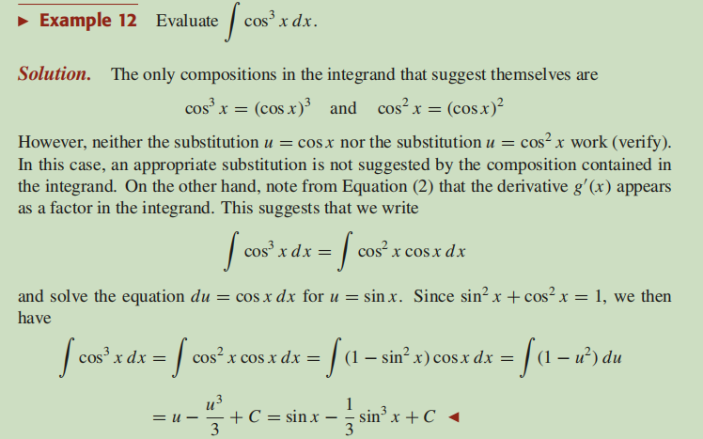
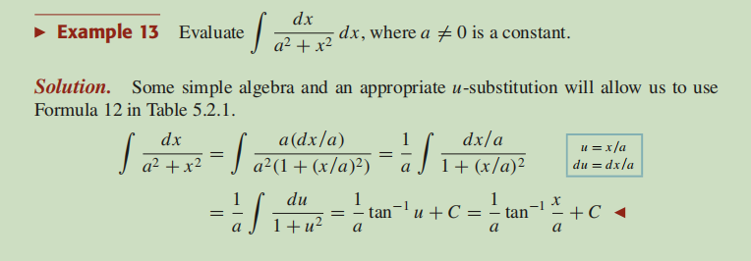
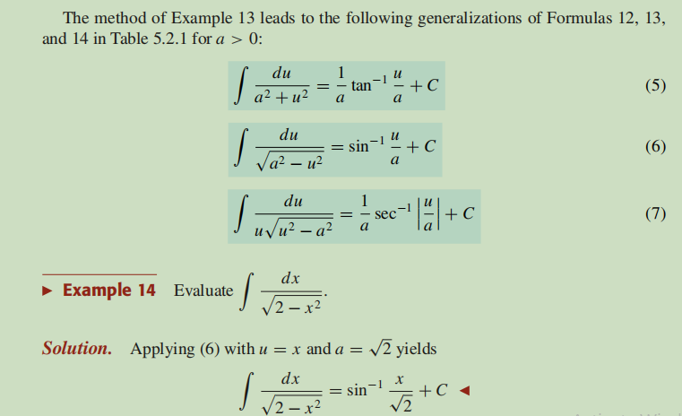
WATCH:
9.1 Integration by substitution - The theory
9.2 Integration by substitution - Examples
Intro to Substitution - Undoing the Chain Rule
Adjusting the Constant in Integration by Substitution
Use the following online solver:
Integral Calculator
Integral Calculator - eMathHelp
Integral Calculator
PRACTISE: HOWARD ANTON: 5.3: Integration by Substitution: 15-68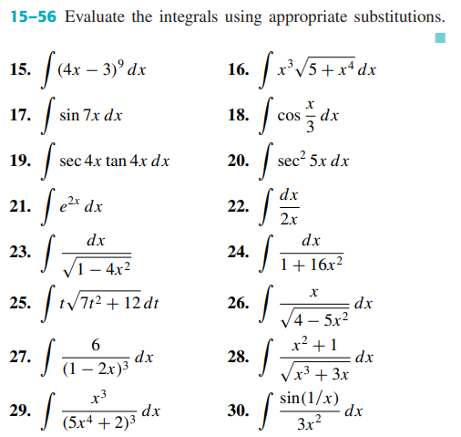
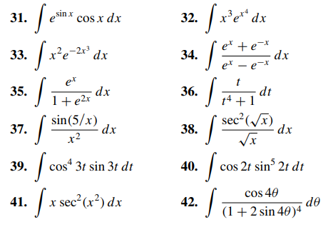

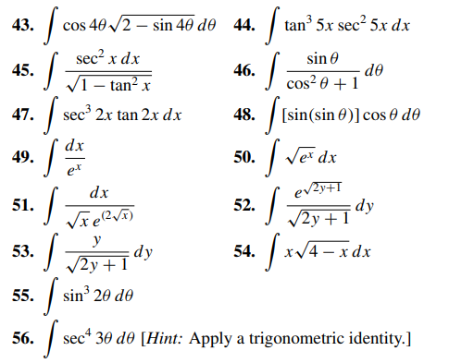
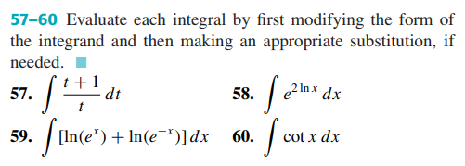
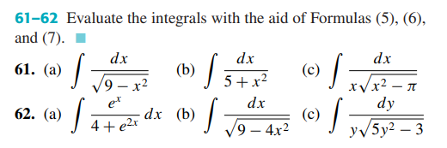
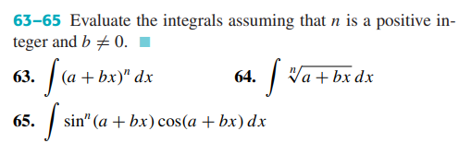
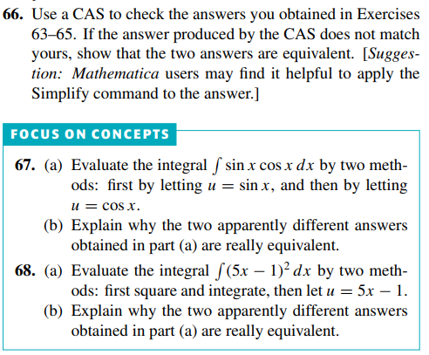

The Definite Integral
READ:
Definite Integrals
Calculus I - Definition of the Definite Integral
Calculus I - Computing Definite Integrals
READ:
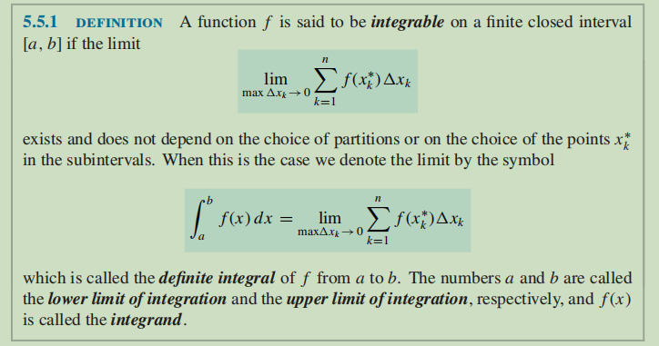
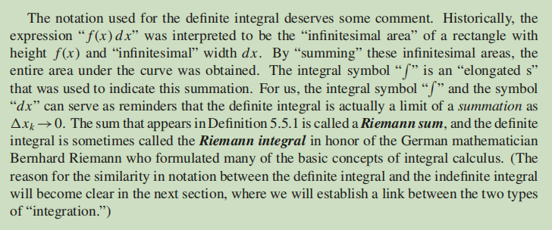
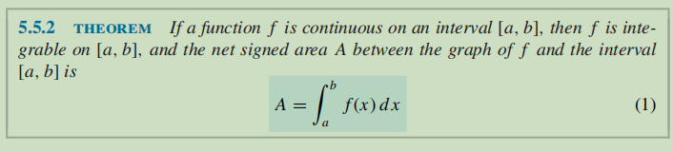

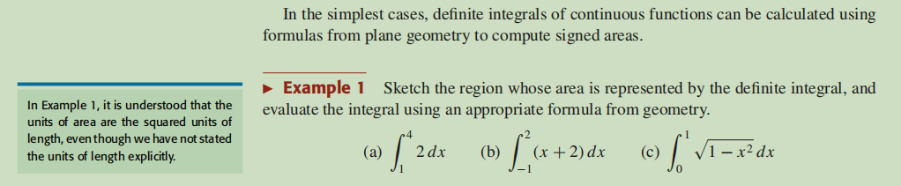
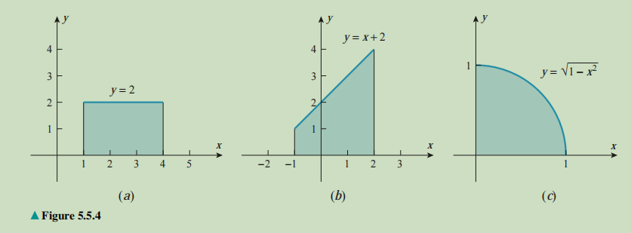
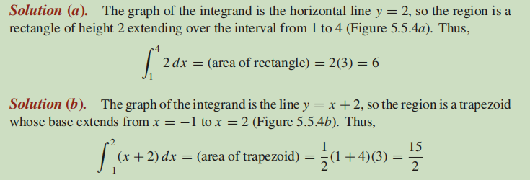
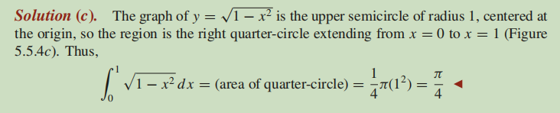
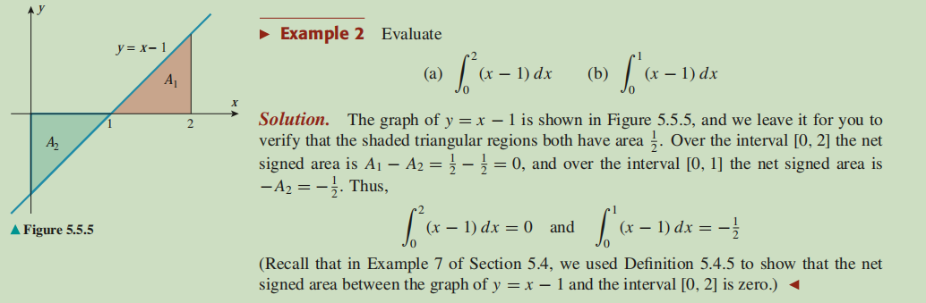

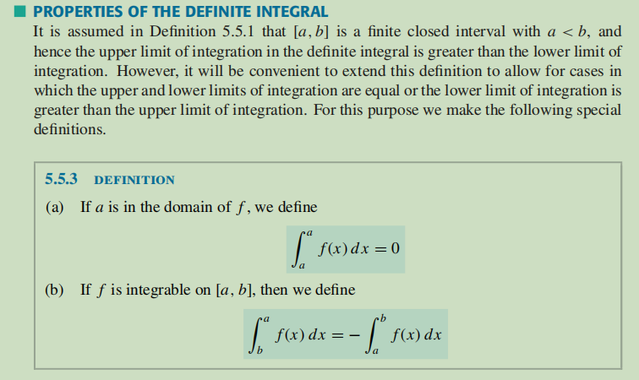
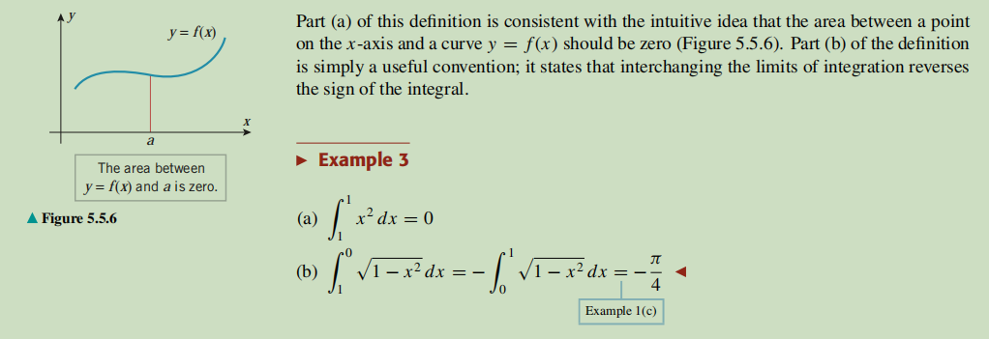
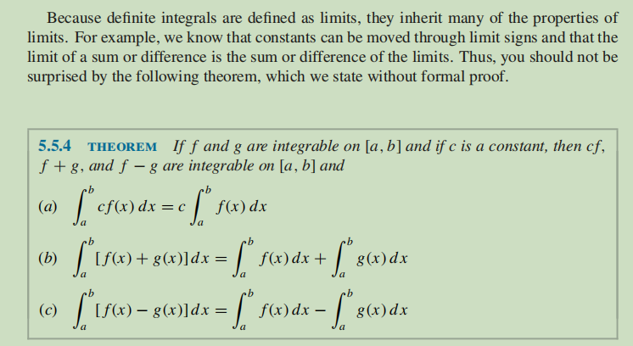
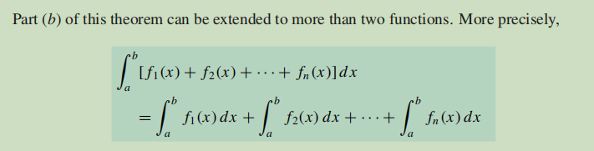
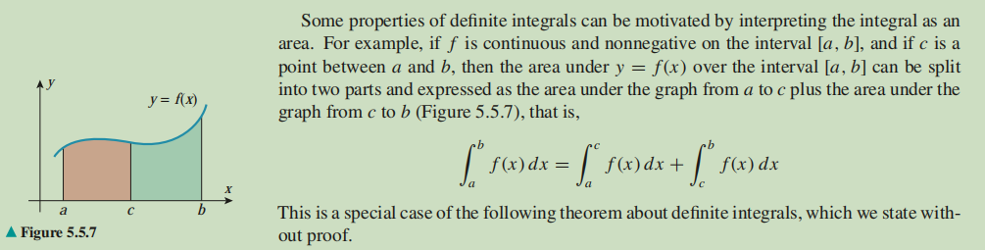
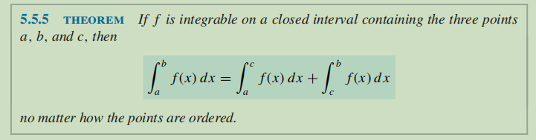
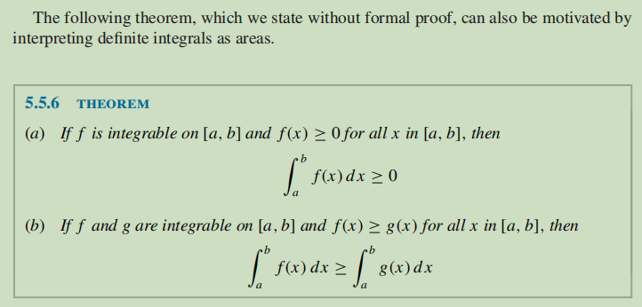
WATCH:
7.11 Five properties of definite integrals
8.2 Functions defined as integrals
8.7 Summary: the three "notions of integral"
the last question on a Harvard-MIT Math Tournament!
Use the following online solver:
Integral Calculator
Integral Calculator - eMathHelp
Integral Calculator
Definite and Improper Integral Calculator - eMathHelp

PRACTISE: HOWARD ANTON: 5.5: The Definite Integral: 13-15, 22, 23, 25, 27, 37
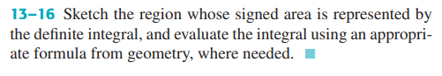
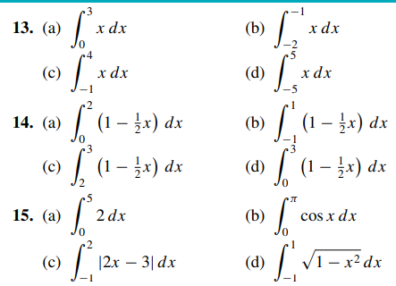
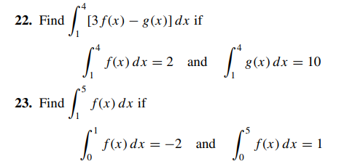
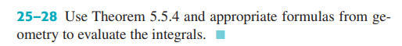
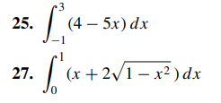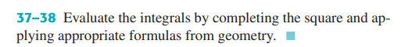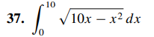

Evaluating Definite Integral by Substitution

READ:
Calculus I - Substitution Rule for Definite Integrals
READ:
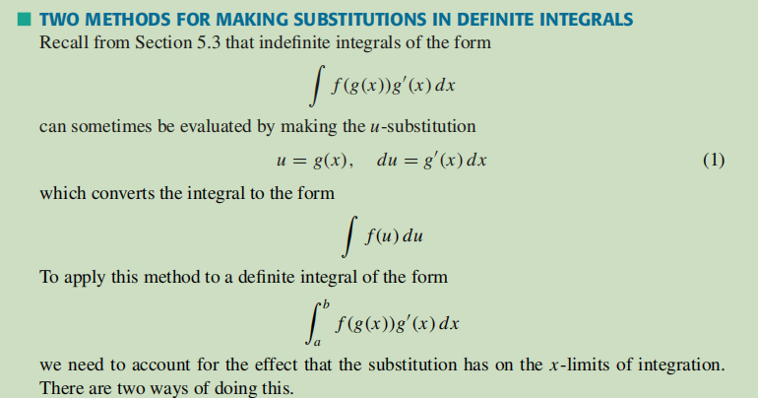
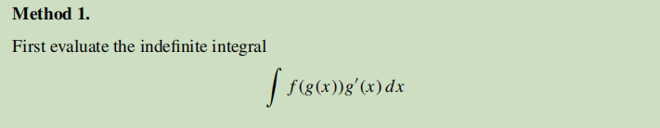
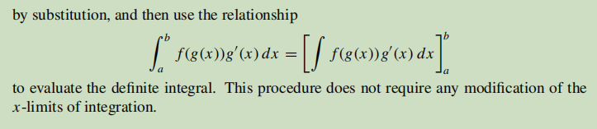
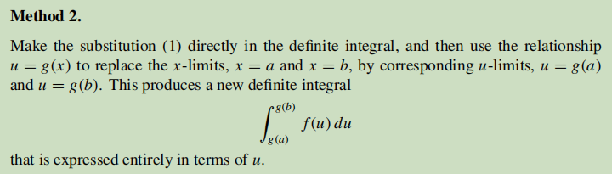
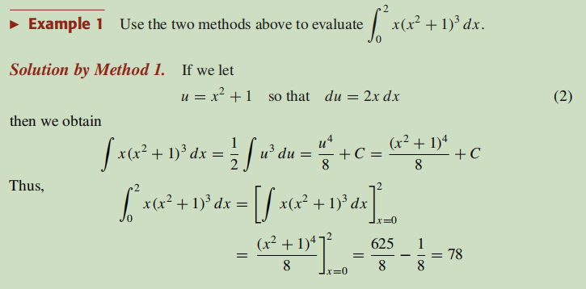
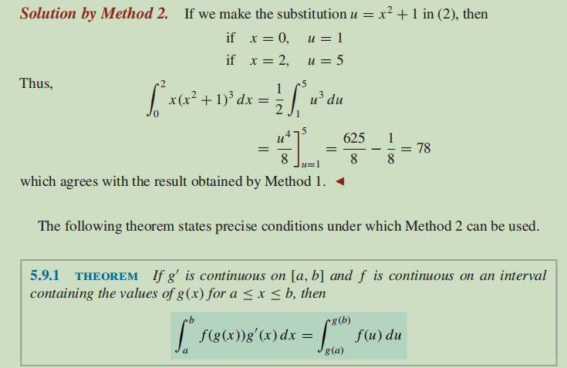
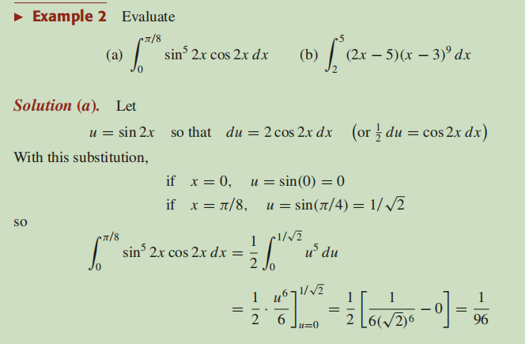
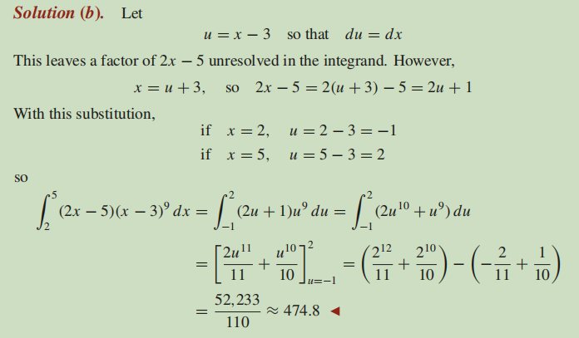
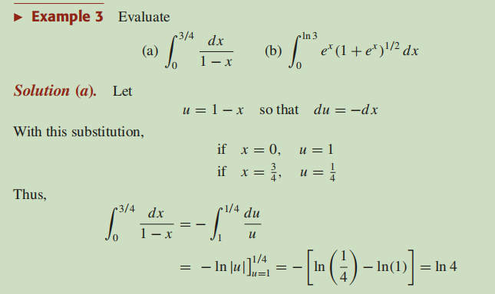
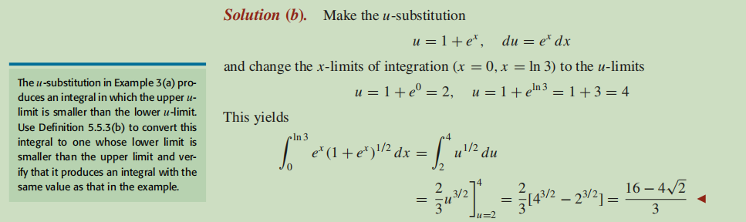
WATCH:
9.3 Substitution for definite integrals
Substitution Method for Definite Integrals **careful!**
Use the following online solver:
Integral Calculator
Integral Calculator - eMathHelp
Integral Calculator
Definite and Improper Integral Calculator - eMathHelp

PRACTISE: HOWARD ANTON: 5.9: Evaluating Definite Integral by Substitution: 5-22, 32, 33, 35-40
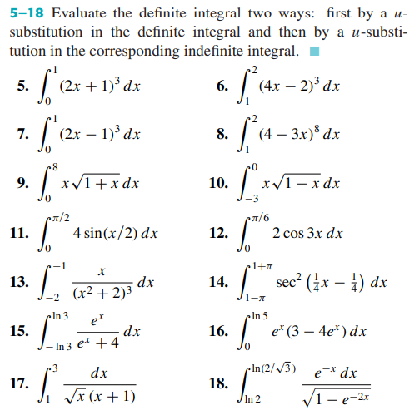
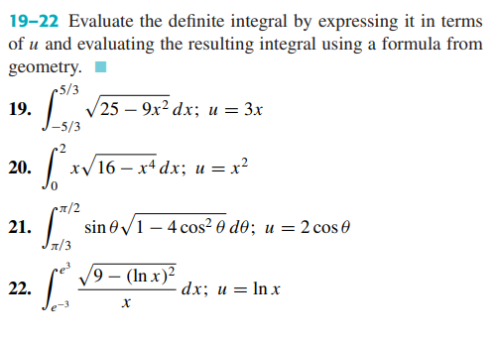
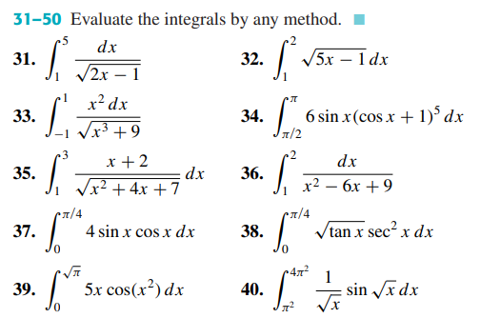

Improper Integrals, Integration by parts, Reduction formula, Integration by Trigonometric Substitution, Integration of Rational Function

Integration by parts, Reduction formula, Improper Integrals, Infinite integrals
READ: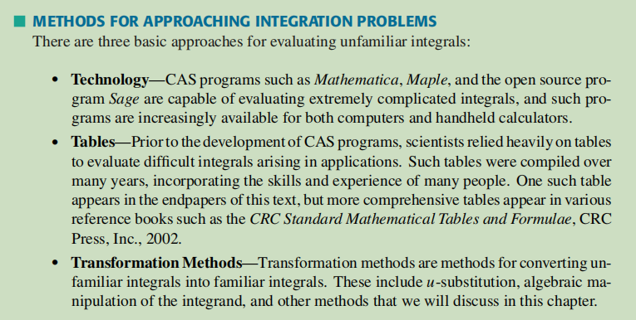
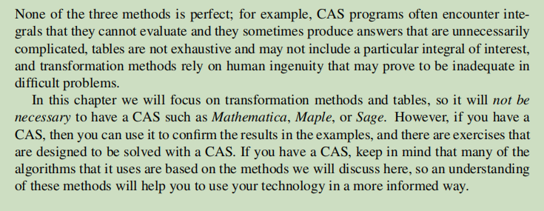
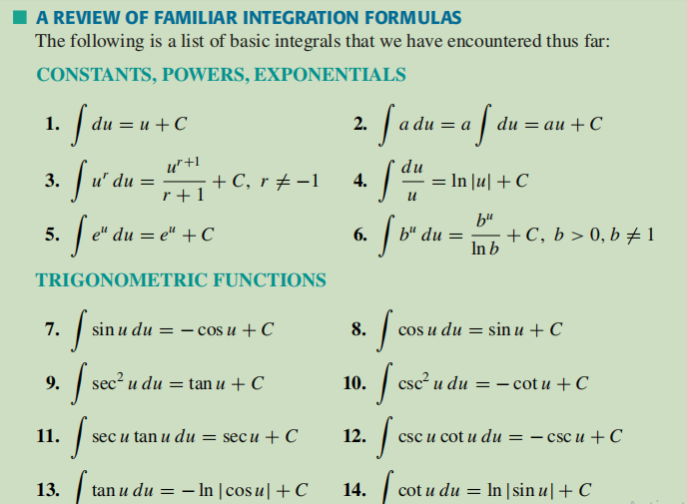
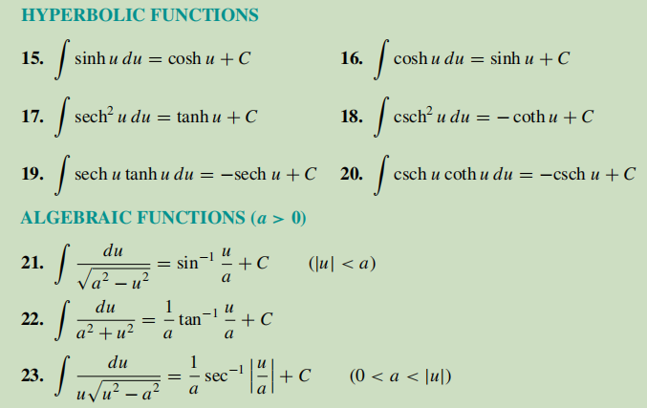
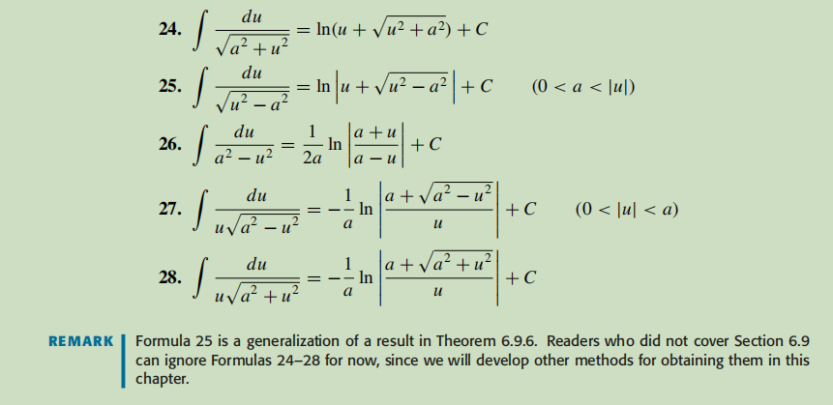
WATCH:
READ: Calculus I - Derivatives of Hyperbolic Functions
OR WATCH: Why hyperbolic functions are actually really nice
Use the following online solver:
Integral Calculator
Integral Calculator - eMathHelp
Integral Calculator
Definite and Improper Integral Calculator - eMathHelp
PRACTISE: HOWARD ANTON: 7.1: Overview of Integration Methods: 1-30
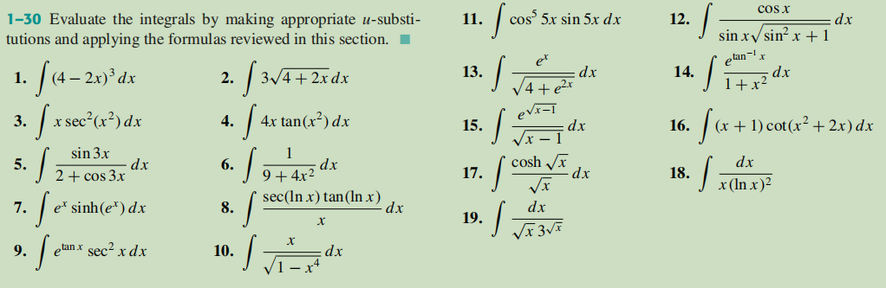
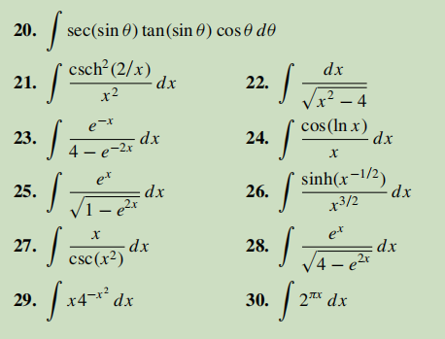

Integration By Parts
READ:
Integration by Parts
READ:
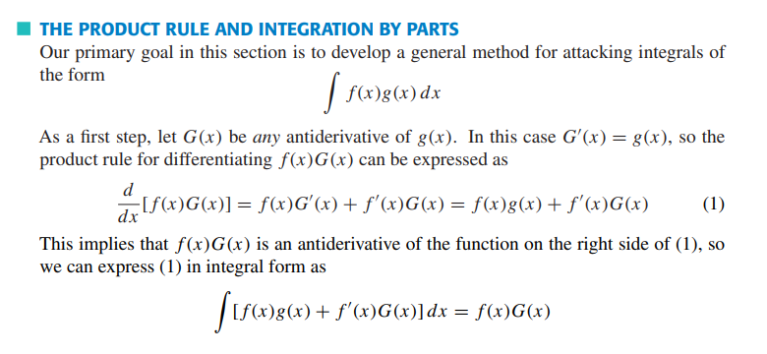
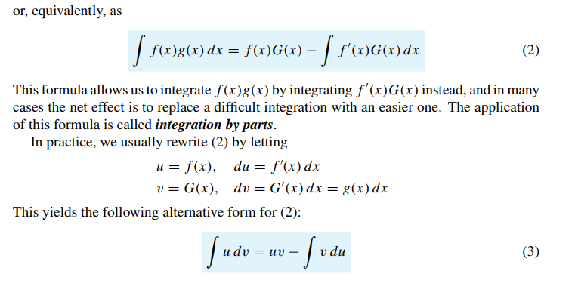
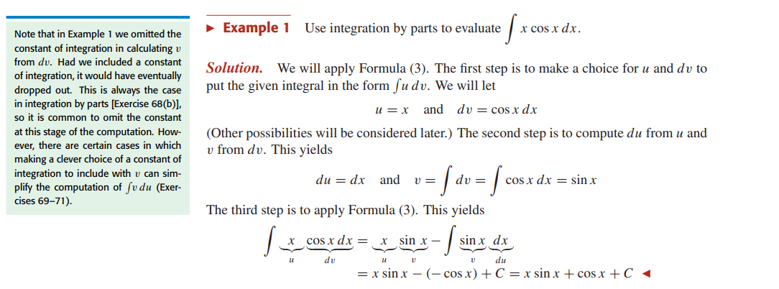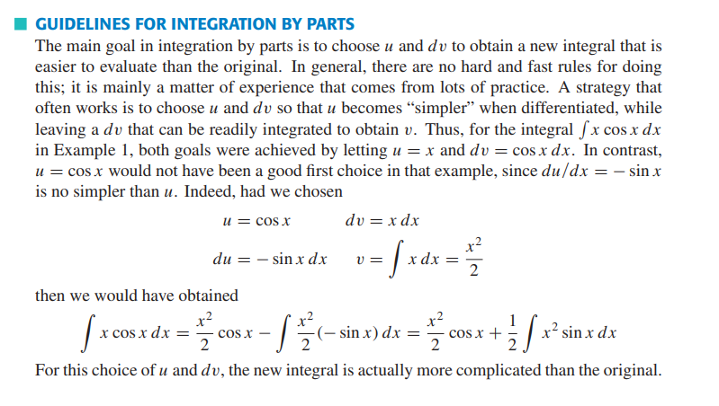
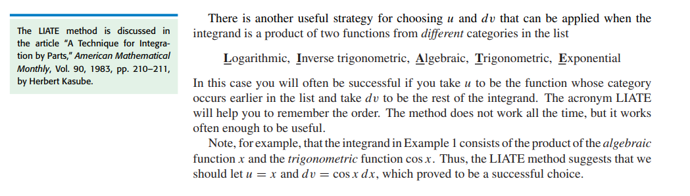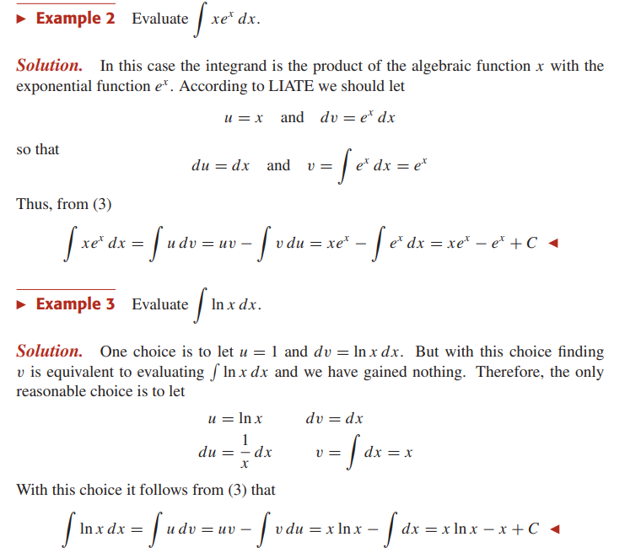
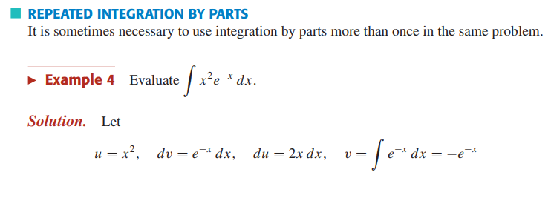
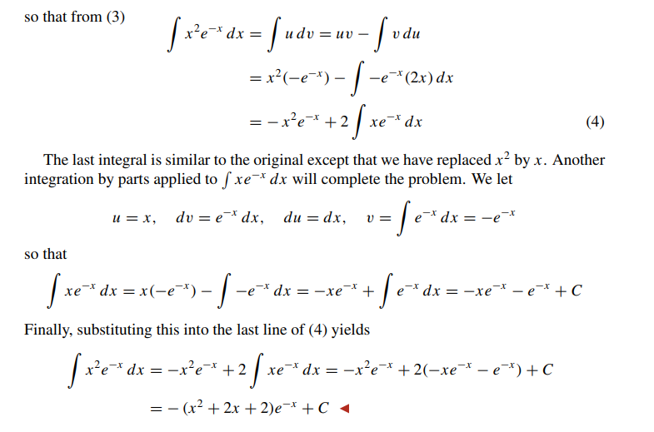
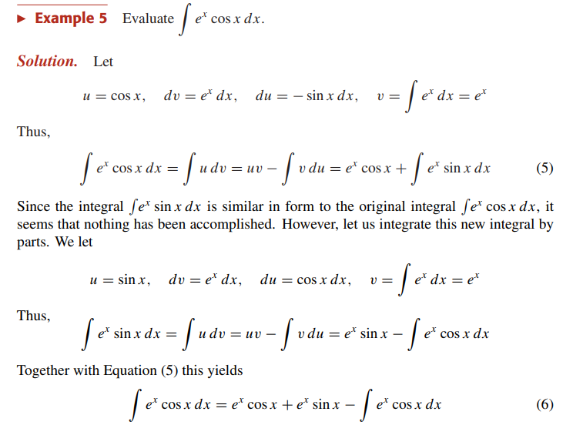
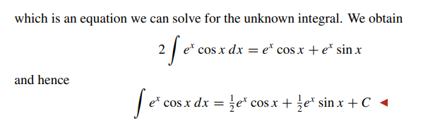
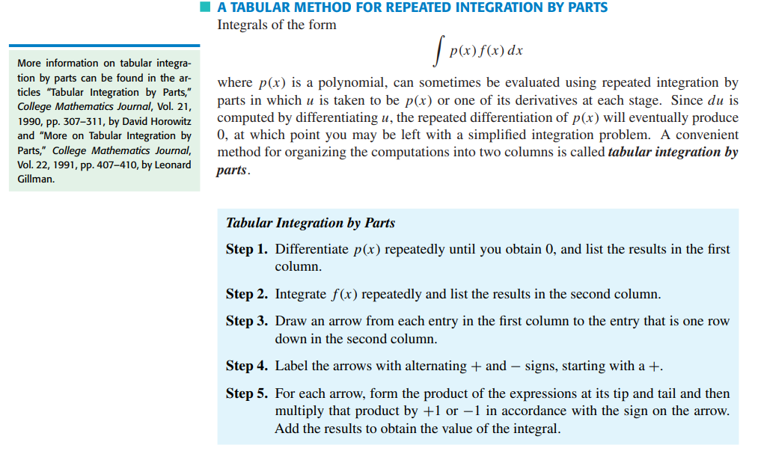
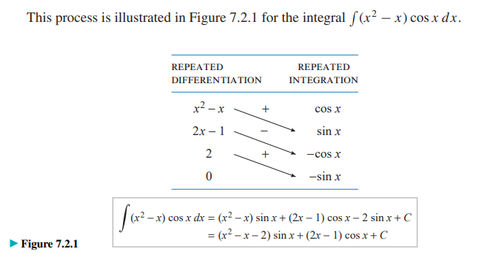
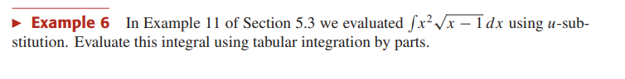
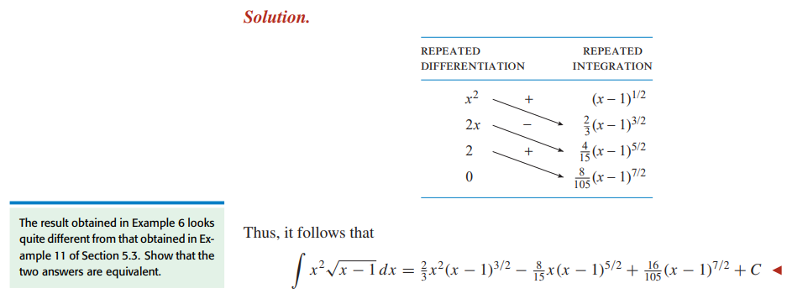
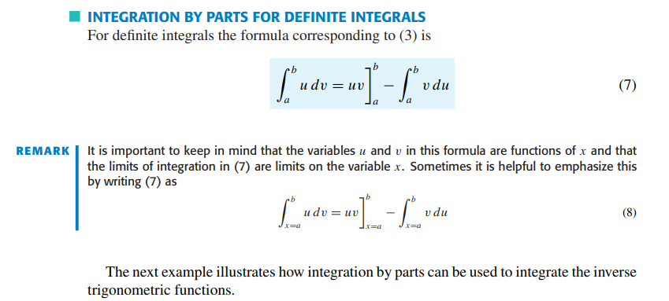
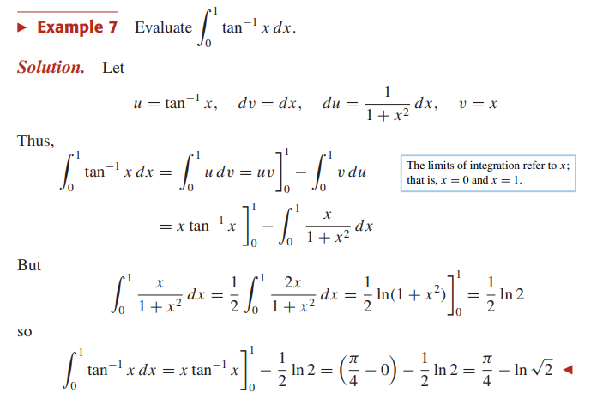

WATCH:
9.4 Integration by parts - The theory
9.5 Integration by parts - Examples
9.6 Integration by parts - One more example
Intro to Integration By Parts --- Examples: ∫xsinxdx & ∫arctan(x)dxTwo Tricky Integration By Parts Examples
life changing integration by parts trick
Use the following online solver:
Integral Calculator
Integral Calculator - eMathHelp
Integral Calculator
Definite and Improper Integral Calculator - eMathHelp
PRACTISE: HOWARD ANTON: 7.2 : Integration By Parts: 10-35
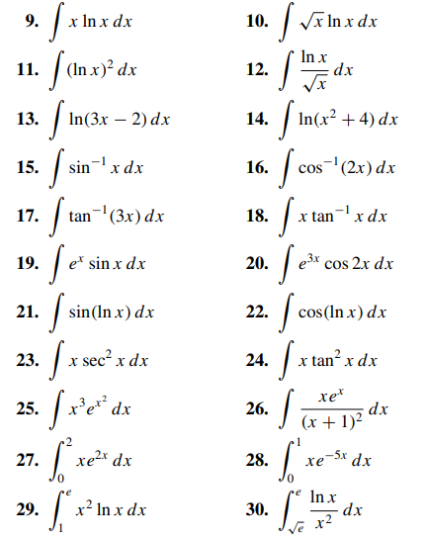
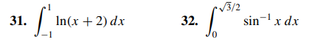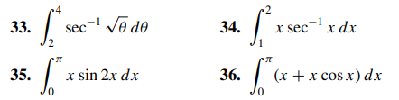

Integrating Trigonometric functions (Reduction Formula)

READ:
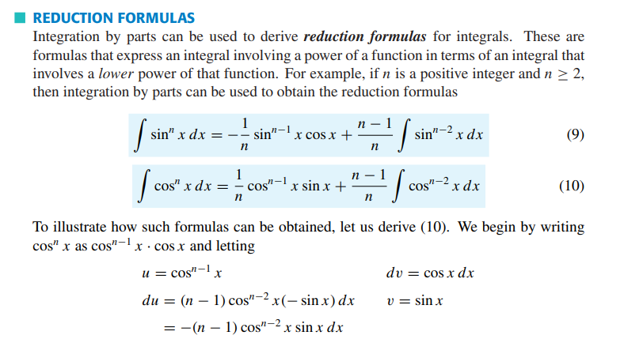
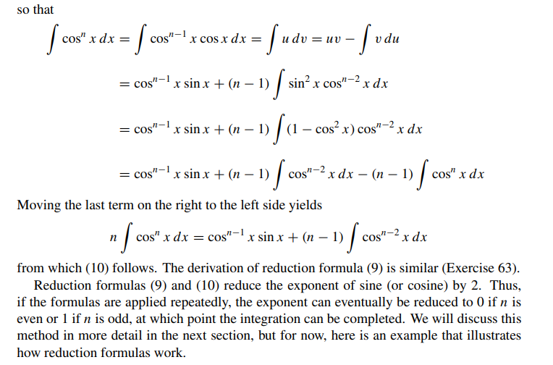
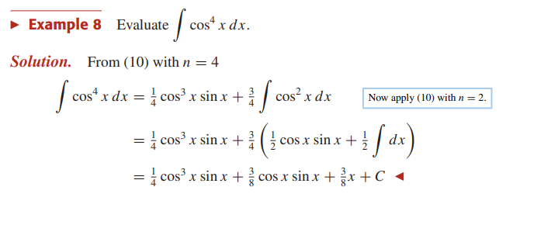
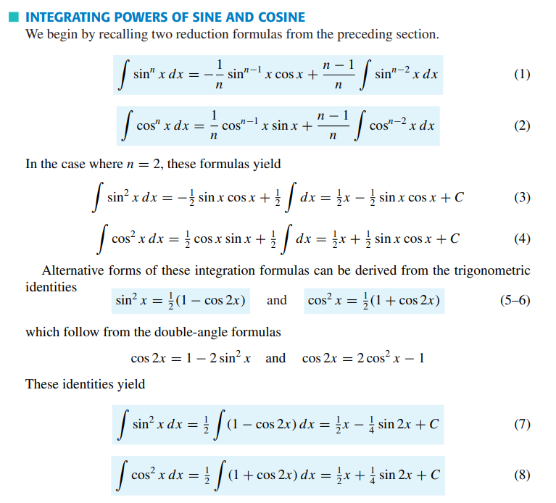
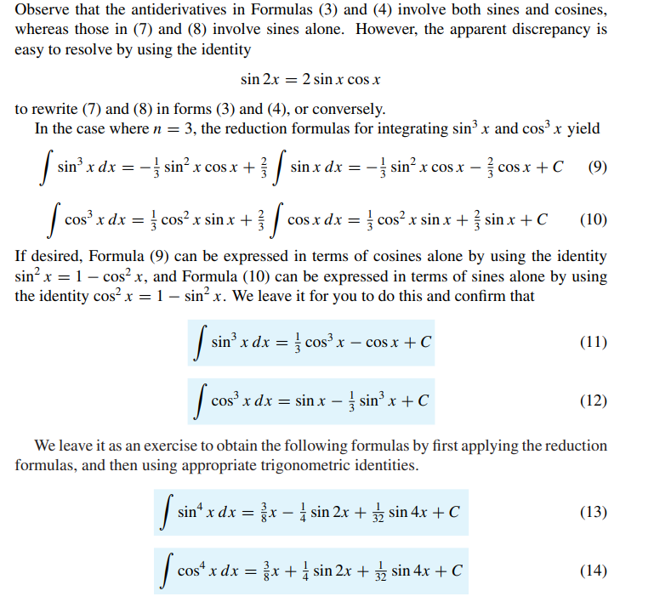
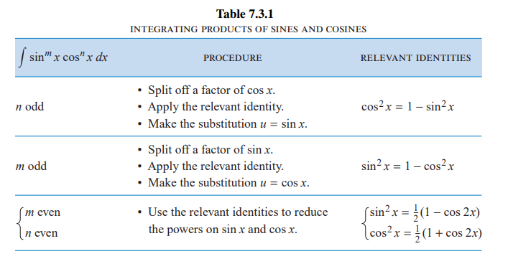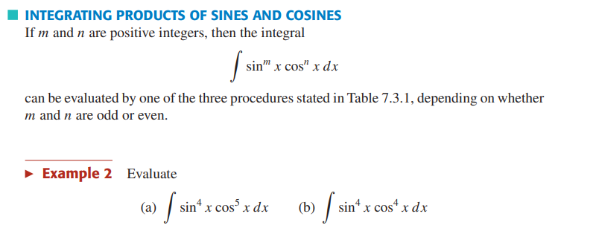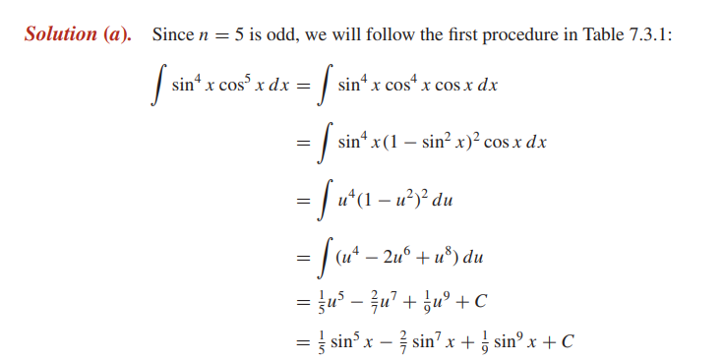
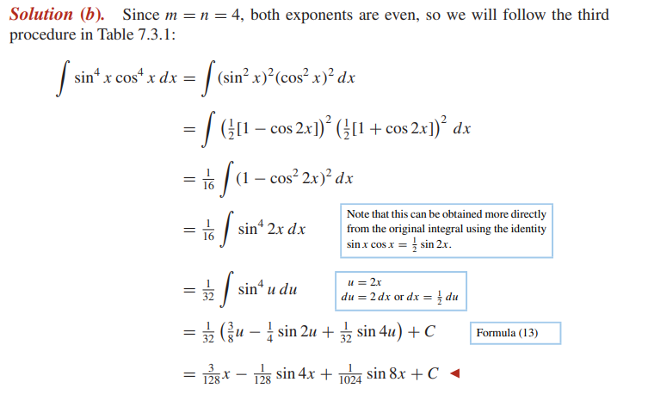
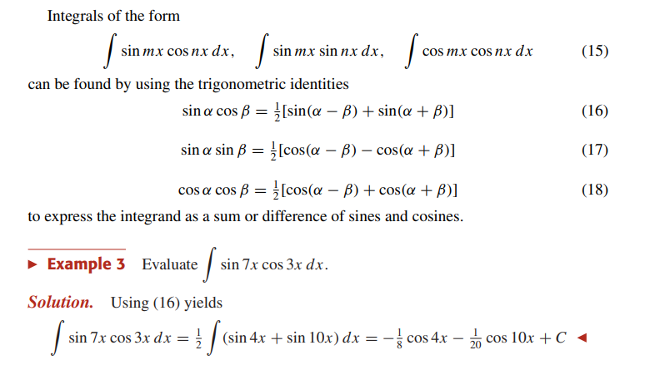
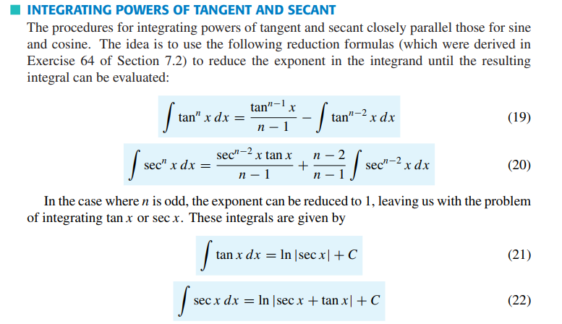
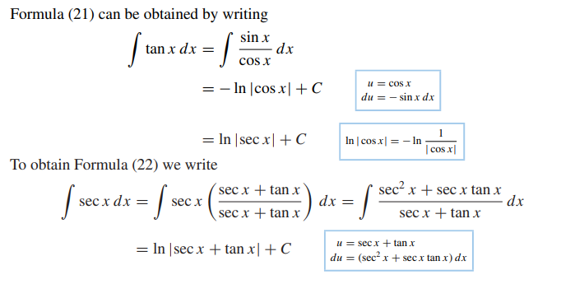
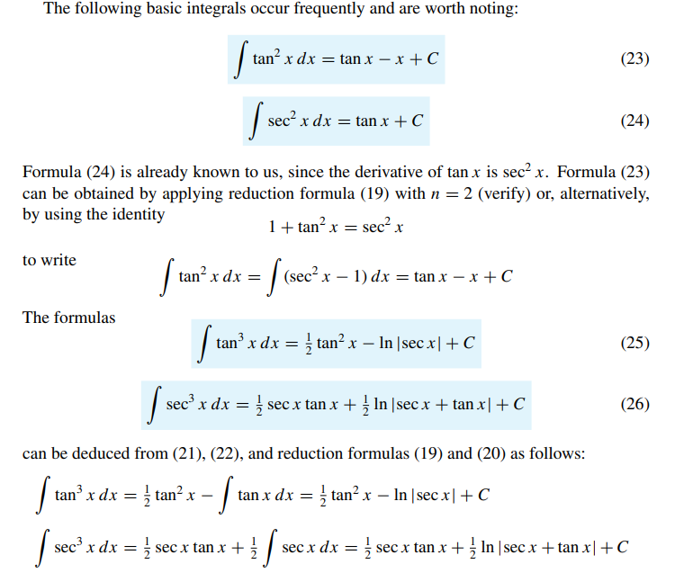
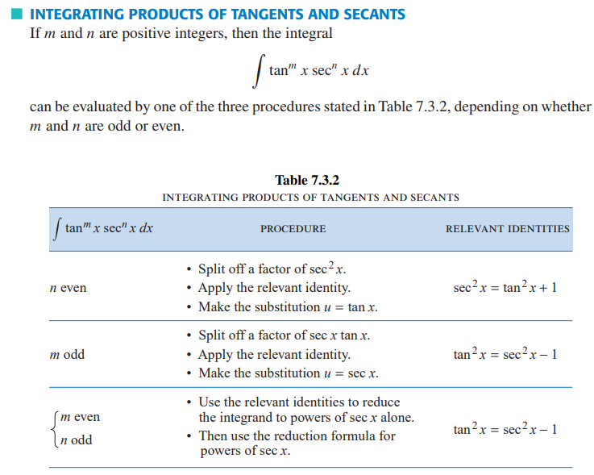
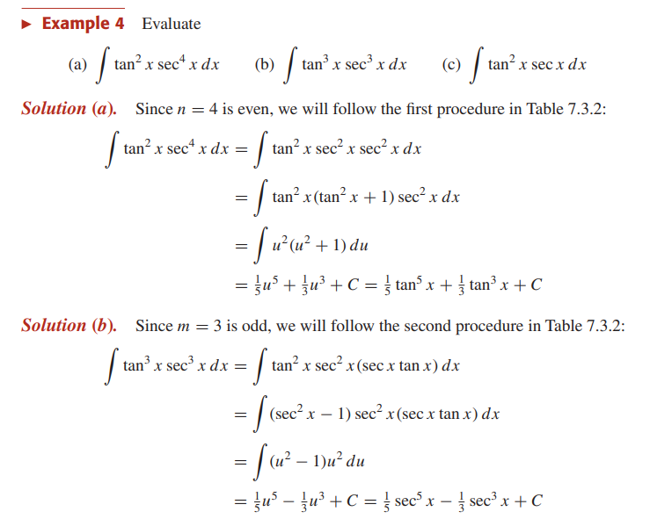
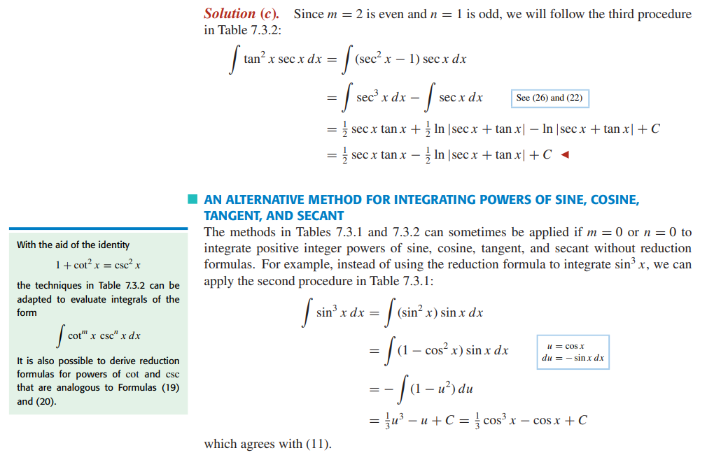
WATCH:
9.7 Integration of products of trigonometric functions (Part 1)9.8 Integration of products of trigonometric functions (Part 2)
9.9 The integral of secant
Trigonometric Integrals --- ∫sin^n(x)cos^m(x)dx via Pythagorean or Half-Angle Identities
Use the following online solver:
Integral Calculator
Integral Calculator - eMathHelp
Integral Calculator
Definite and Improper Integral Calculator - eMathHelp
PRACTISE: HOWARD ANTON: 7.3: Integrating Trigonometric functions (Reduction Formula):
5, 7, 13, 19, 43, 44, 47
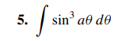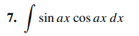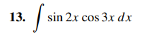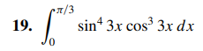
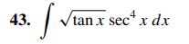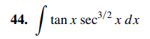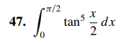

Improper Integrals
READ:
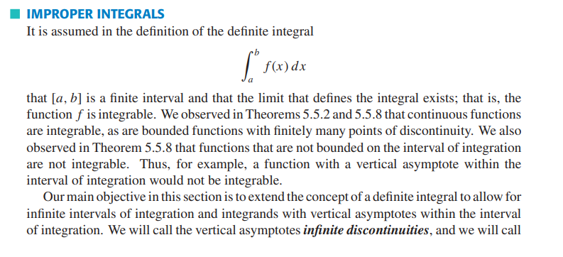
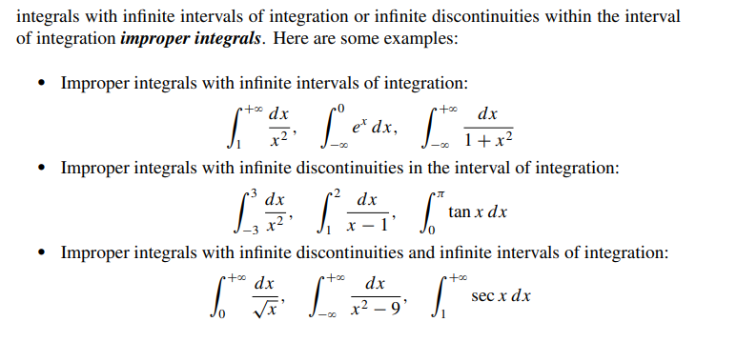
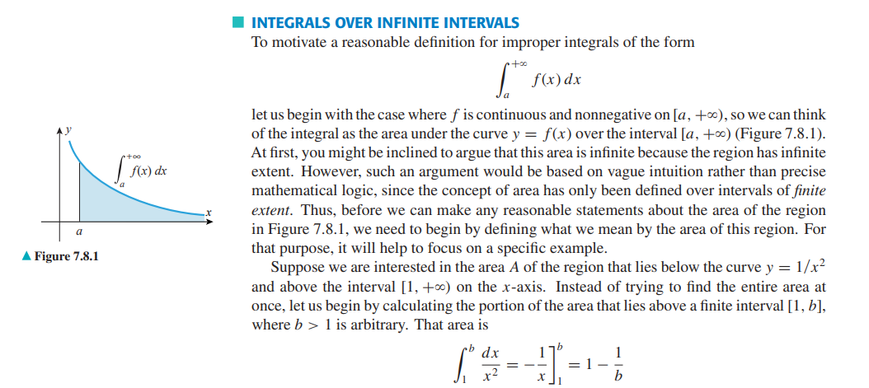
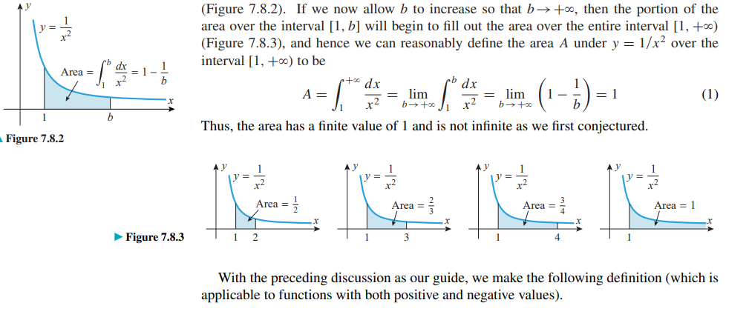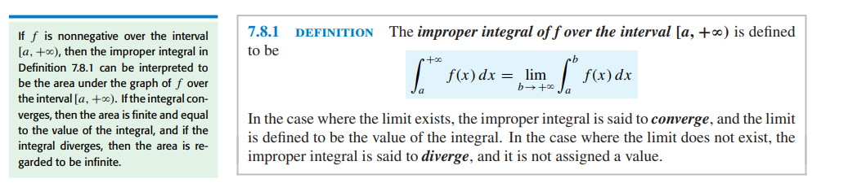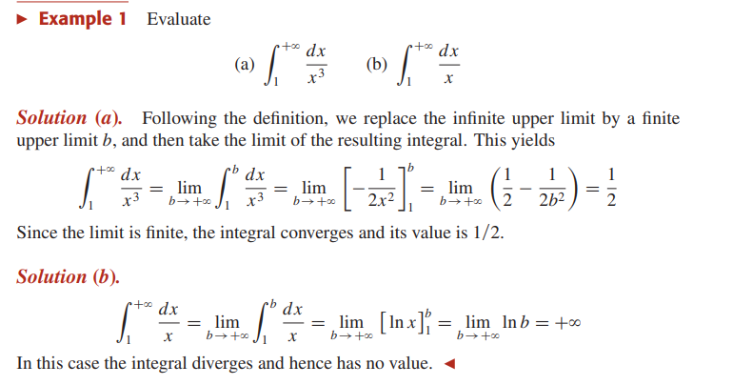
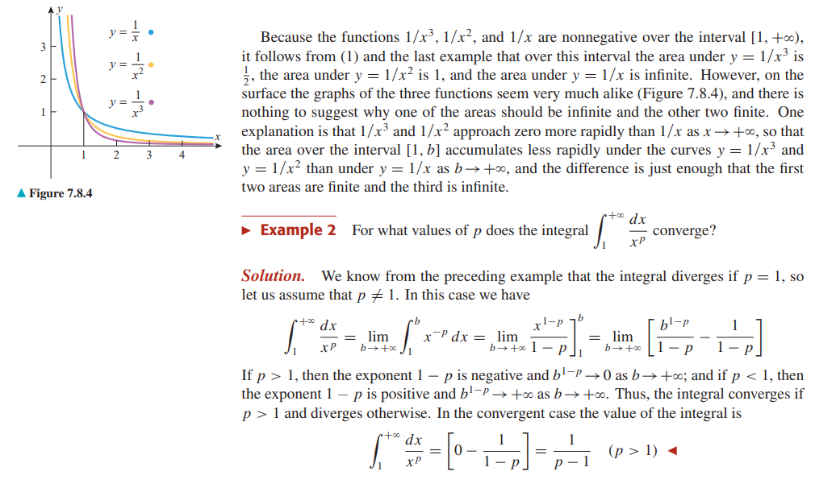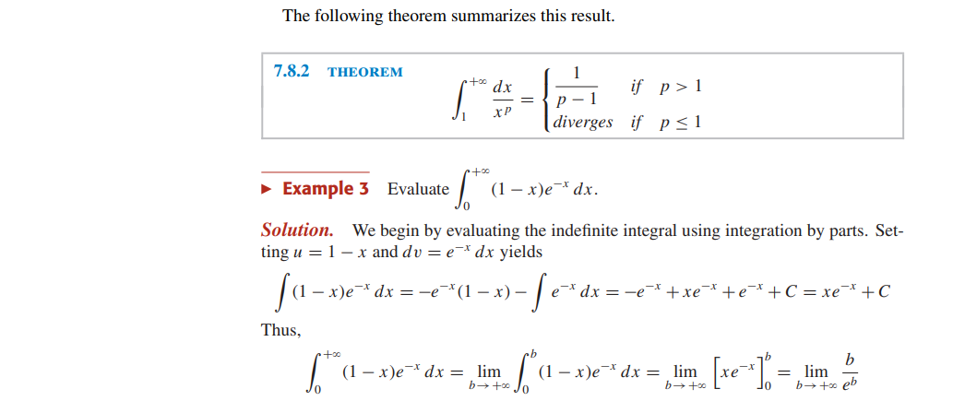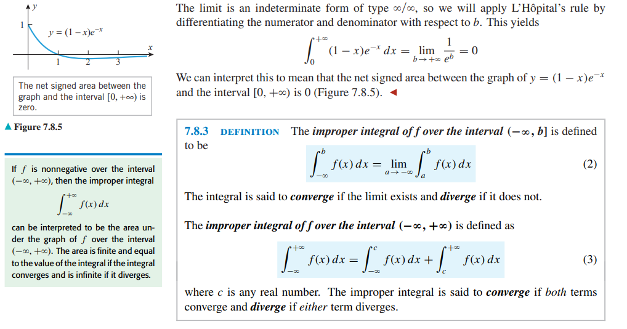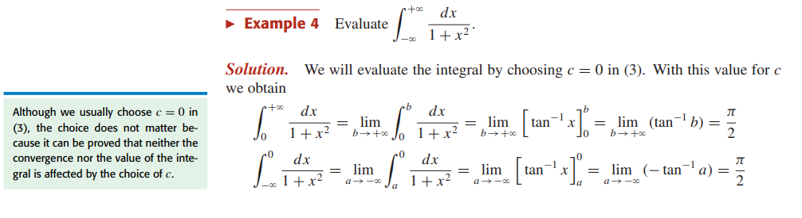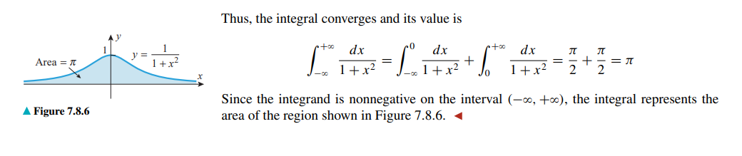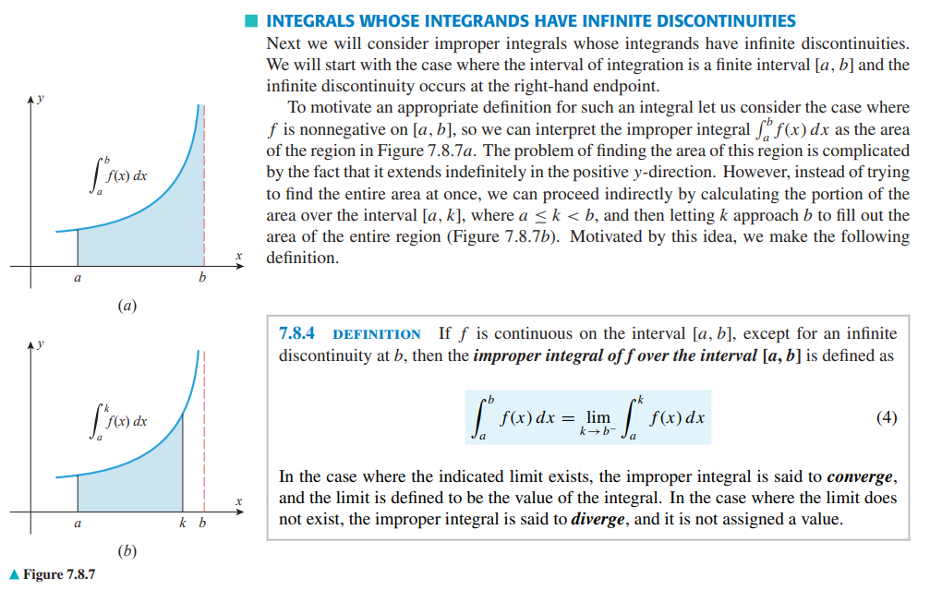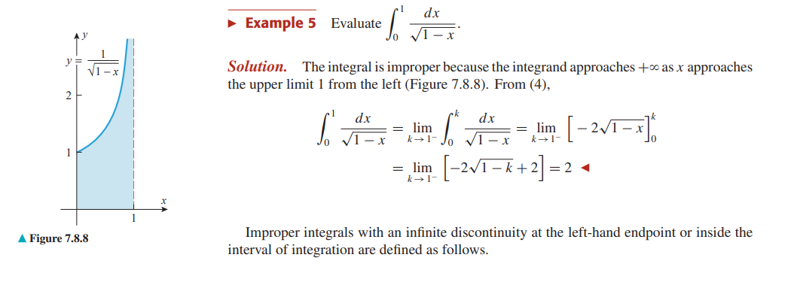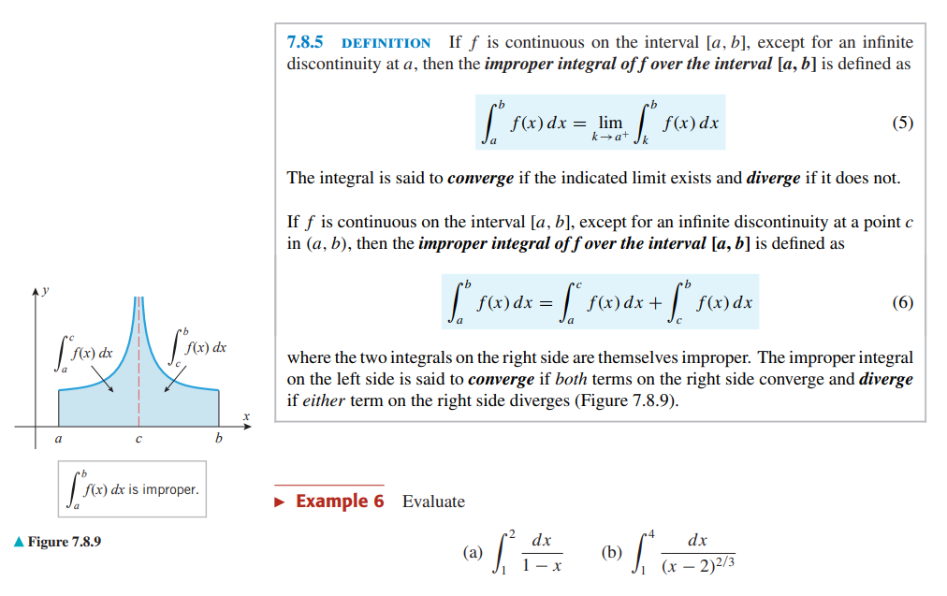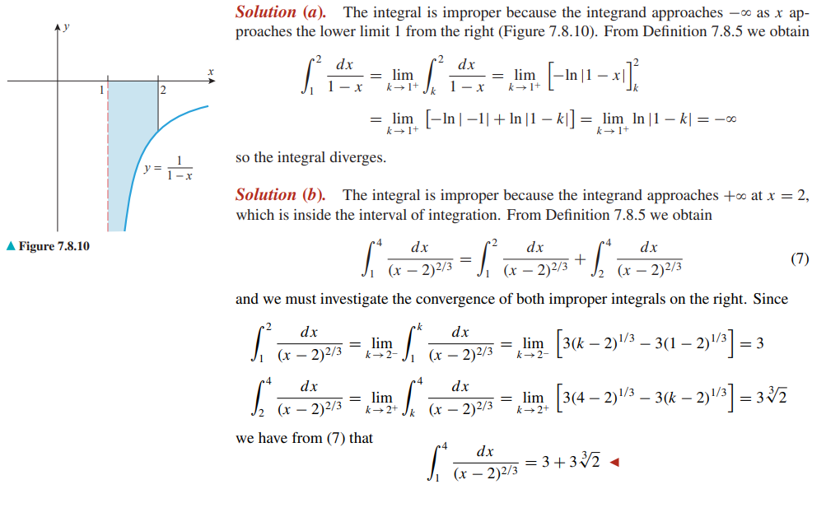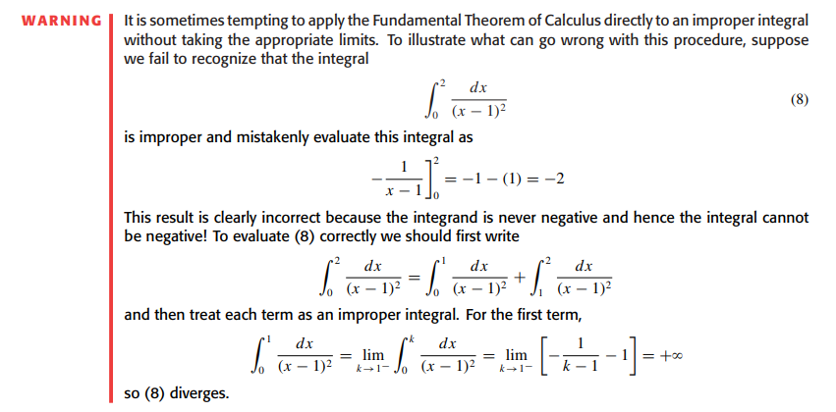
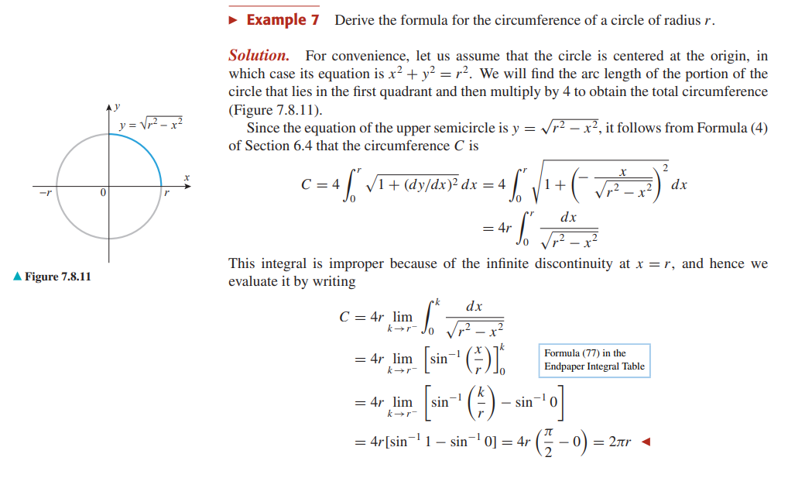
WATCH:
12.1 Improper integrals: Definition and Example 1
12.2 Improper integrals: Example 2
12.3 Improper integrals: Example 3
12.4 Improper integral - Example 4 ("p functions")
12.5 Improper integral: Example 5 (vertical asymptote)
12.6 Doubly improper integrals
Improper Integrals: How to Integrate with Infinities, 2 ways!
Use the following online solver:
Integral Calculator
Integral Calculator - eMathHelp
Integral Calculator
Definite and Improper Integral Calculator - eMathHelp
PRACTISE: HOWARD ANTON: 7.8: Improper Integrals: 3-32
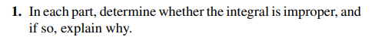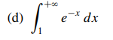
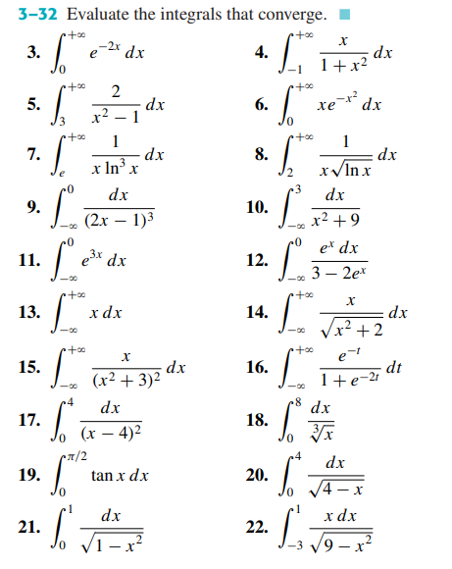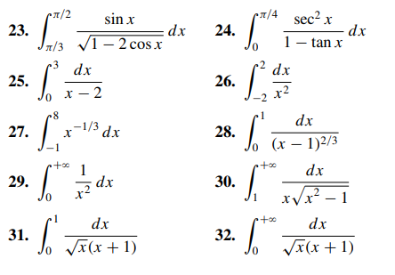
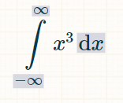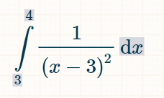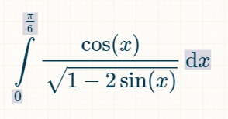

Integration by Trigonometric Substitution, Integration of Rational Function

Integration by Trigonometric Substitution
READ:
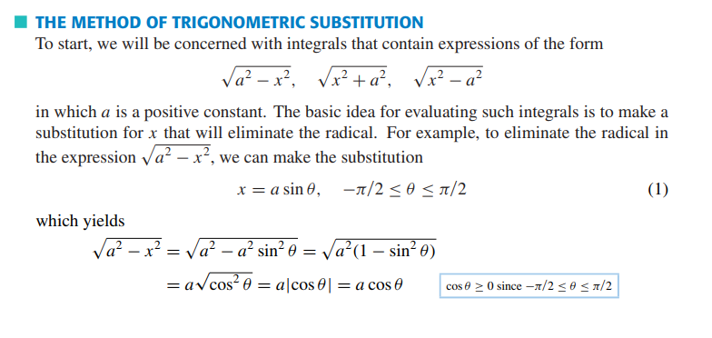
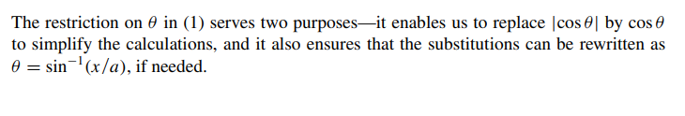
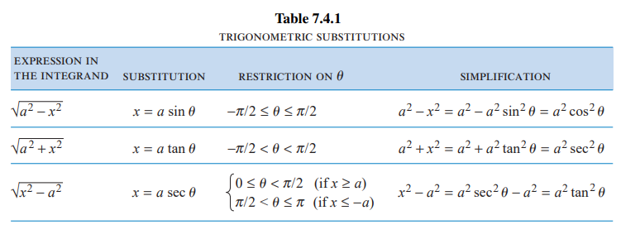
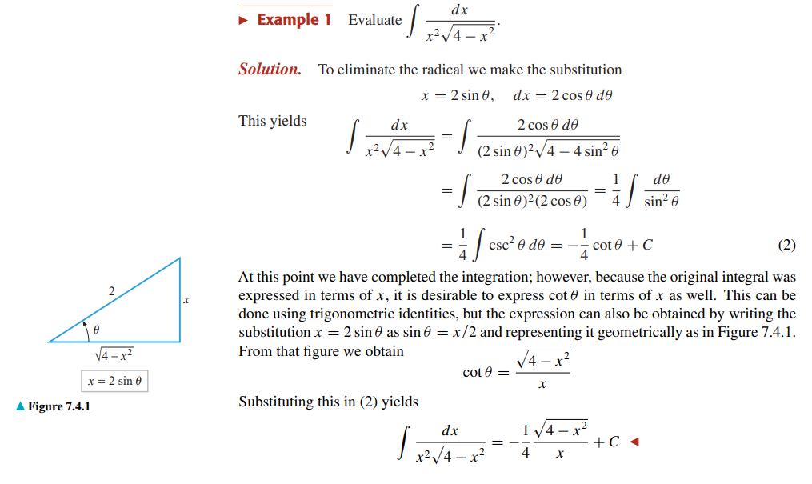
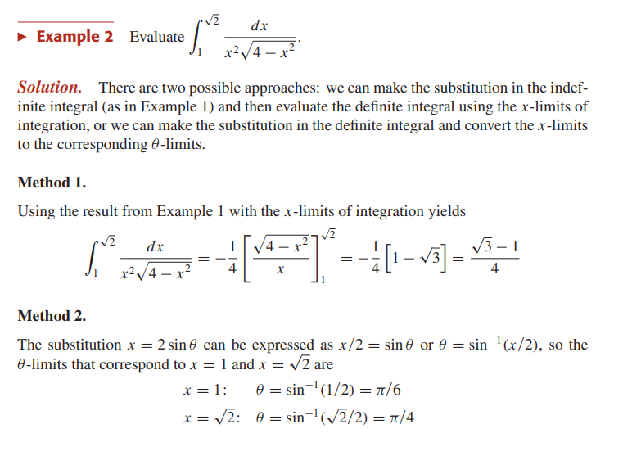

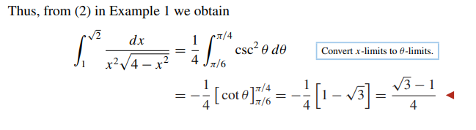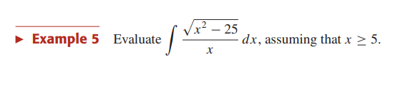
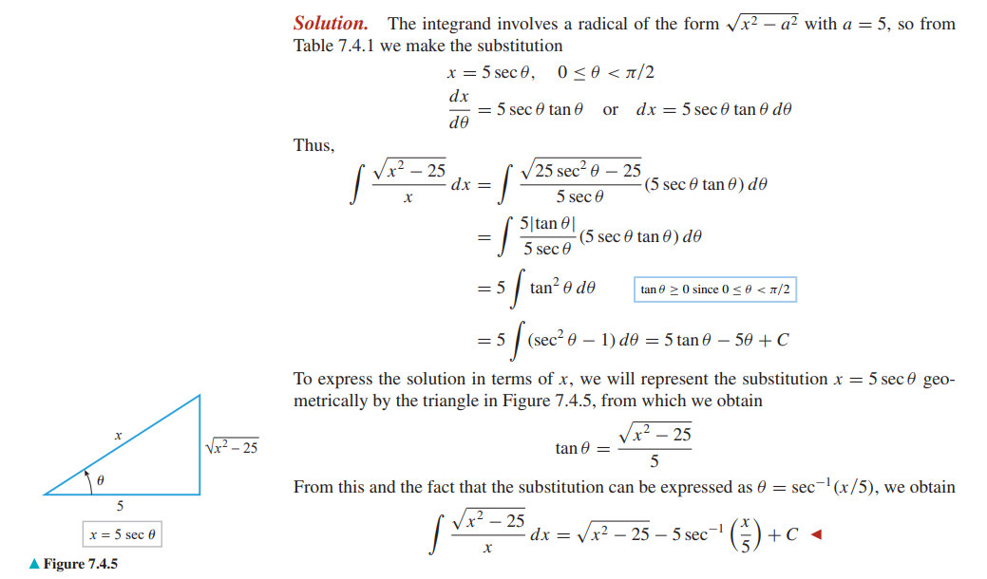

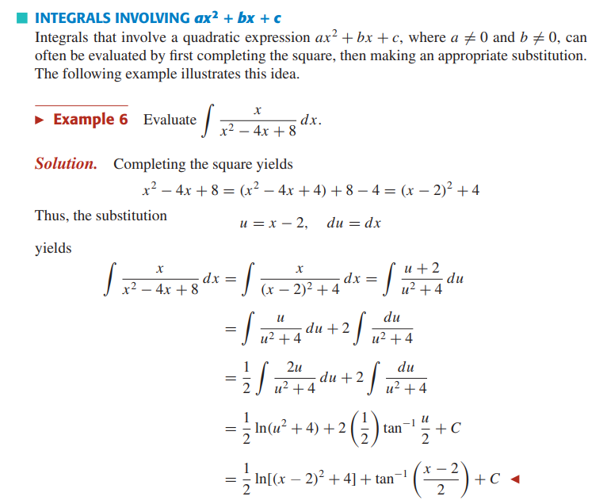
WATCH:
All the TRIGONOMETRY you need for calculus actually explained
Intro to Trigonometric Substitution --- Ex: Deriving Area of Circle Formula
Trig Subs | How To Choose The Substitution & Deal With Indefinite Integrals
Deconstructing a messy integral | Trig subs & u-subs combined
Integrating by Weierstrass Substitution (visual proof)
Use EULER'S SUBSTITUTION not TRIG SUBSTITUTION!
Use the following online solver:
Integral Calculator
Integral Calculator - eMathHelp
Integral Calculator
Definite and Improper Integral Calculator - eMathHelp

PRACTISE: HOWARD ANTON: 7.4: Trigonometric Substitution: 3, 5, 7, 19, 23, 27
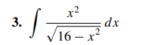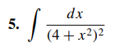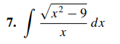
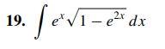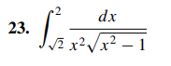
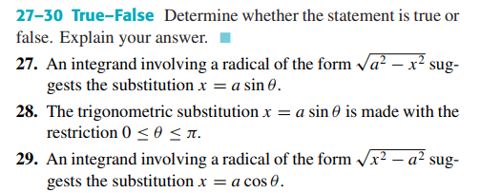

Integration of Rational Function by partial fractions
READ:
Partial Fractions
Polynomials - Long Division
READ:
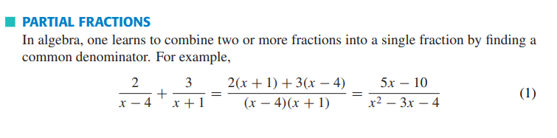
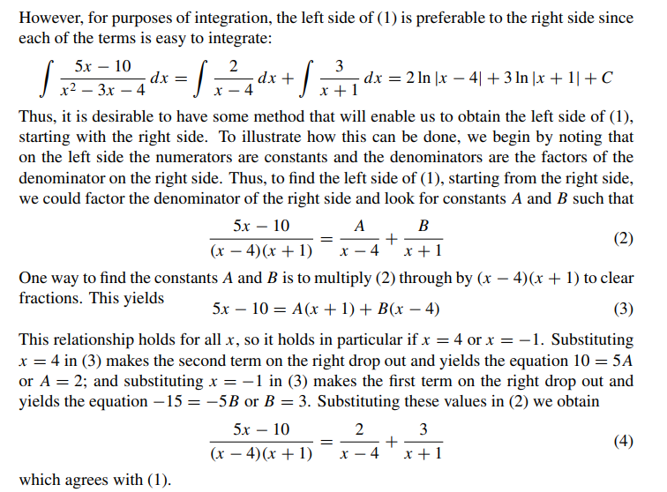
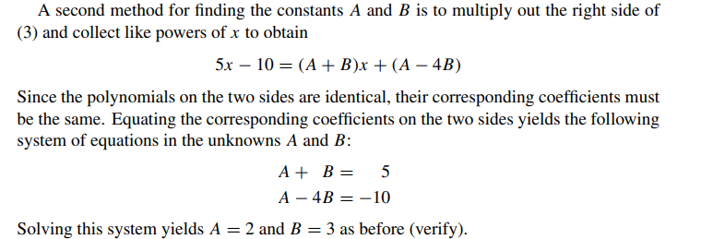
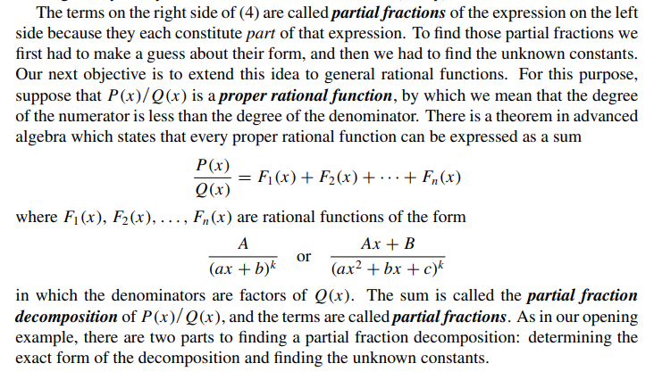
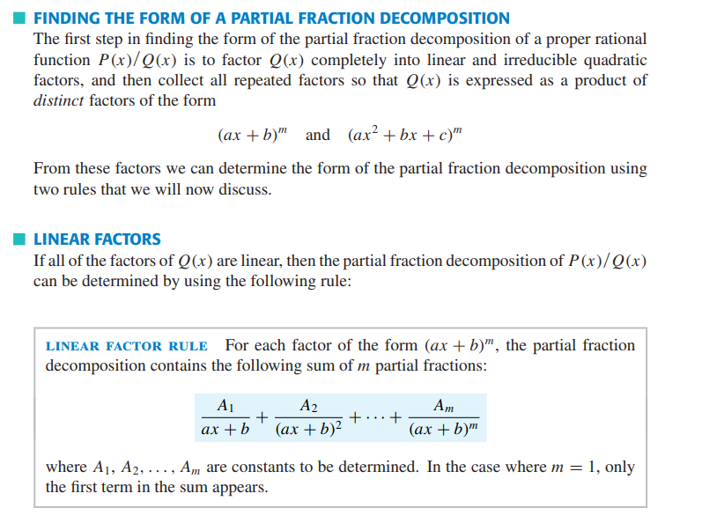
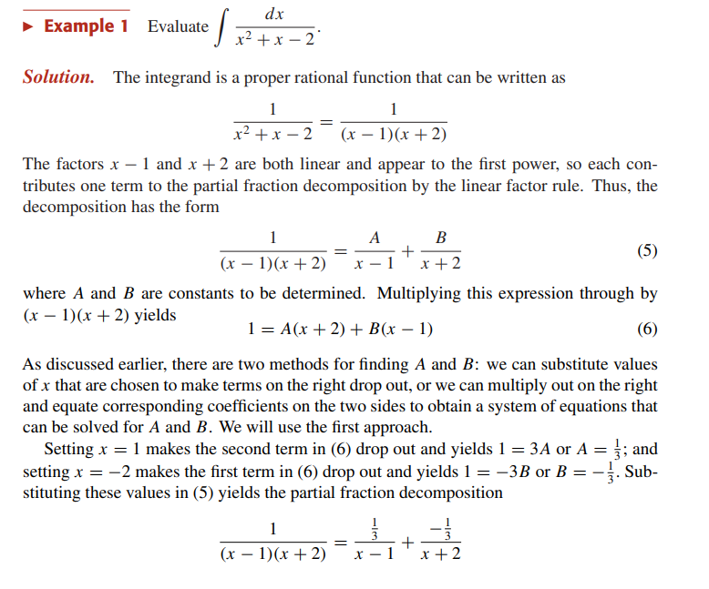
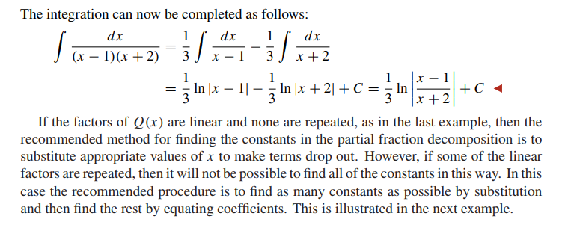
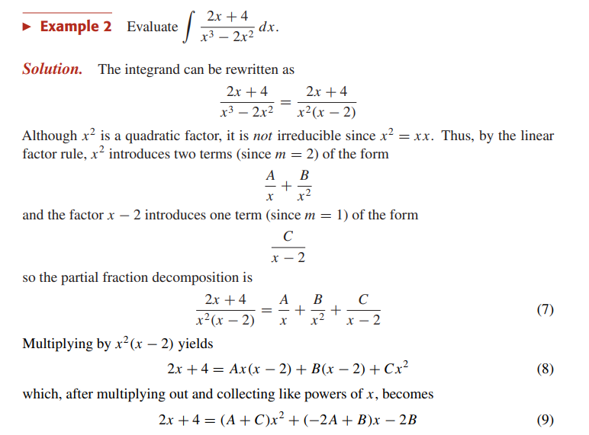
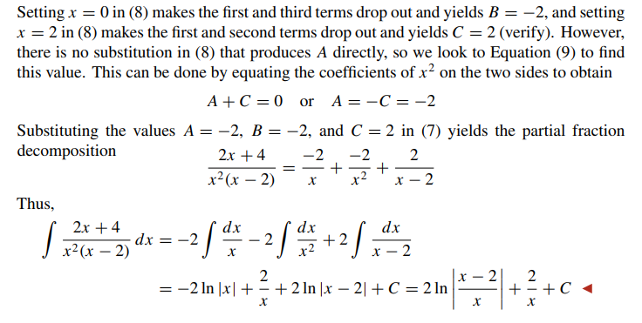
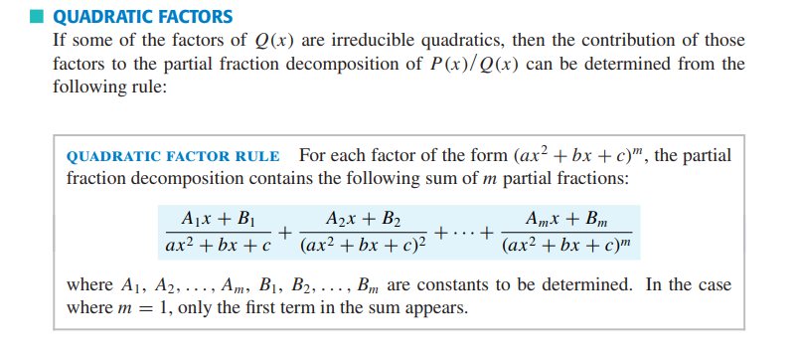
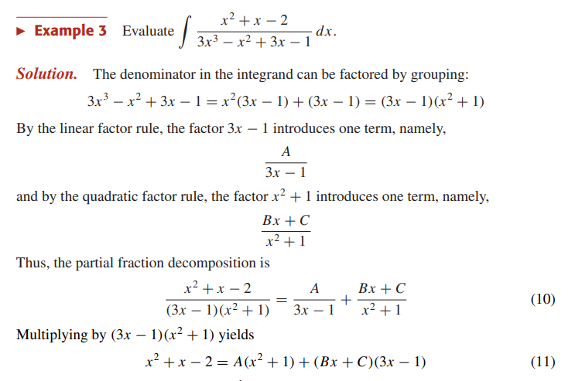
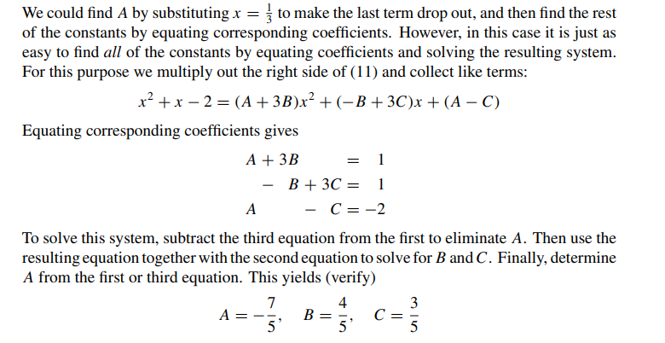
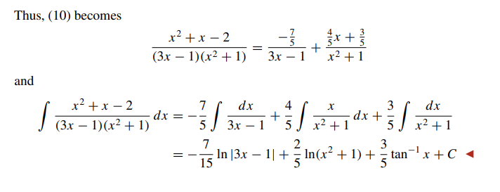
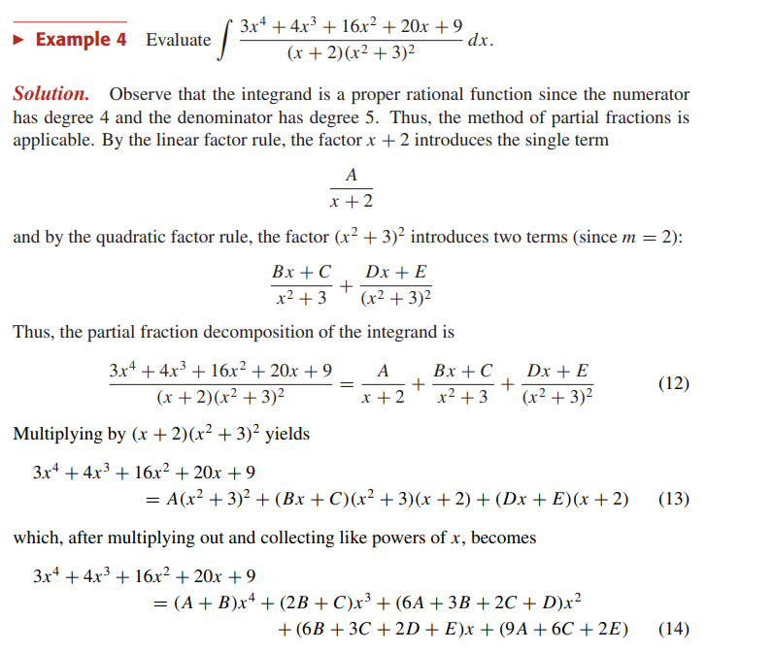
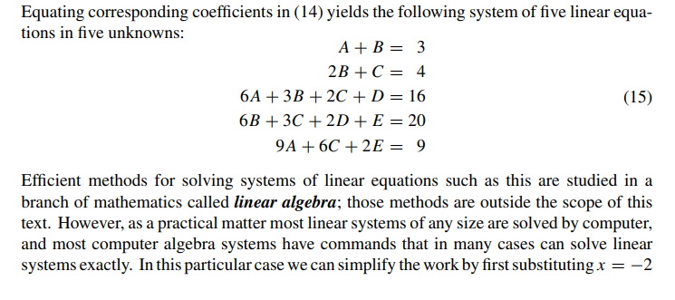
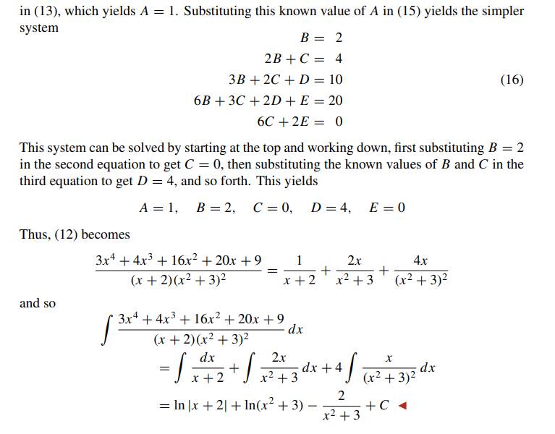
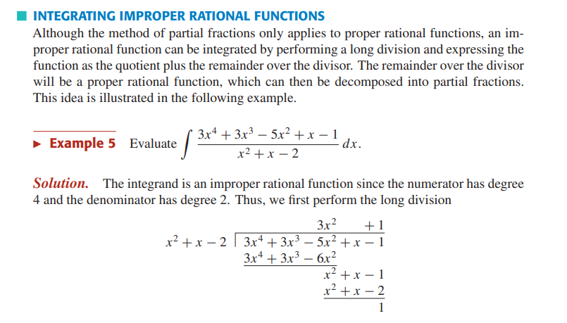
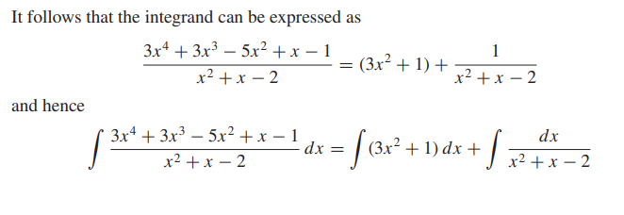
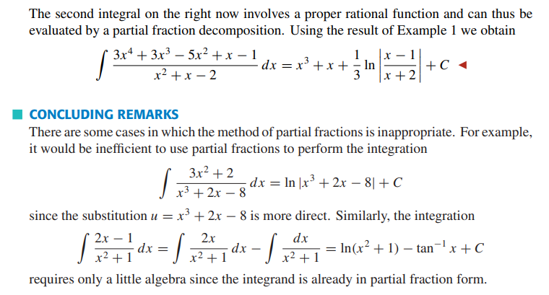

WATCH:
9.10 Integration of rational functions - Example 1
9.11 Integration of rational functions - Example 2
9.12 Integration of rational functions - Example 3
Integration by Partial Fractions | Big Idea + First Example
Partial Fractions | Repeating and irreducible Quadratic Terms
Use the following online solver:
Integral Calculator
Integral Calculator - eMathHelp
Integral Calculator
Definite and Improper Integral Calculator - eMathHelp
Polynomial Long Division Calculator - eMathHelp
Partial Fraction Decomposition Calculator - eMathHelp

PRACTISE: HOWARD ANTON: 7.5: Integrating rational functions by partial fractions: 1-34
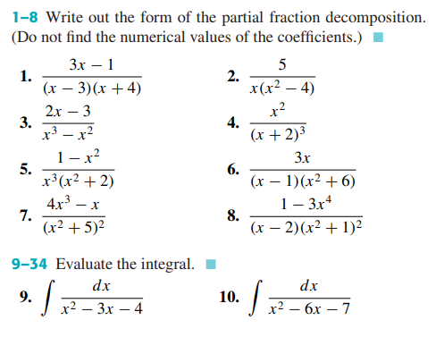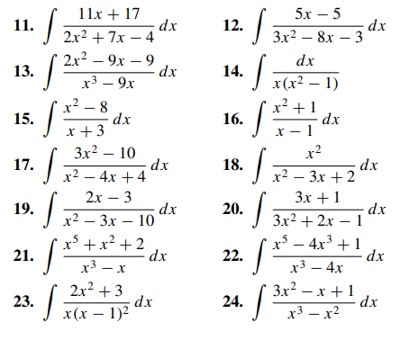
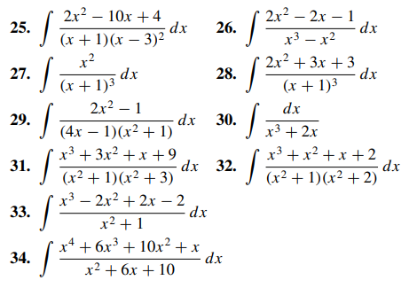

Beta and Gamma Function
READ:
Gamma Function
How to Integrate Using the Gamma Function - wikiHow
Beta Function | Brilliant Math & Science Wiki
How to Integrate Using the Beta Function - wikiHow
WATCH:
Gamma Function | Integral Functions - YouTube
Beta Function | Integral Functions - YouTube
Use the following online solver:

PRACTISE:
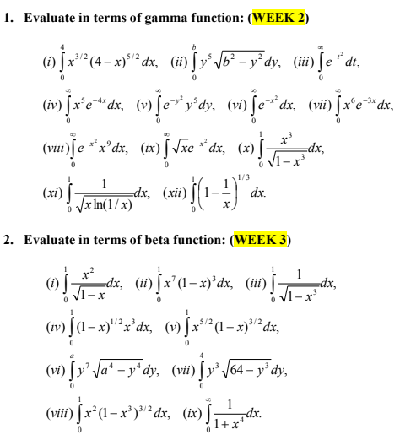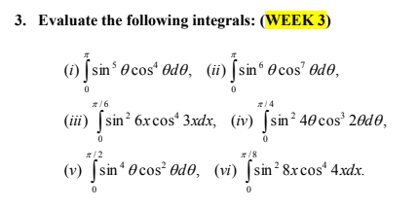
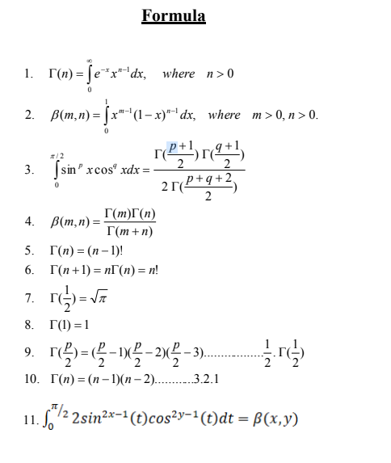
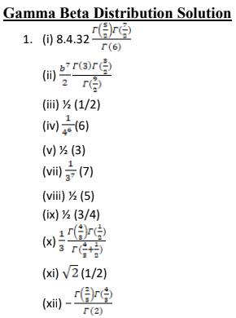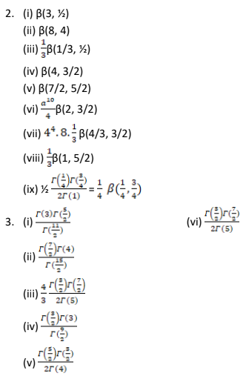

Length of a curve, Surface area of revolution

Length of a curve
READ: Arc Length
READ:
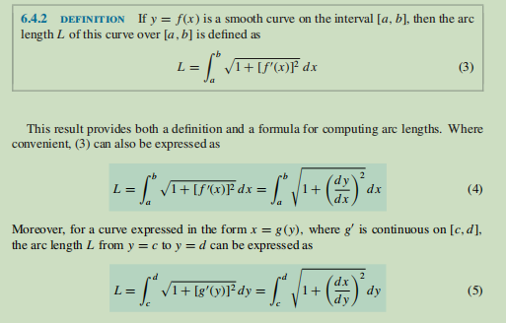

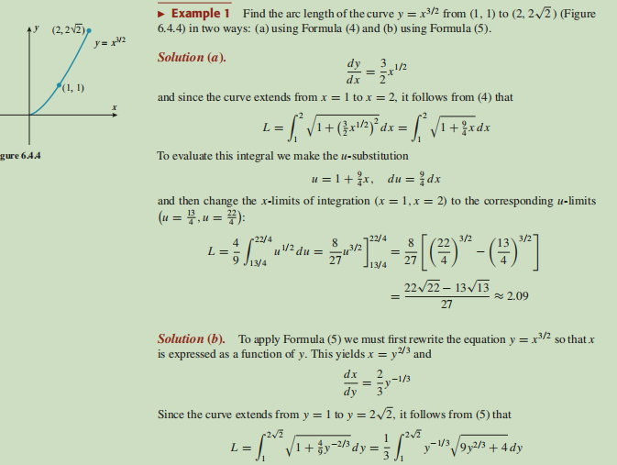

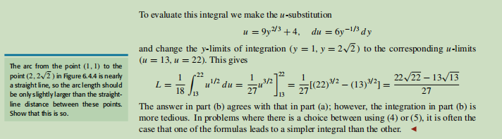
WATCH:
Arclength Formula | Derivation & Ex: Circumference of a Circle

Use the following online solver:
Curve Arc Length Calculator - eMathHelp

PRACTISE: HOWARD ANTON: 6.4: Length of a Plane Curve: 3-8, 27-32
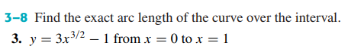
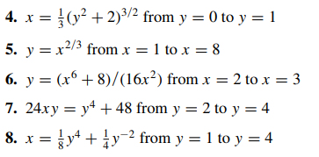

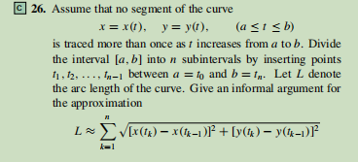
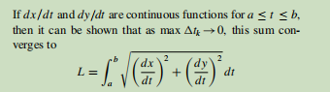

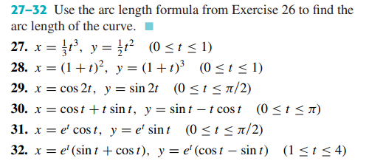

Surface Area of revolution
READ:
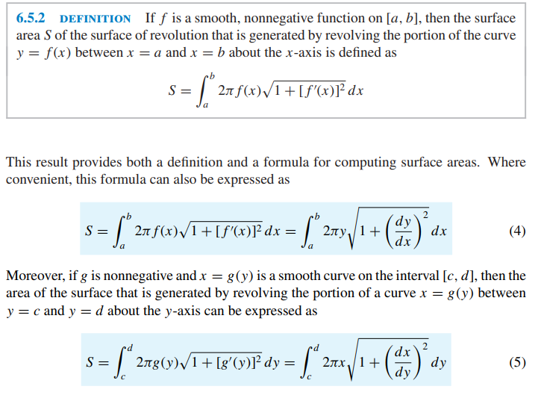
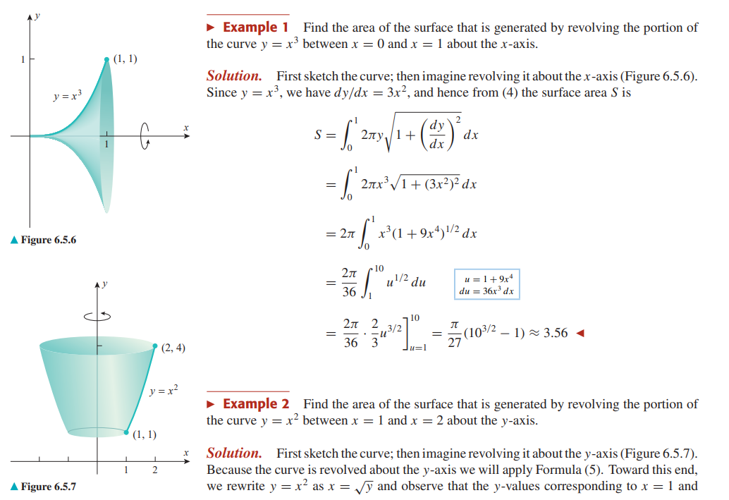
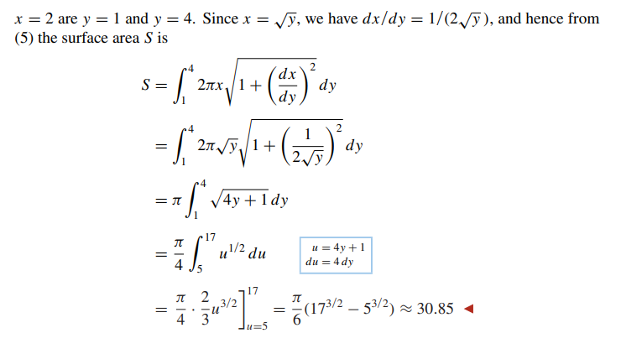

WATCH:
Area of Surfaces of Revolution | Derivation & Example
Use the following online solver:
Area of Surface of Revolution Calculator - eMathHelp
PRACTISE: HOWARD ANTON: 6.5: Area of Surface of Revolution: 1-4, 5-8
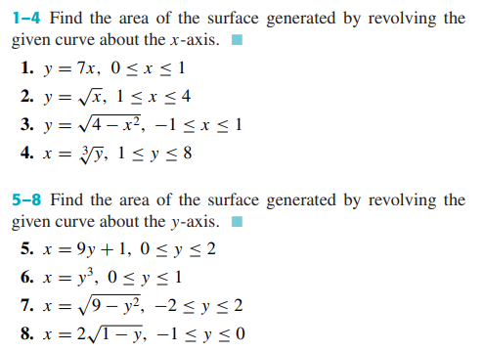

Basic concept of Double integral, Double integral in Cartesian and Polar Coordinate system

Prerequisite

READ:
HOWARD ANTON - 11.8: Cylindrical and Spherical Coordinates
Read only the selected parts from:
https://shorturl.at/sySX8
WATCH:
Pixar: The math behind the movies - Tony DeRose
Coordinate Systems: Animated
READ: Polar and Cartesian Coordinates or WATCH: Intro to Polar Coordinates
Sketching Polar Curves
CalcBLUE 3 : Ch. 13.5 : Cylindrical Coordinates
CalcBLUE 3 : Ch. 14.1 : Intro to Spherical CoordinatesCalcBLUE 3 : Ch. 14.2 : Visualizing Spherical CoordinatesSpherical Coordinate System (With 3D Animation)Twos-Day Tuesday: 22 Slices of Pizza with Six Cuts

Double Integrals
READ: HOWARD ANTON: 14.1: Double Integrals
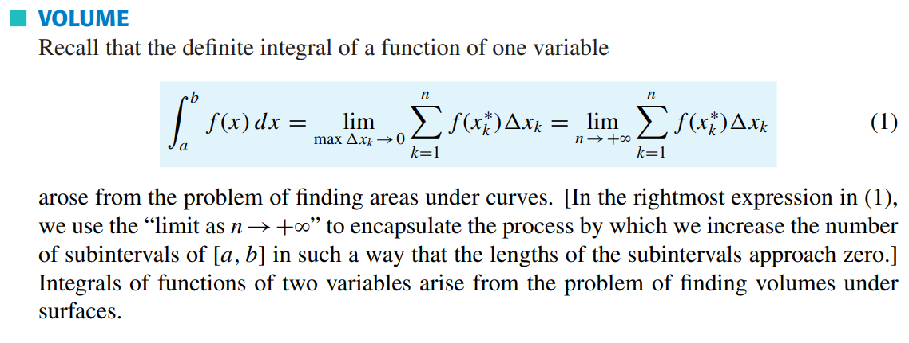
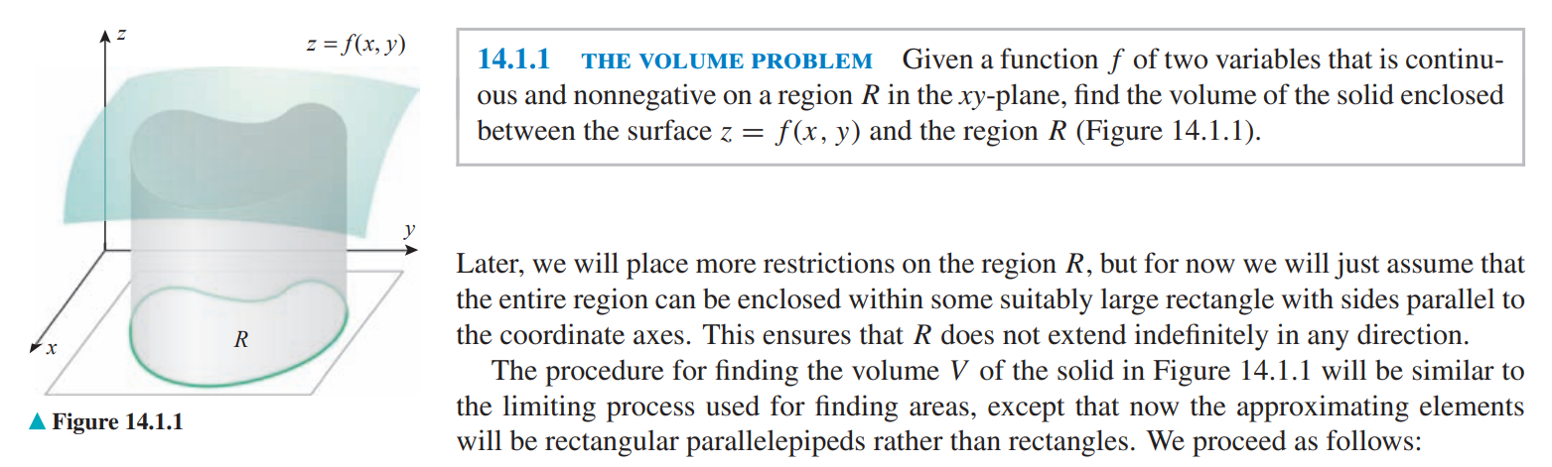

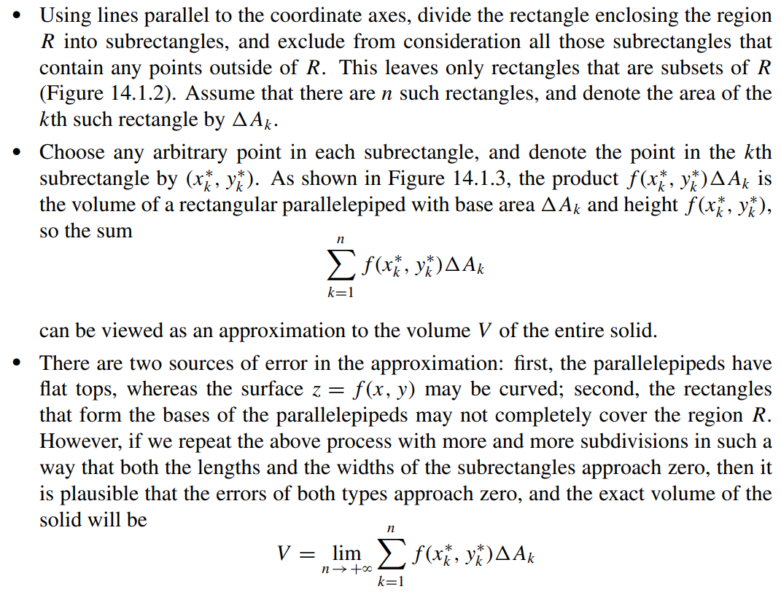
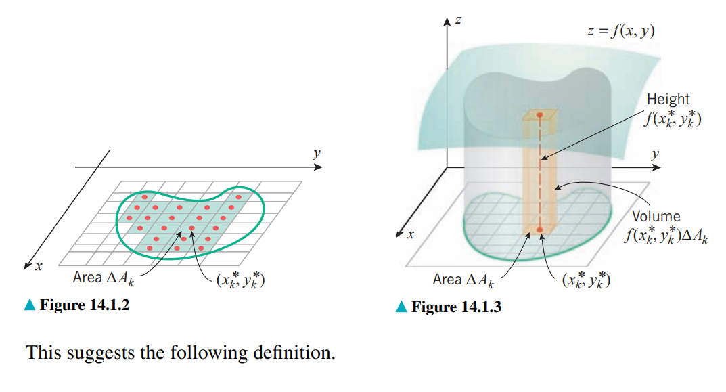
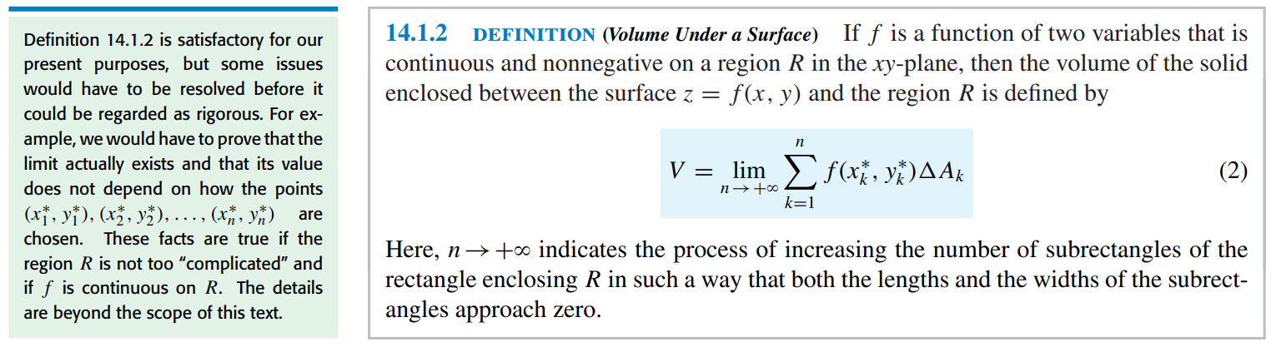
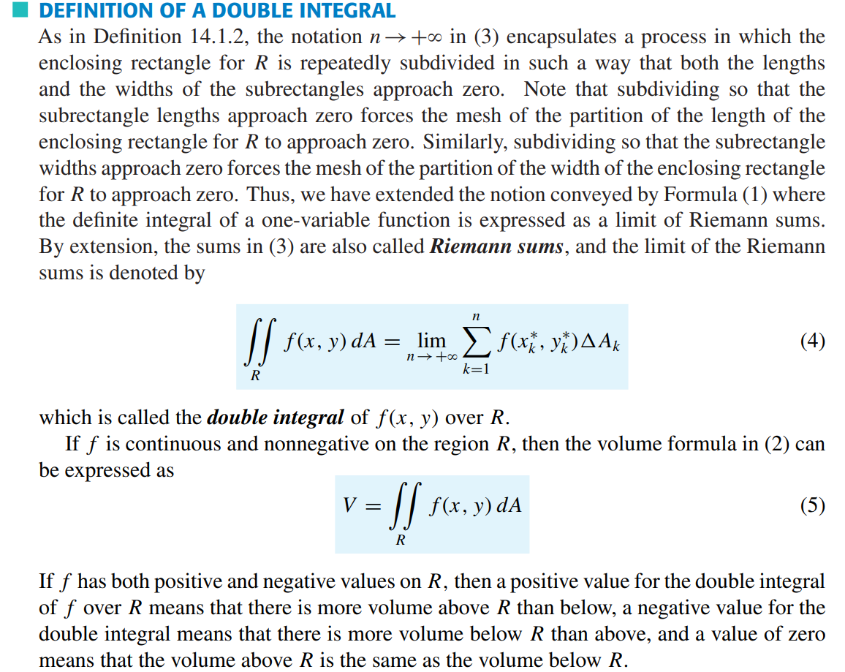
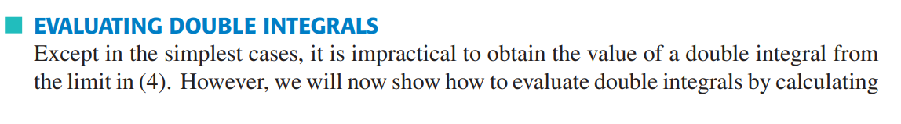
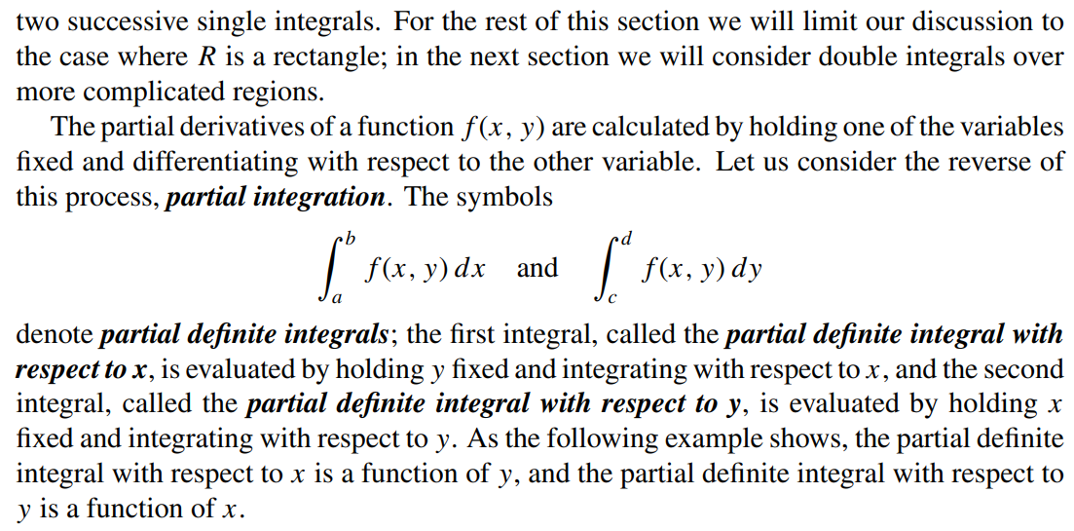
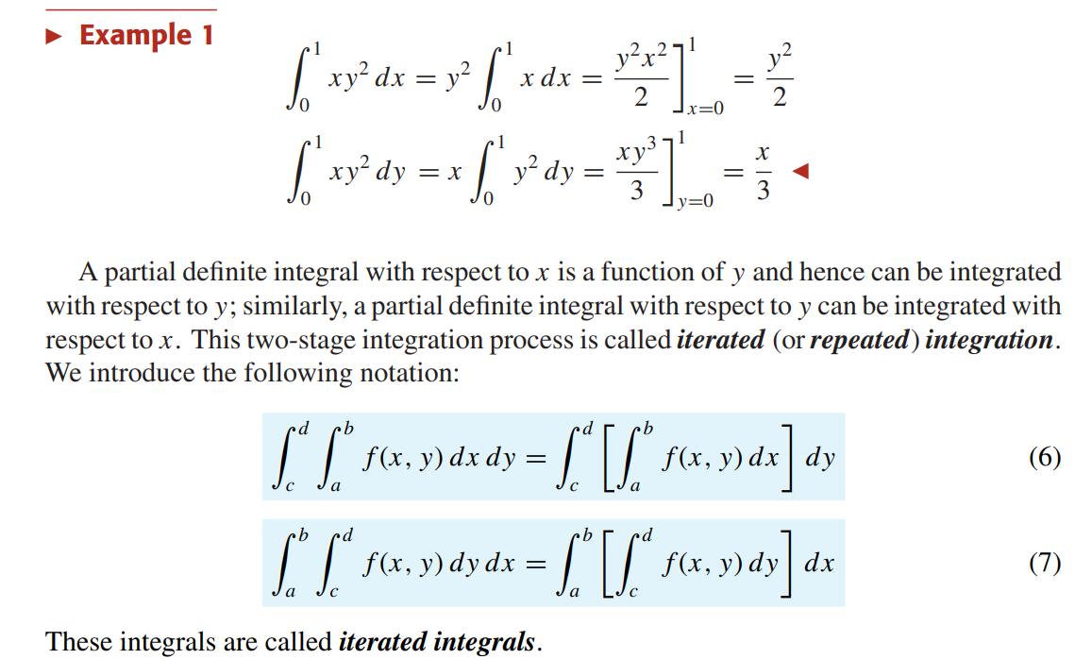
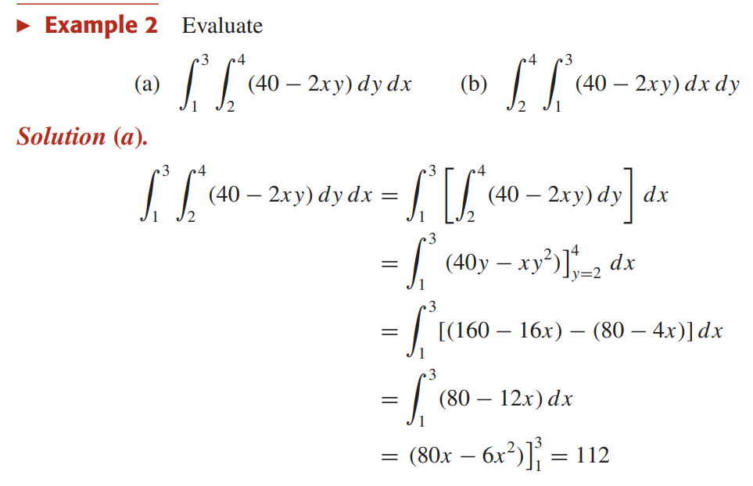
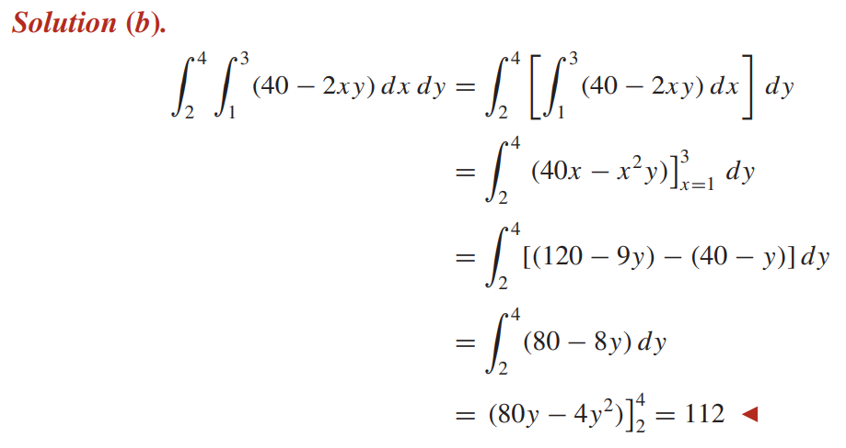
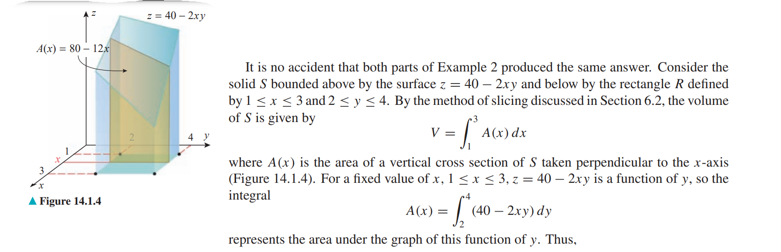
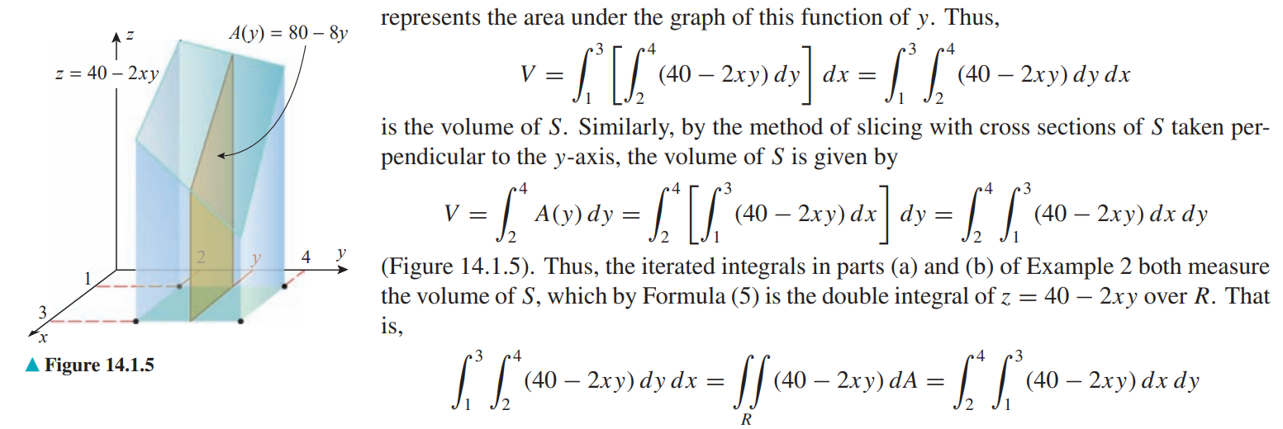
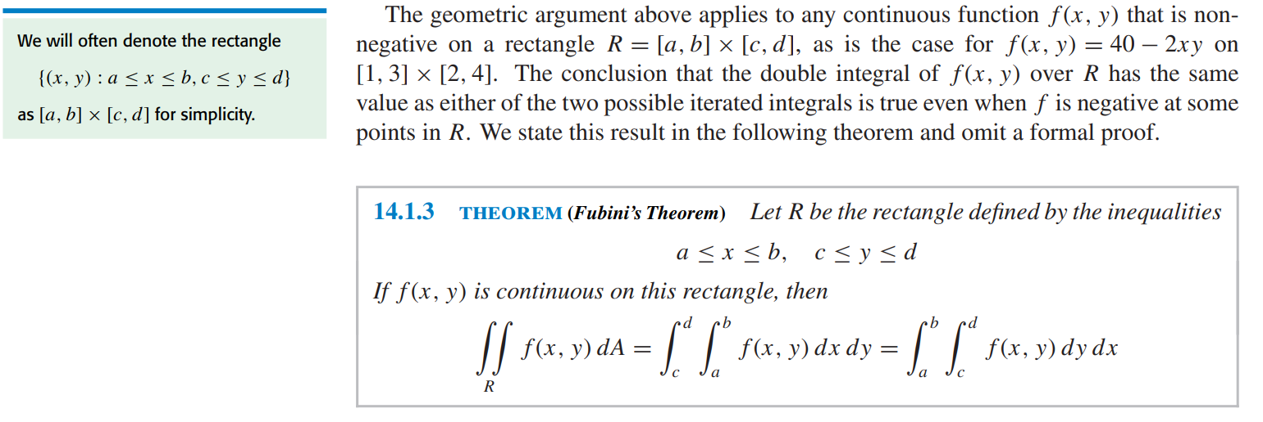
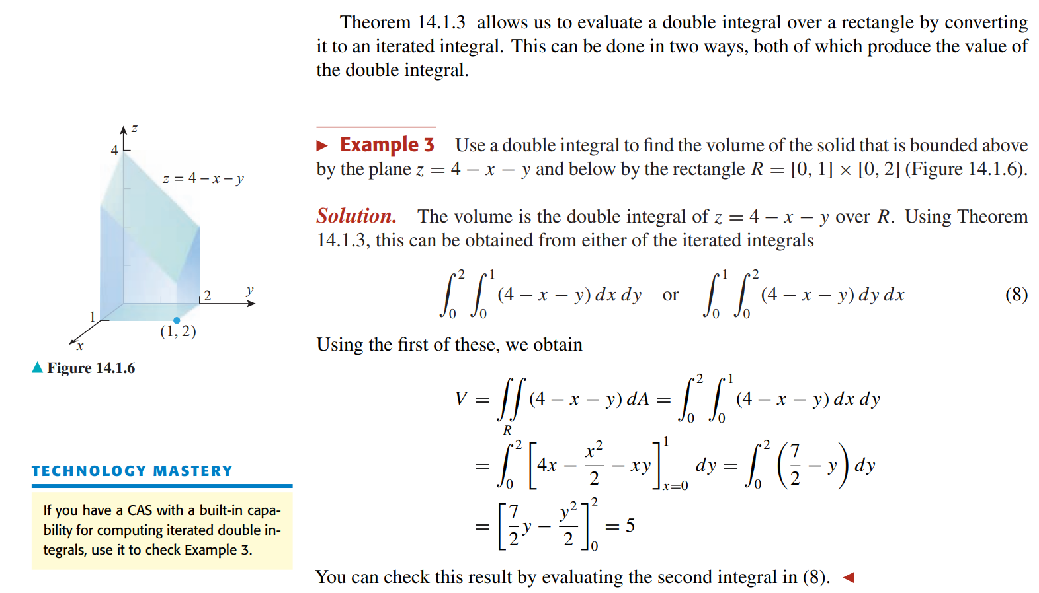
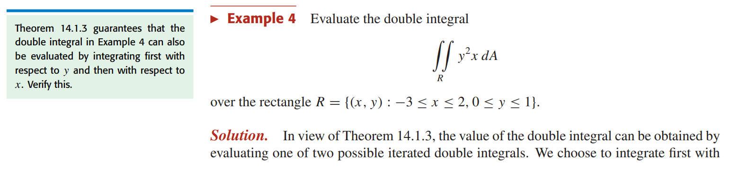
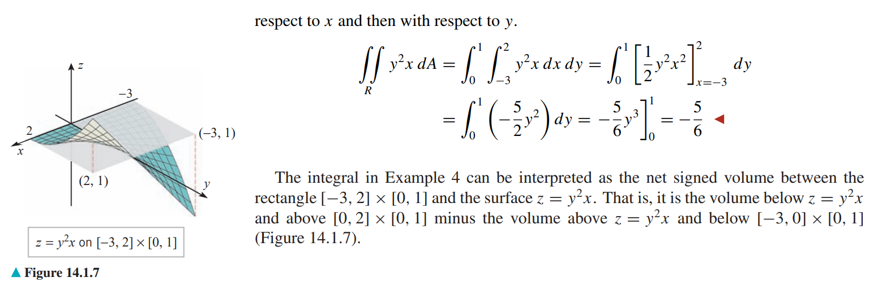
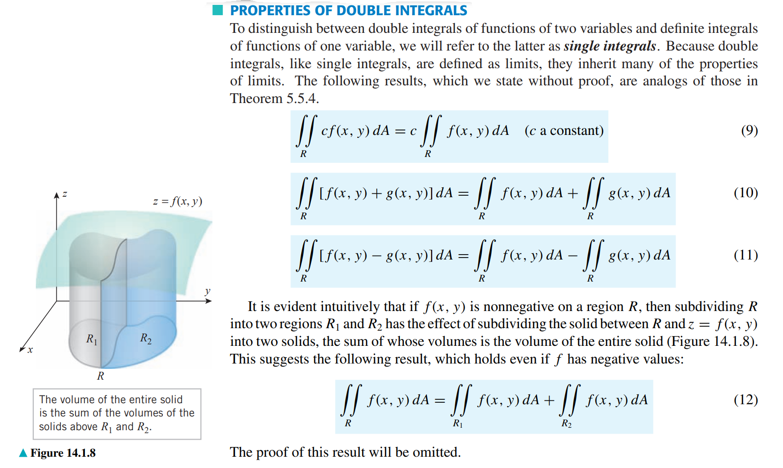

WATCH:
CalcBLUE 3 : Ch. 1.1 : Integrals, Definite & IndefiniteCalcBLUE 3 : Ch. 1.2 : Recalling Riemann Sums
CalcBLUE 3 : Ch. 1.3 : The Definite Integral
CalcBLUE 3 : Ch. 1.4 : Multiple Integrals - What & Why?
CalcBLUE 3 : Ch. 1.5 : Integrating Constants
CalcBLUE 3 : Ch. 1.6 : BONUS! Integration Theory
CalcBLUE 3 : Ch. 2.1 : What Do We Do Now?
CalcBLUE 3 : Ch. 2.2 : The Fubini Theorem
CalcBLUE 3 : Ch. 2.3 : Iterated Integrals
CalcBLUE 3 : Ch. 2.4 : Fubini & Areas
CalcBLUE 3 : Ch. 3.1 : Limits & Double Integrals
CalcBLUE 3 : Ch. 3.2 : Examples - Simple Double Integrals
CalcBLUE 3 : Ch. 3.3 : Example - Order of Integration
CalcBLUE 3 : Ch. 3.4 : Example - Additivity of Integrals
CalcBLUE 3 : Ch. 3.5 : Example - Improper, Unbounded Integrals
Double integrals and Polar integrals: Explained with 3D visualizations
How to Set Up Double Integrals
Defining Double Integration with Riemann Sums | Volume under a Surface
What are double integrals? What are they for? | #SoME1 #3b1b

Use the following online solver:
Double Integral Calculator
Double Integral Calculator
Multiple (Double, Triple) Integral Calculator - eMathHelp

PRACTISE: HOWARD ANTON: 14.1: Double Integrals: 1-16
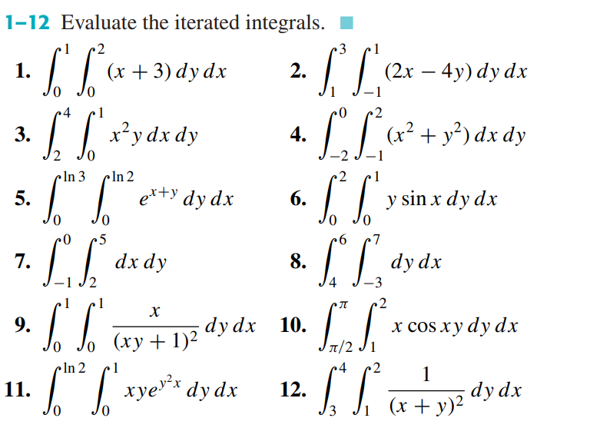
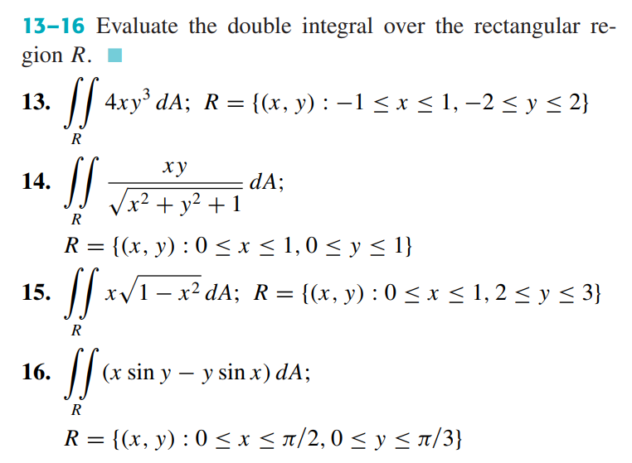

Double Integrals over non rectangular regions

READ:
READ: HOWARD ANTON: 14.2: Double Integrals over non rectangular regions
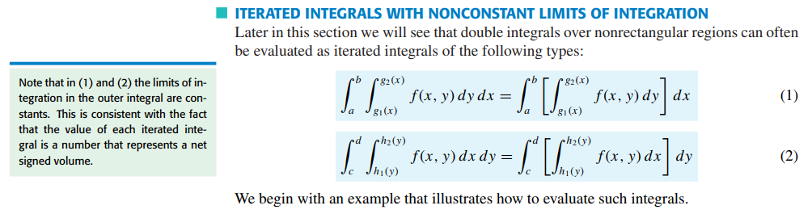
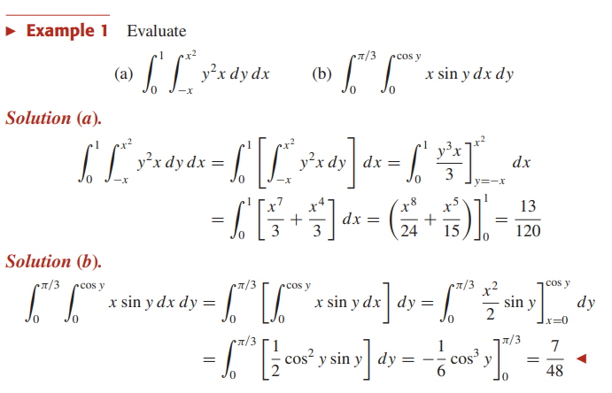
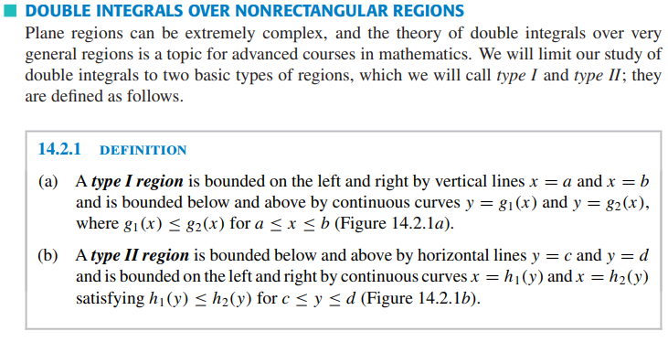
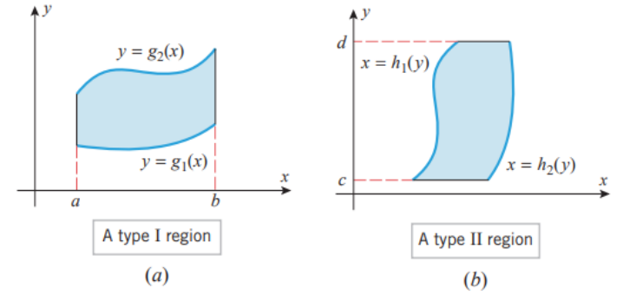
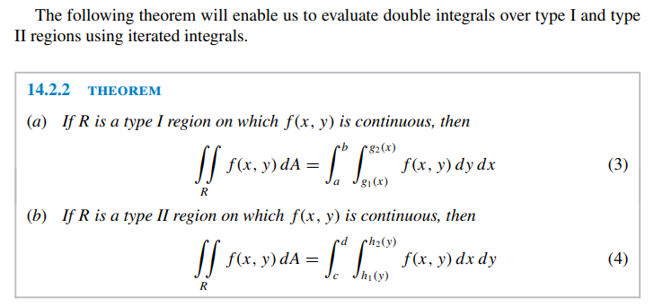
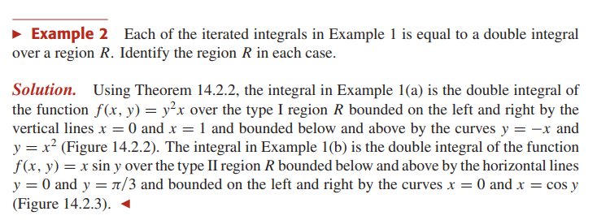
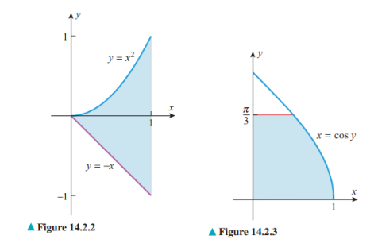
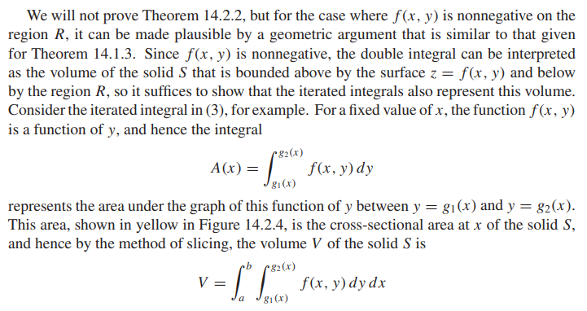
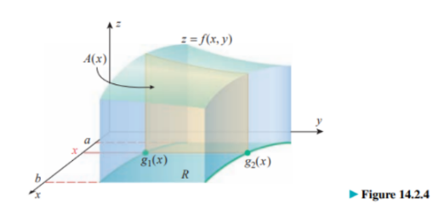
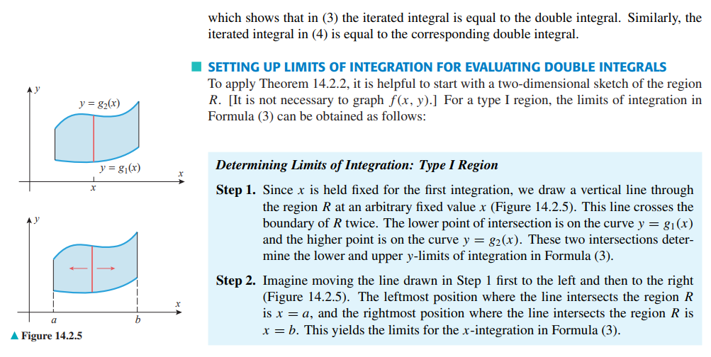
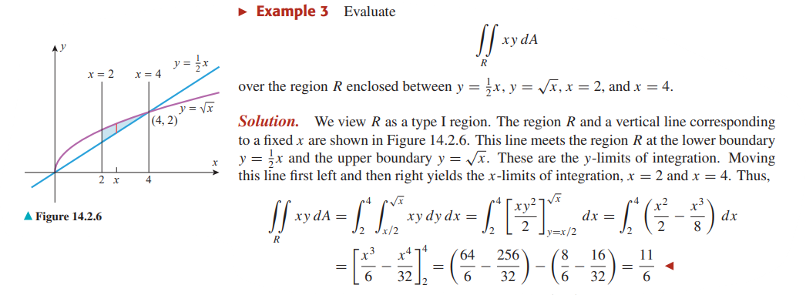
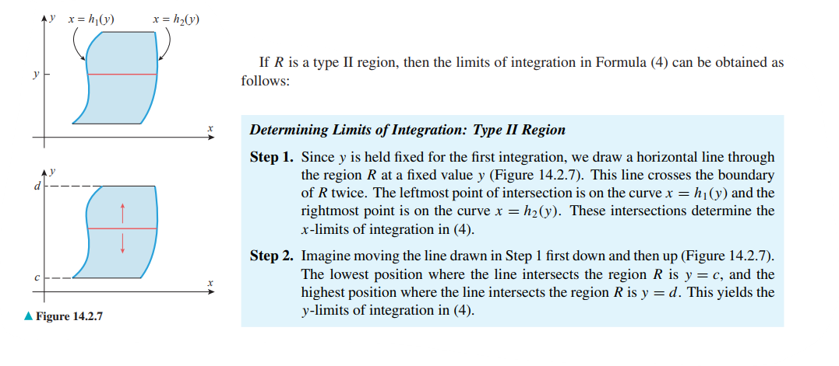
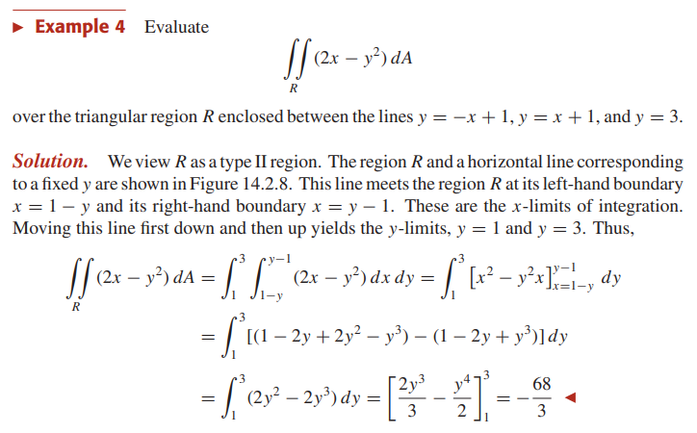
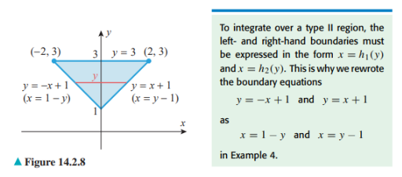
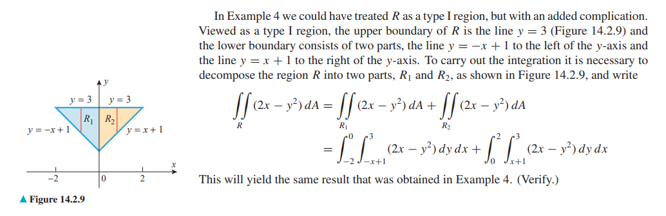

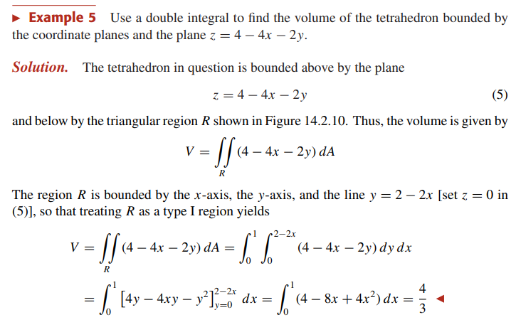
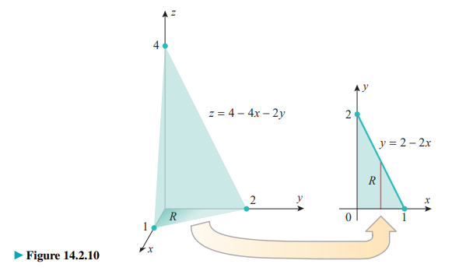
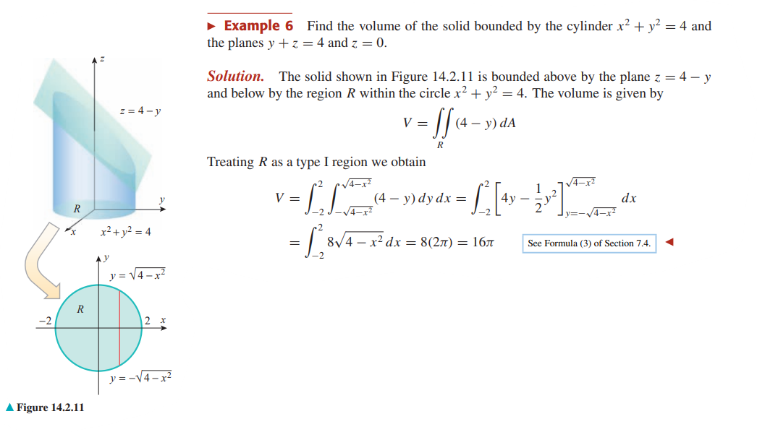
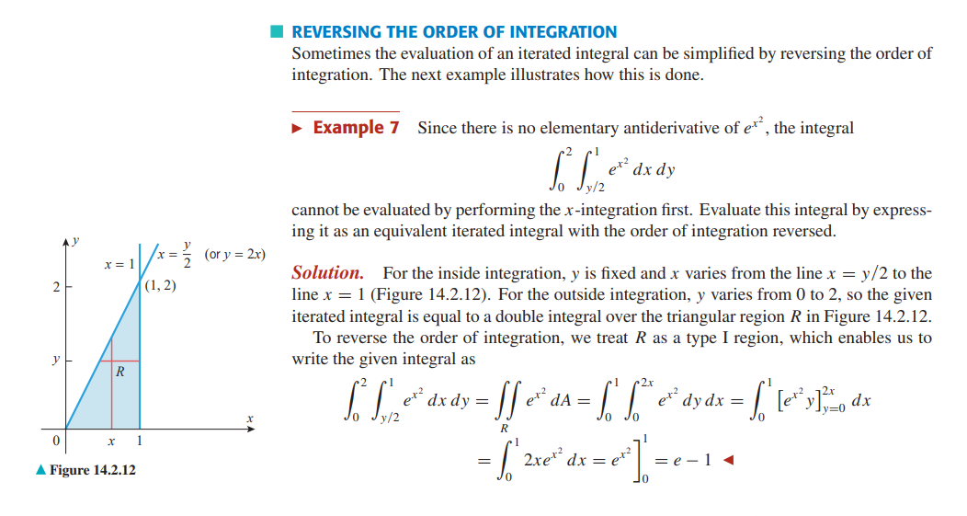
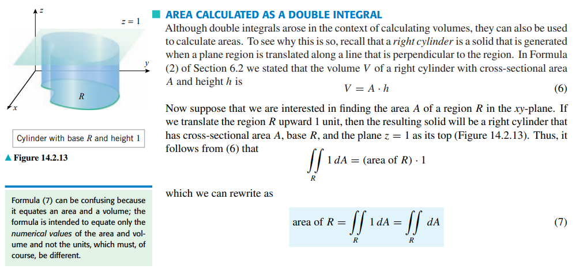
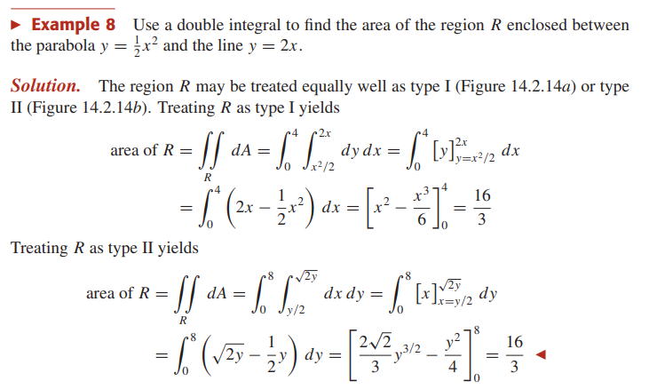
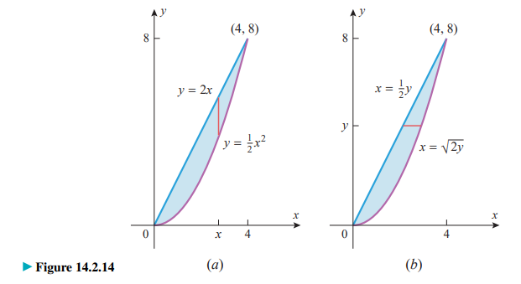

WATCH:
How to Set Up Double Integrals
Double Integration Example over General Regions --- two ways!Change the order of integration to solve tricky integrals
What are double integrals? What are they for? | #SoME1 #3b1b
Use the following online solver:
Double Integral Calculator
Double Integral Calculator
Multiple (Double, Triple) Integral Calculator - eMathHelp

PRACTISE: HOWARD ANTON: 14.2: Double Integrals over non rectangular regions:
1-26
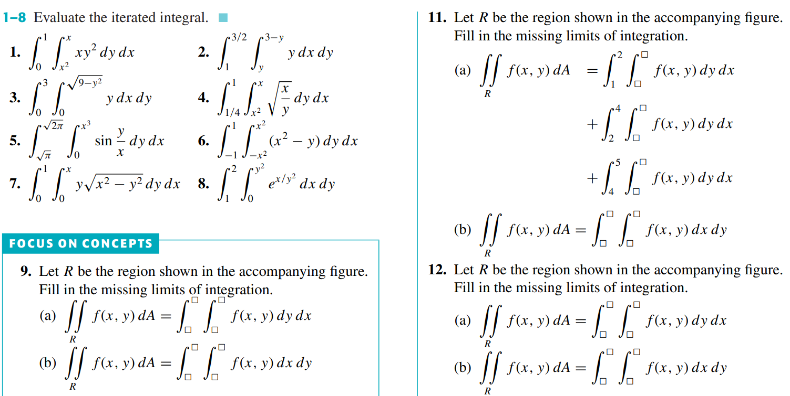
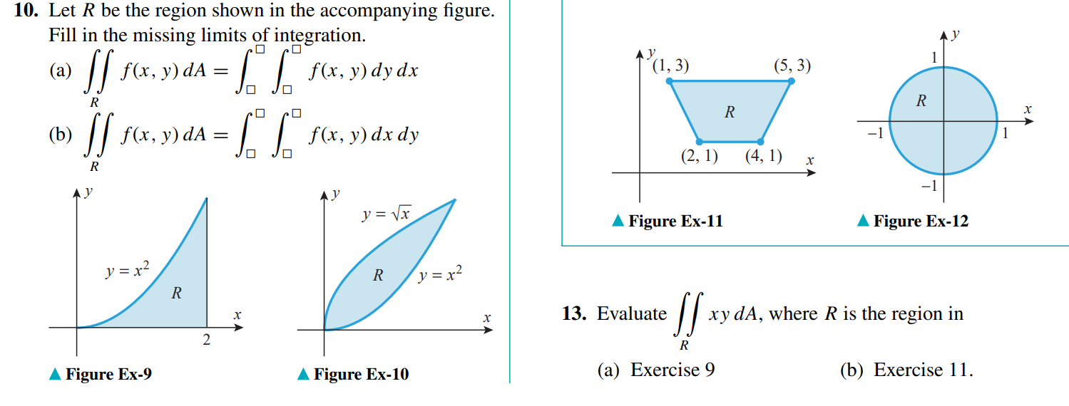
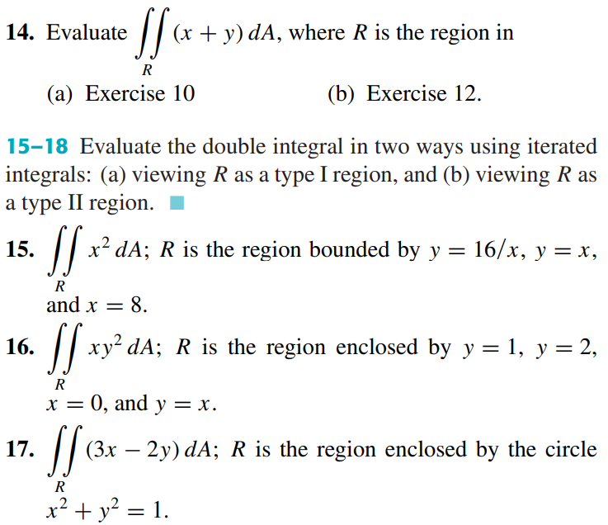
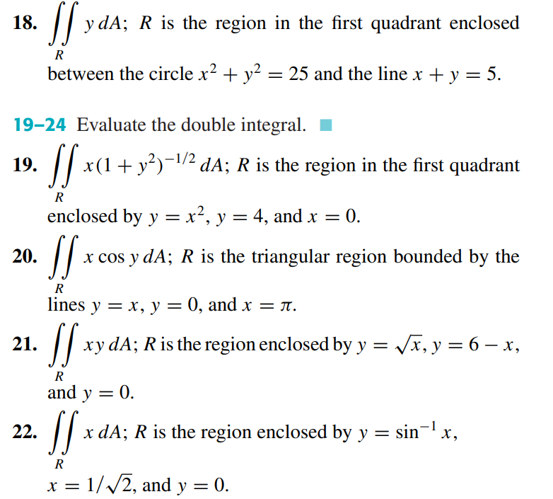
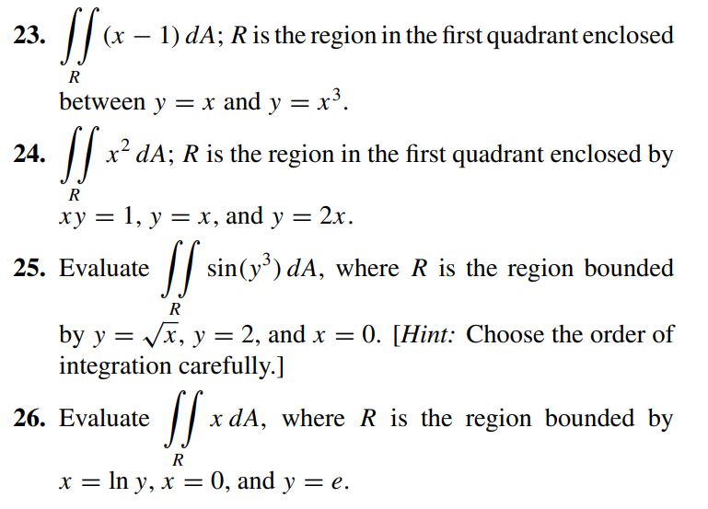

Double Integrals in polar Coordinates

READ:
READ: HOWARD ANTON: 14.3: Double Integrals in polar Coordinates

WATCH:
READ: Polar and Cartesian Coordinates or WATCH: Intro to Polar Coordinates
Sketching Polar Curves
Double integrals and Polar integrals: Explained with 3D visualizations
Double Integration in Polar Coordinates | Example & Derivation
The Gaussian Integral // Solved Using Polar Coordinates
Use the following online solver:
Polar/Rectangular Coordinates Calculator - eMathHelp
Polar/Rectangular Equation Calculator - eMathHelp
Polar equation plotter – GeoGebra

PRACTISE: HOWARD ANTON: 14.3: Double Integrals in polar Coordinates: 1-12, 23-34
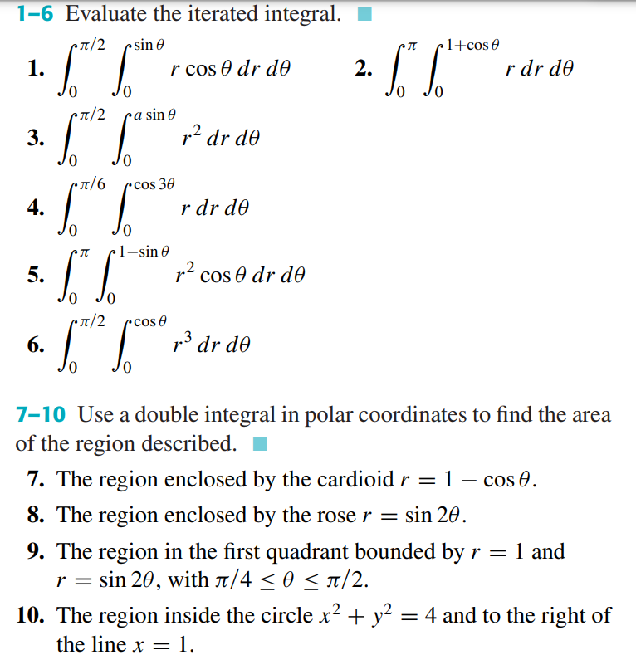
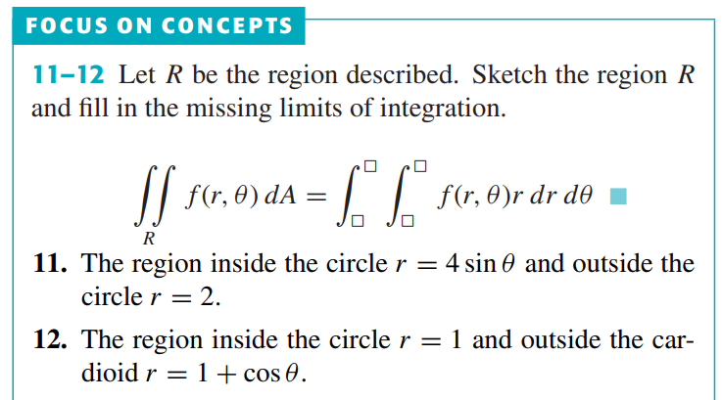
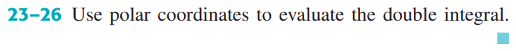
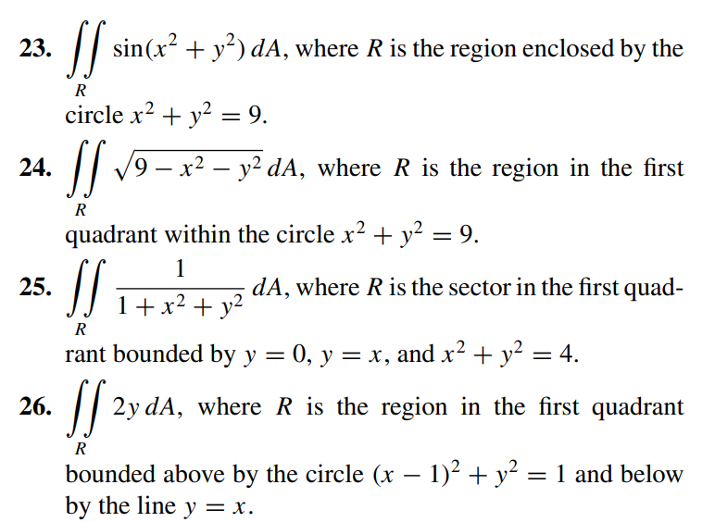
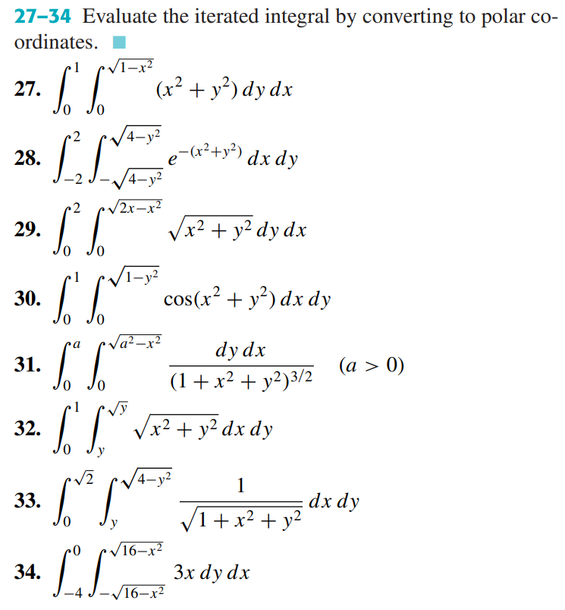

Surface Area; Parametric Surfaces

READ:
READ: HOWARD ANTON: 14.4: Surface Area; Parametric Surfaces
WATCH:

PRACTISE: HOWARD ANTON: 14.4: Surface Area; Parametric Surfaces: 1-9
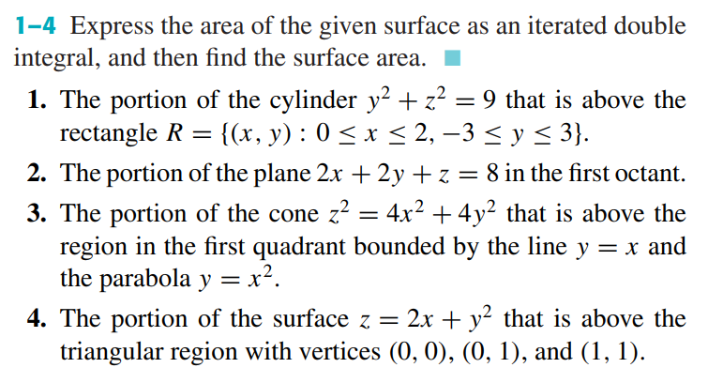
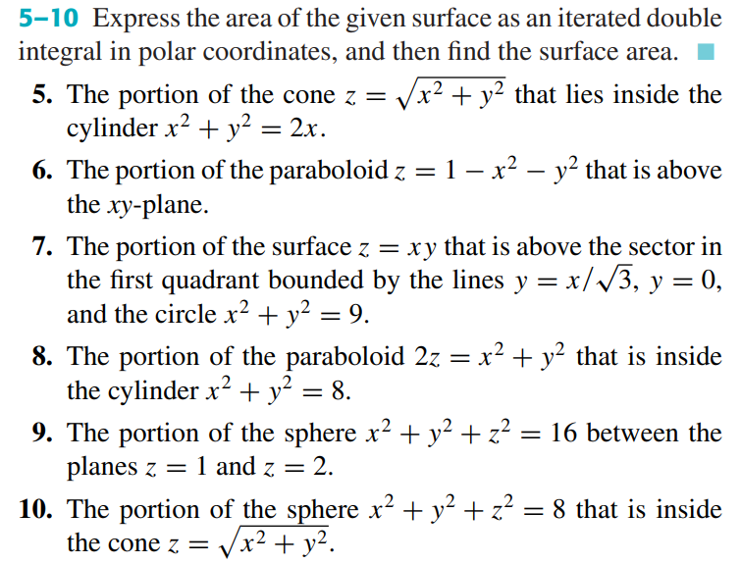

Concept of Triple Integral, Triple integral in Cartesian, Cylindrical and Spherical Coordinate system.

Triple Integrals
READ:
READ: HOWARD ANTON: 14.5: Triple Integrals
WATCH:
Calculus - How to find the bounds of a triple integral
Triple Integrals in Cartesian Coordinates | Volume between Surfaces

PRACTISE: HOWARD ANTON: 14.5: Triple Integrals: 1-12, 15-18
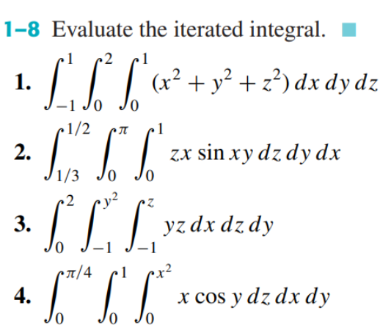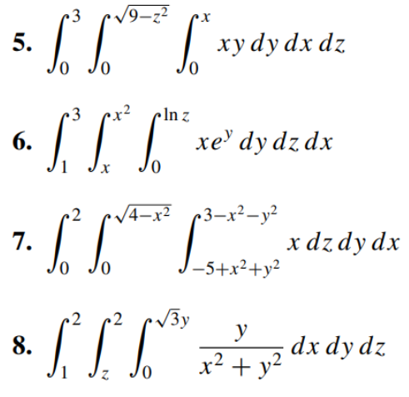
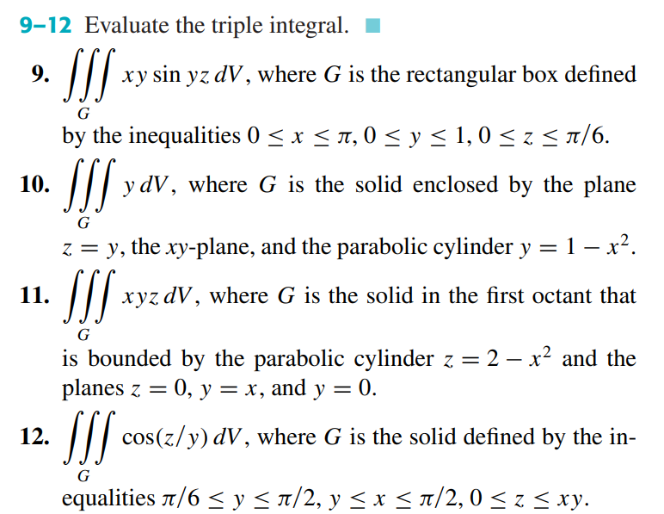
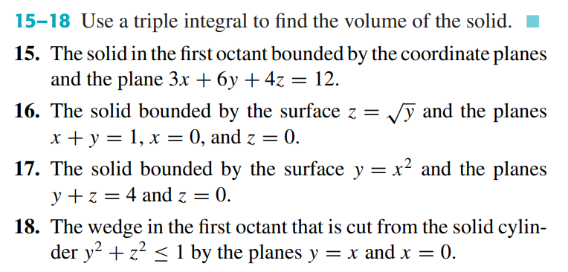

Triple Integrals in Cylindrical and Spherical Coordinates

READ:
READ: HOWARD ANTON: 14.6: Triple Integrals in Cylindrical and Spherical Coordinates
WATCH:

Integration in Spherical Coordinates

PRACTISE: HOWARD ANTON: 14.6: Triple Integrals in Cylindrical and Spherical Coordinates:
9-12, 13-16, 17-20
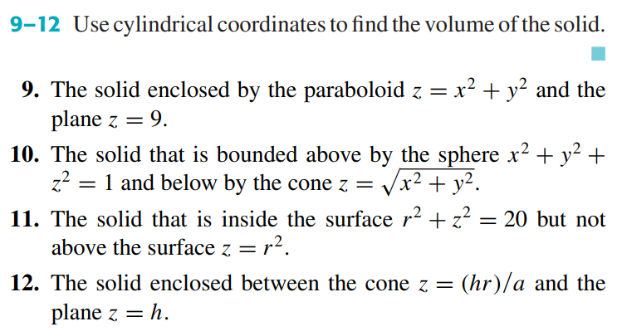
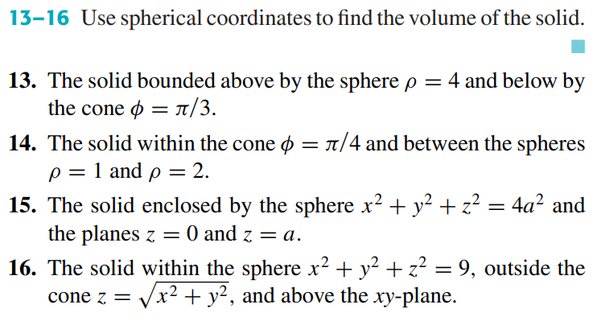
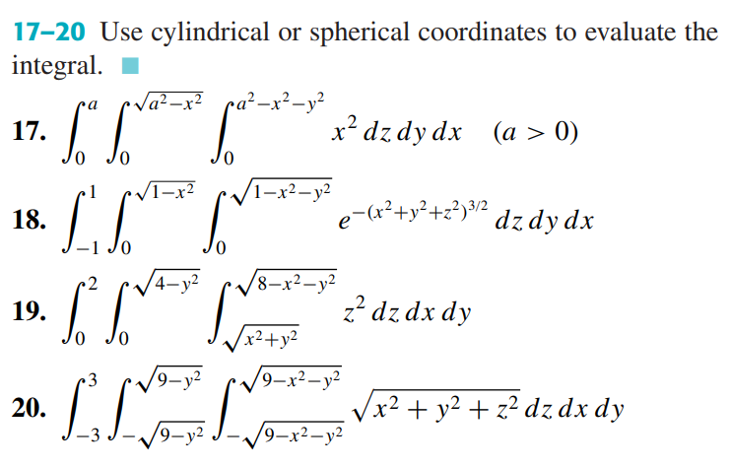

Change of Variables in Multiple Integrals, Jacobians

READ:
READ: HOWARD ANTON: 14.7: Change of Variables in Multiple Integrals, Jacobians
WATCH:
Change of Variables and the Jacobian
Use the following online solver:
Jacobian Calculator - eMathHelp

PRACTISE: HOWARD ANTON: 14.7: Change of Variables in Multiple Integrals, Jacobians:
1-12, 21-24, 35-37
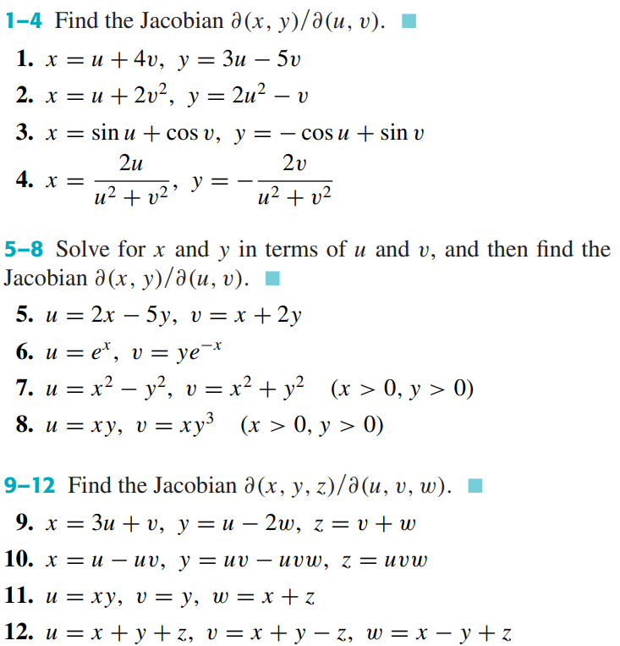
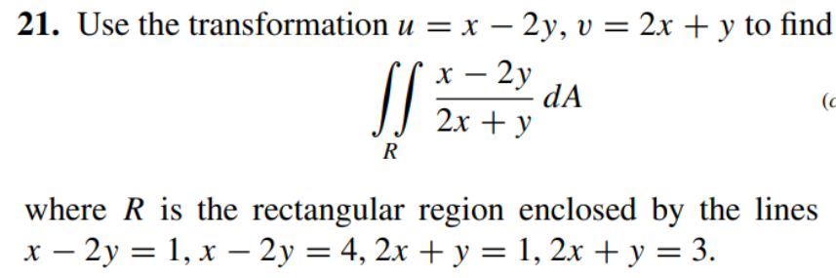
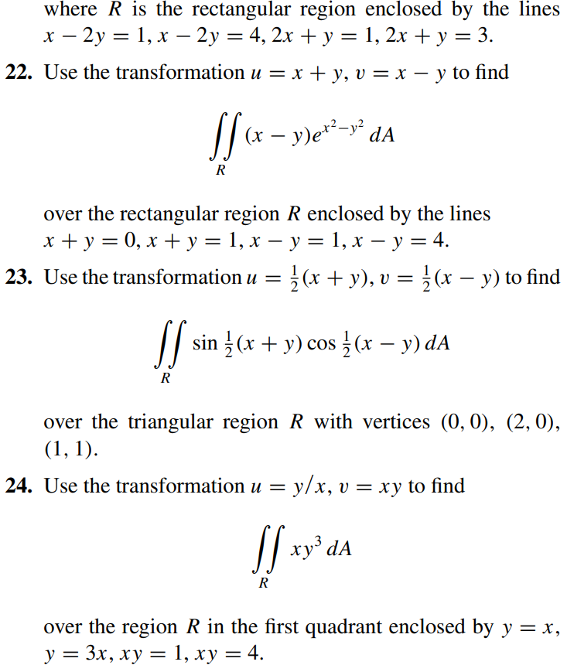
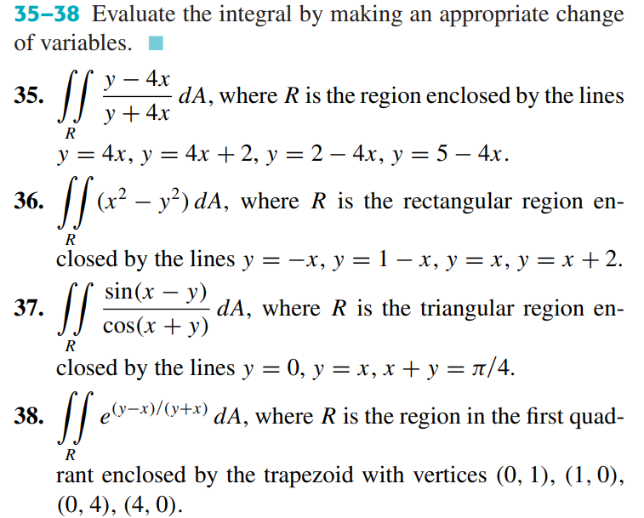

Introduction to Differential Equation, Separable Variables, Linear Equations, Integrating Factor

Introduction to Differential Equation

READ:
Introduction to Differential Equations
Differential Equations Solution Guide
READ:
WATCH:
Differential equations, a tourist's guide | DE1
This is why you're learning differential equationsHow Pixar Uses Differential Equations (BASIS Oro Valley Diff-eq Final)
CalcGREEN 2 : Ch. 1.4 : Differential EquationsWhat is a DIFFERENTIAL EQUATION?? **Intro to my full ODE course**The Key Definitions of Differential Equations: ODE, order, solution, initial condition, IVP
The Geometric Meaning of Differential Equations // Slope Fields, Integral Curves & Isoclines

Separable Variables
READ:
Separation of Variables
See more: Homogeneous Differential Equations (Homogeneous Functions)
READ: DENNIS G. ZILL: 2.2: Separable Variables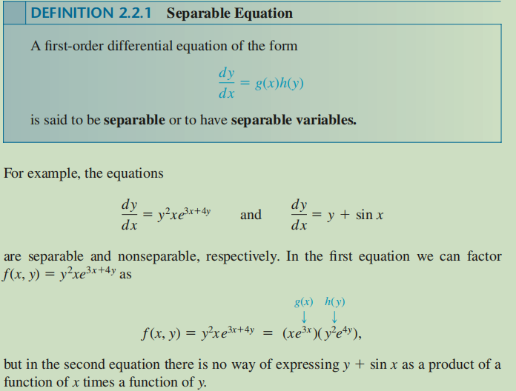
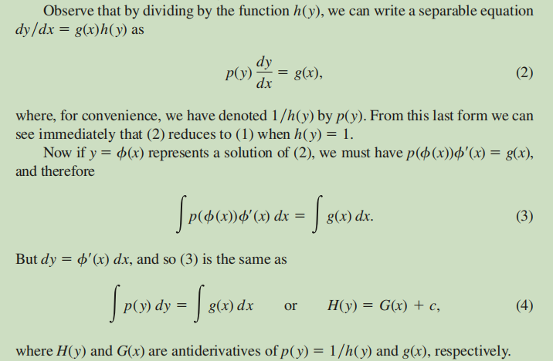
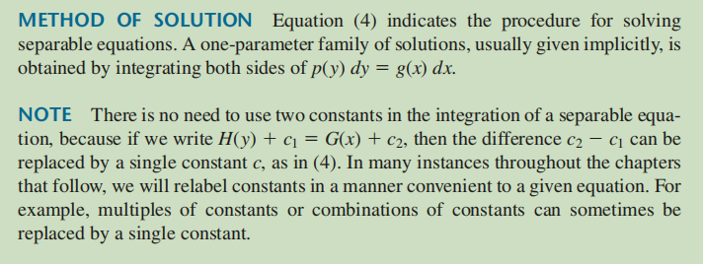
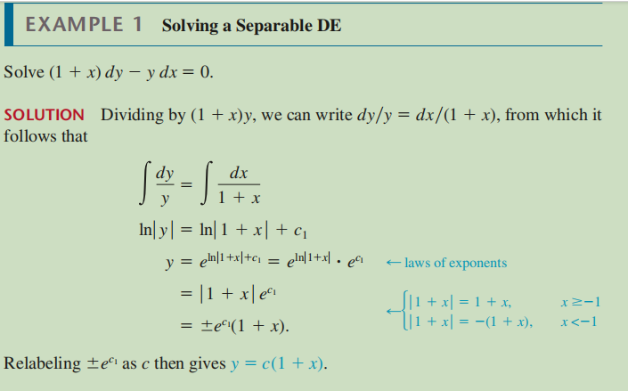
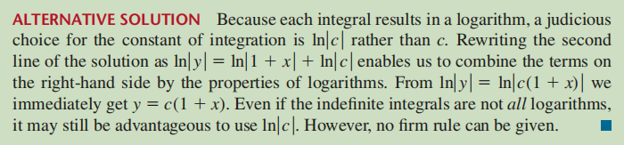
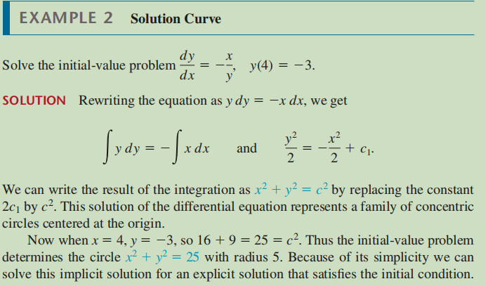
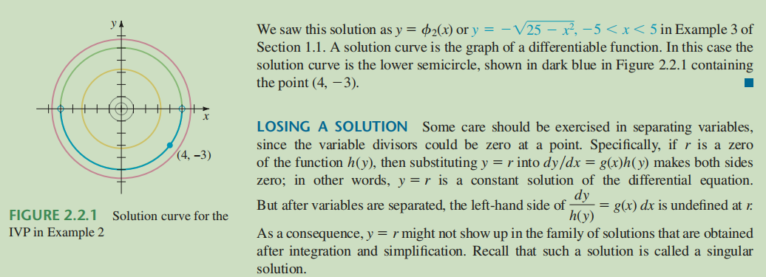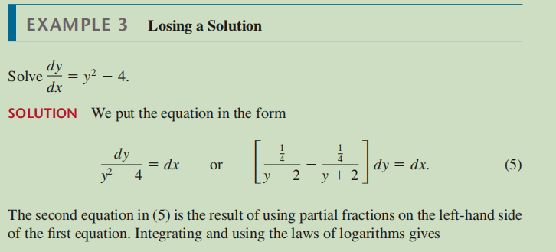
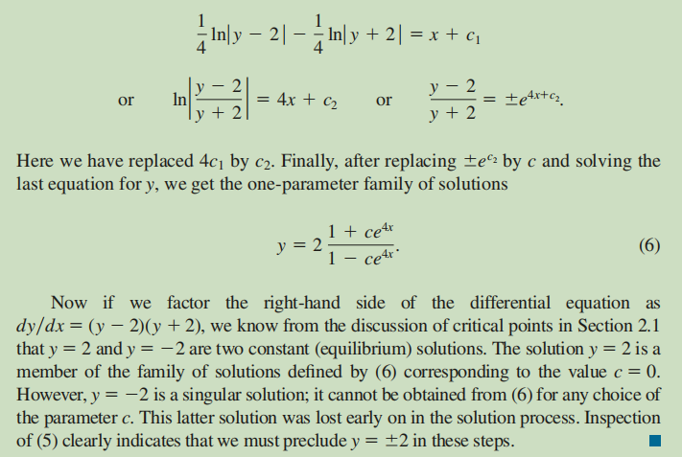
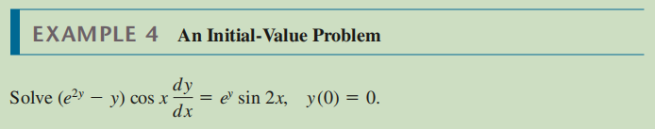
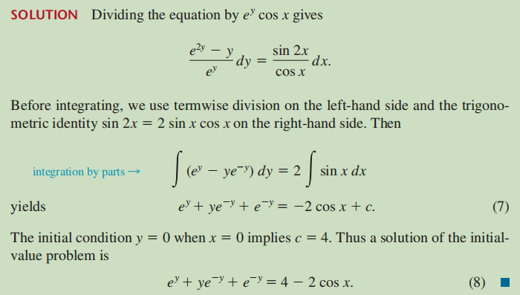

WATCH:
Animated Short Story - Differential Equations
CalcGREEN 2 : Ch. 3.1 : Integrating the Linear ODE
CalcGREEN 2 : Ch. 3.2 : Affine ODEs and Integration
CalcGREEN 2 : Ch. 3.3 : Affine ODEs in Practice
Separation of Variables // Differential Equations
Newton's Law of Cooling // Separable ODE Example
The Big Theorem of Differential Equations: Existence & Uniqueness
Use the following online solver:
Calculator Ordinary Differential Equations (ODE) and Systems of ODEs
Solve differential equations online
Differential Equation Calculator - eMathHelp
Function Calculator - eMathHelp

PRACTISE: DENNIS G. ZILL: 2.2: Separable Variables: 1-14, 19-26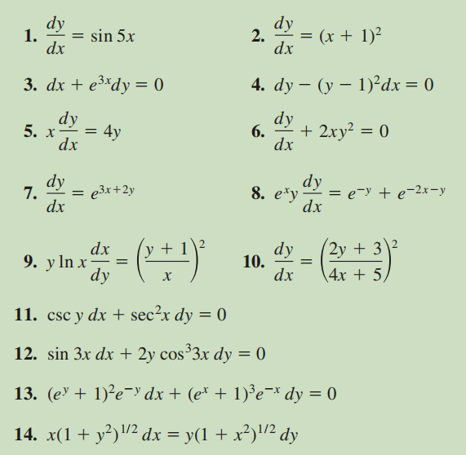
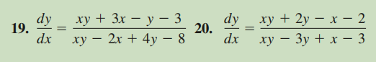
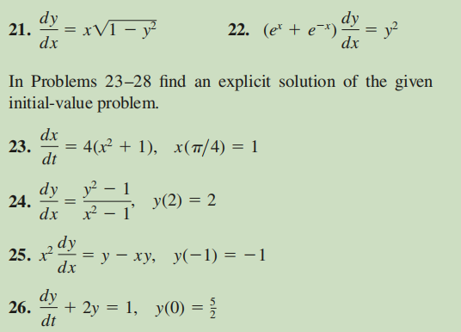

Linear Equations

READ:
First Order Linear Differential Equations
See more: The Bernoulli Differential Equation
READ: DENNIS G. ZILL: 2.3: Linear Equations
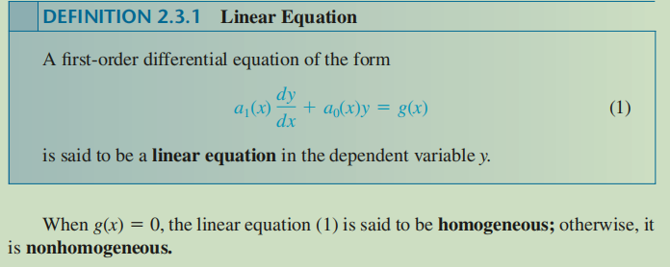
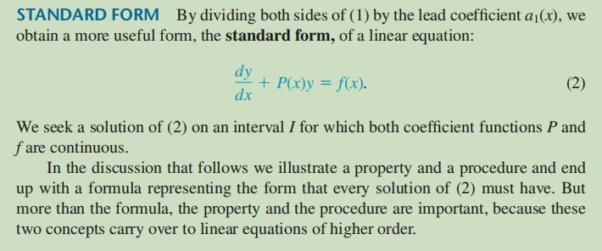
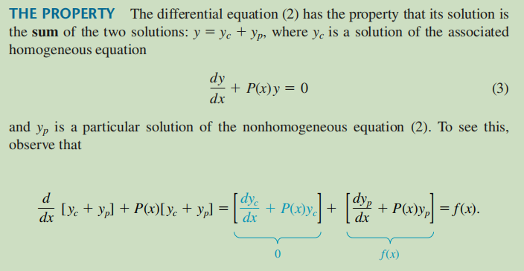
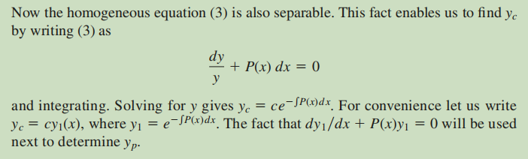
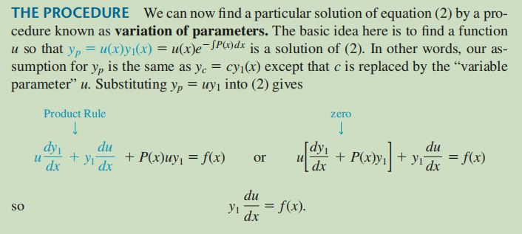
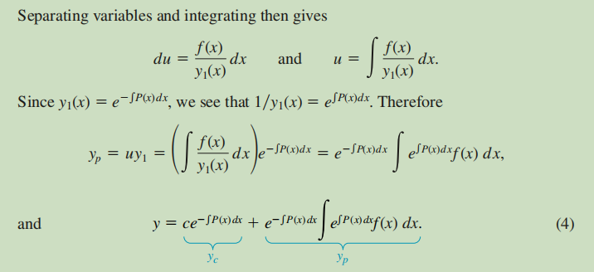
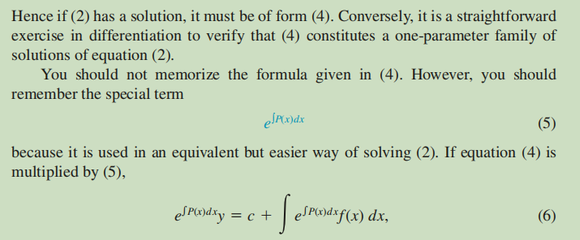
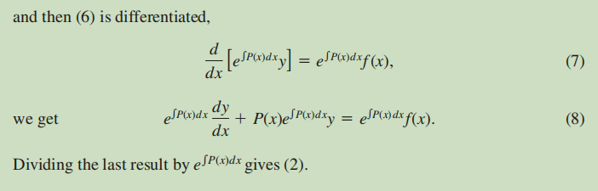
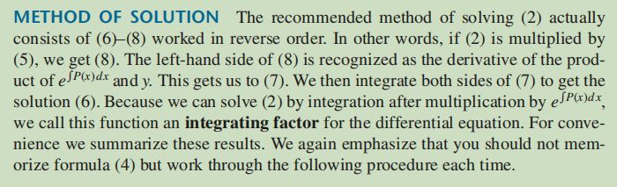
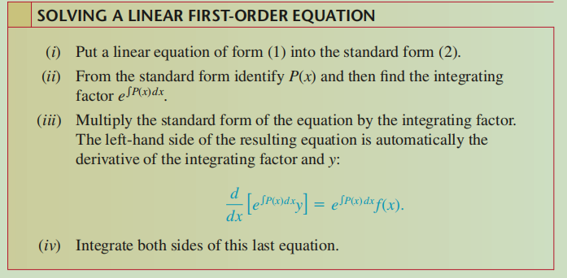
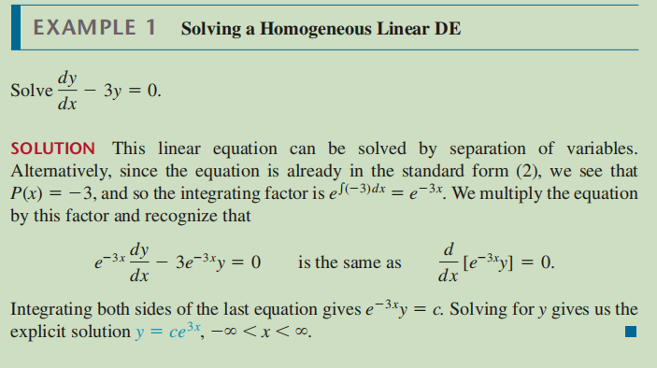
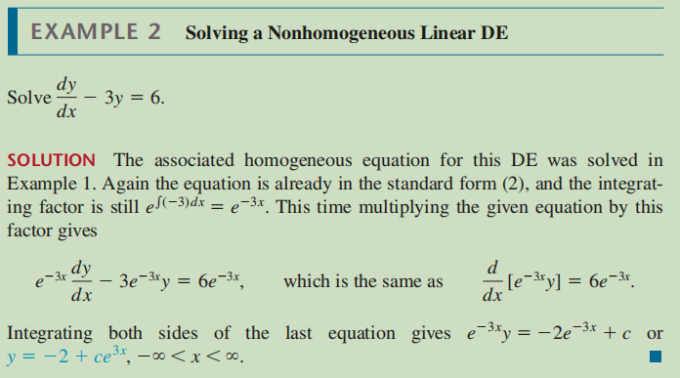
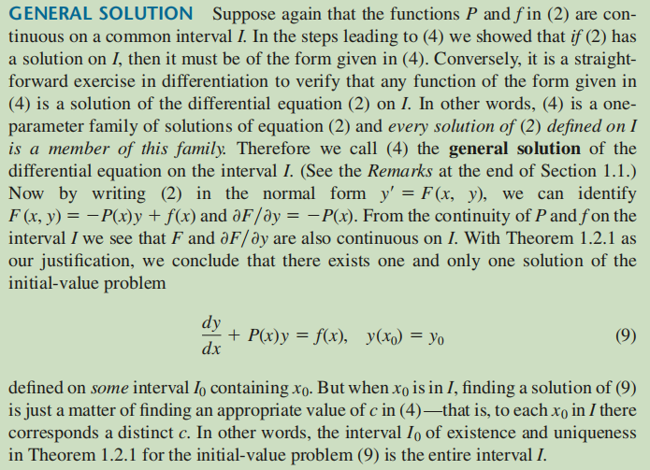
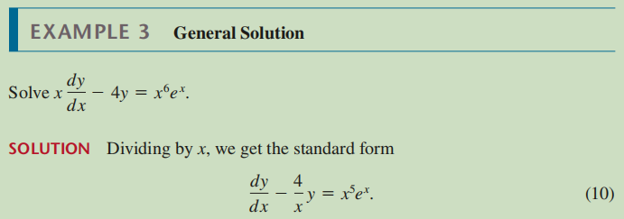
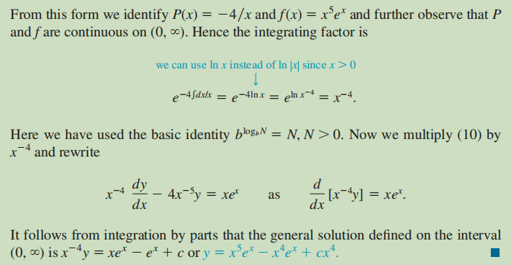
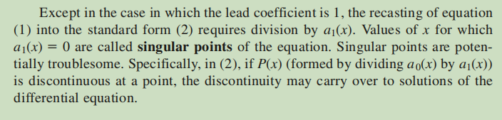
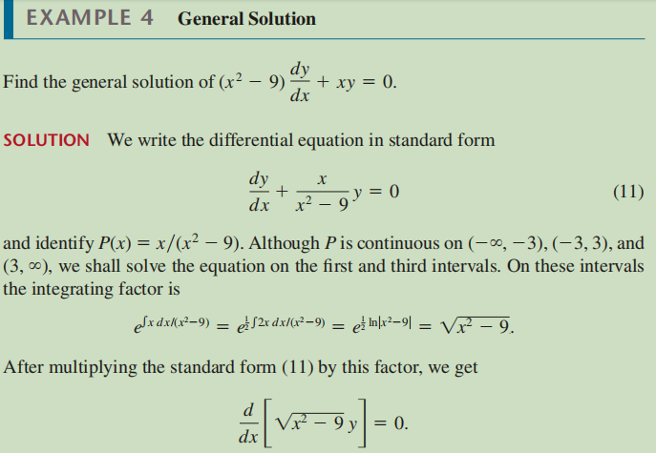
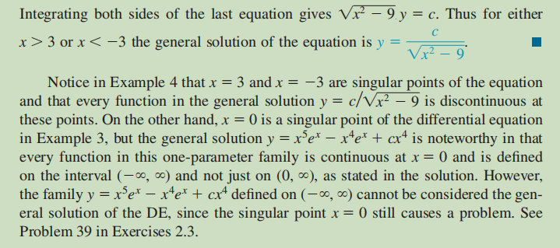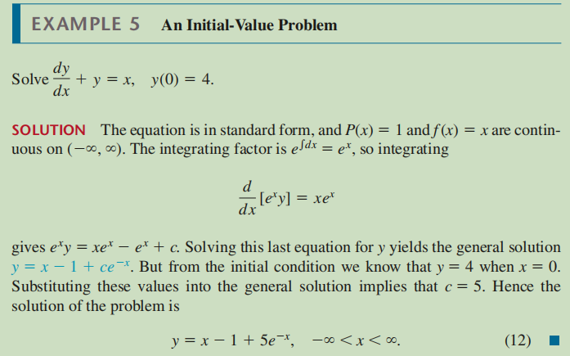

WATCH:
CalcGREEN 2 : Ch. 1.5 : A Linear Differential EquationCalcGREEN 2 : Ch. 2.1 : Using the Linear ODE
Linear Differential Equations & the Method of Integrating FactorsThe Method of Integrating Factors for Linear 1st Order ODEs **full example**The Bernoulli Equation // Substitutions in Differential Equations
Use the following online solver:
Calculator Ordinary Differential Equations (ODE) and Systems of ODEs
Solve differential equations online
Differential Equation Calculator - eMathHelp
Function Calculator - eMathHelp
PRACTISE: DENNIS G. ZILL: 2.3: Linear Equations: 3-17,19,24,25,26,29,30
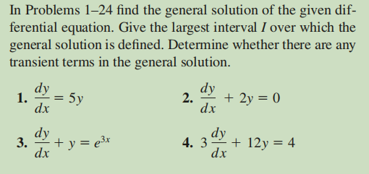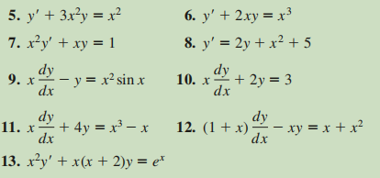
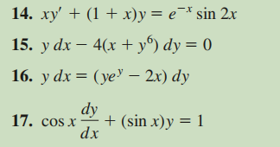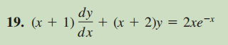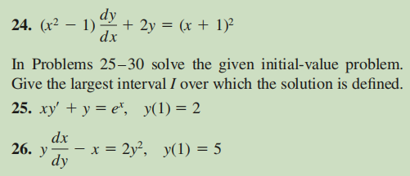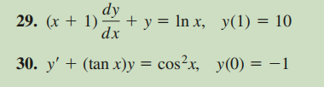

Exact Equation, A non-Exact DE made Exact.

Exact Equations
READ:
Exact Equations and Integrating Factors
READ: DENNIS G. ZILL: 2.4: Exact Equations
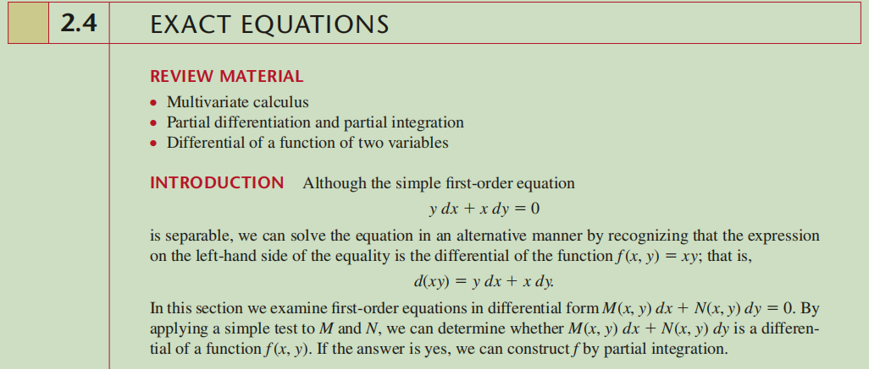

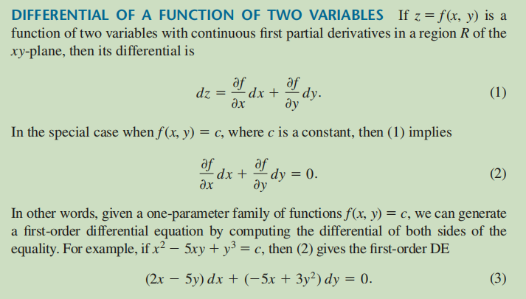
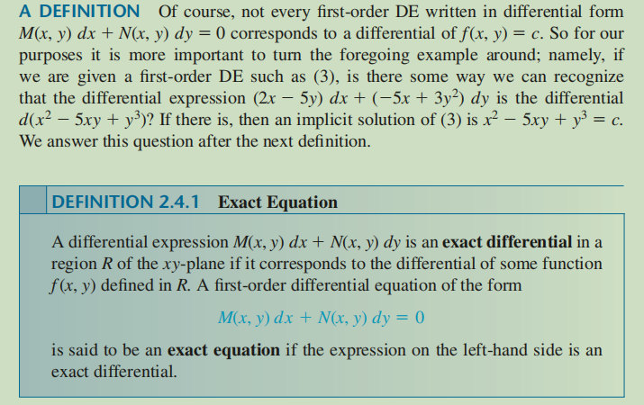
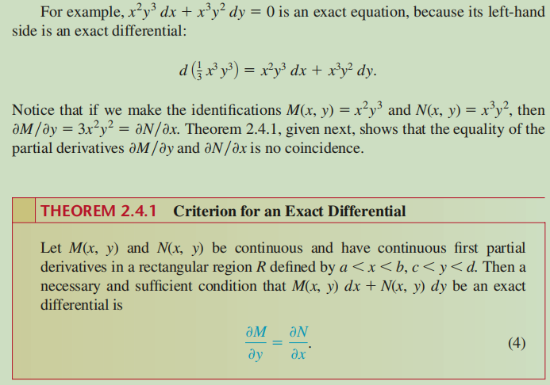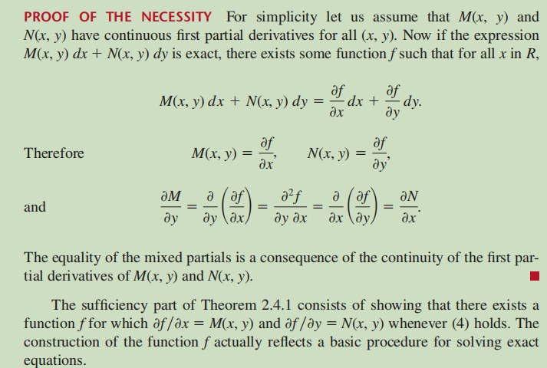
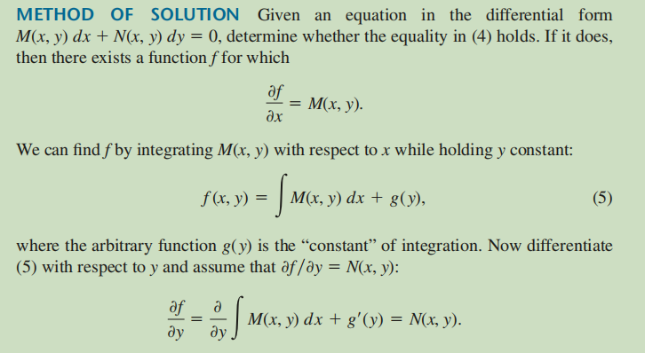
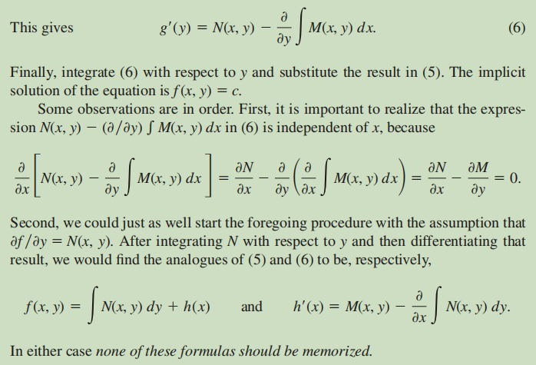
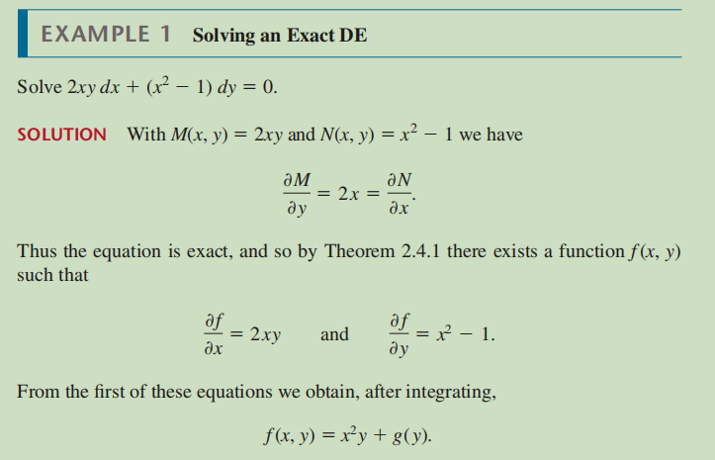
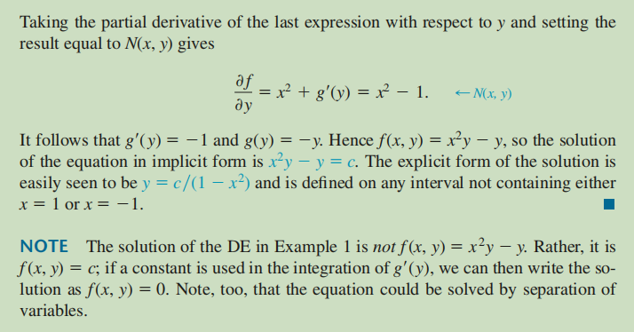
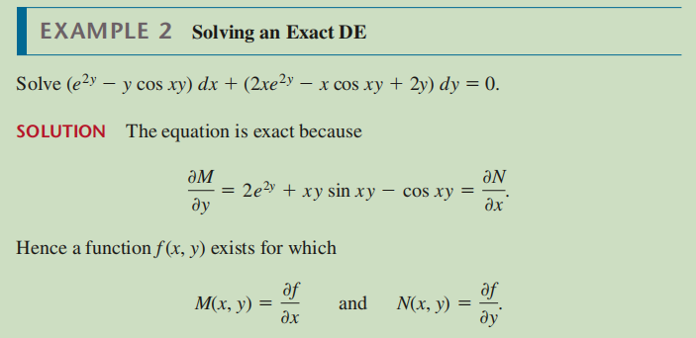
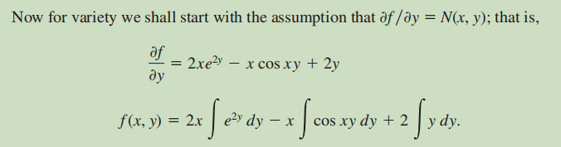
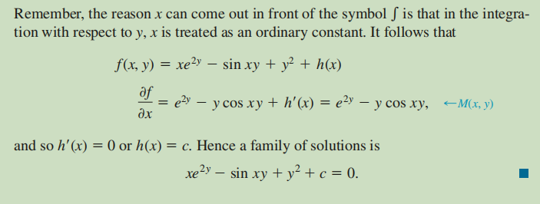
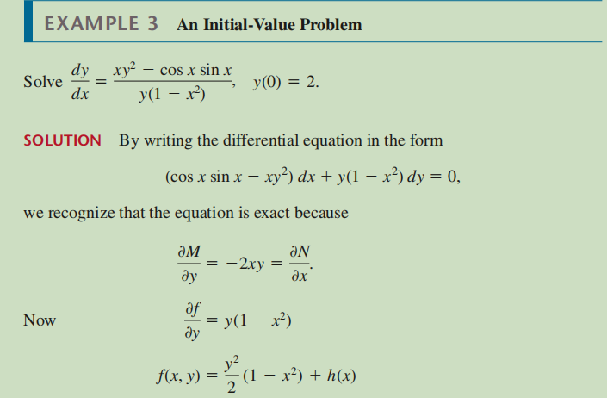
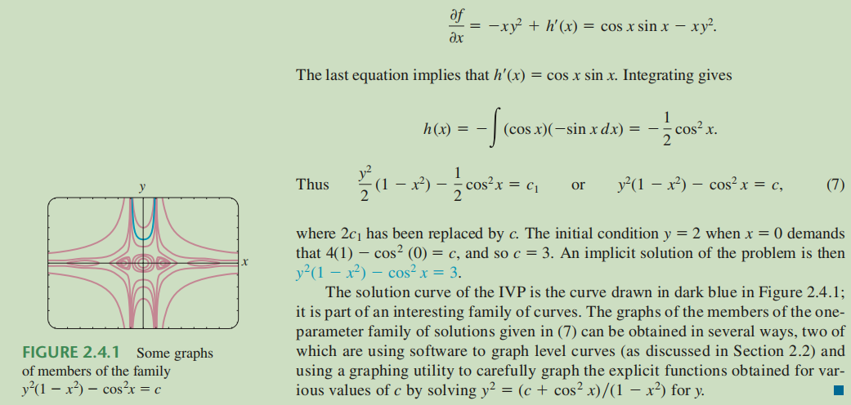

A non-Exact DE made Exact
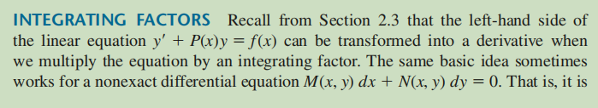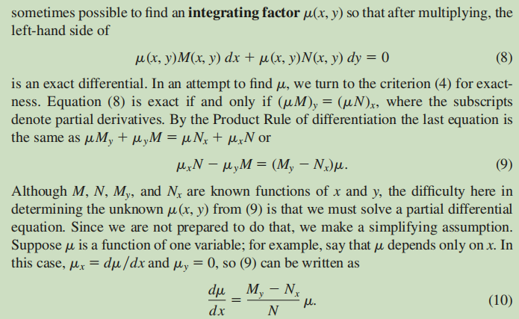
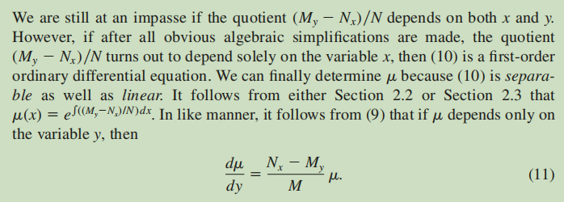
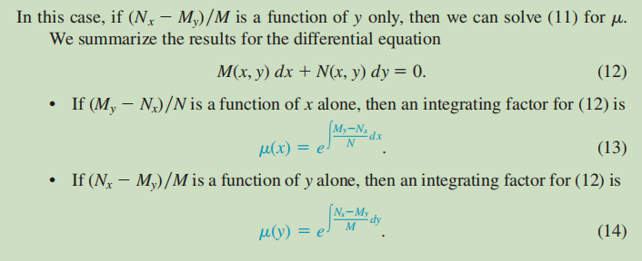
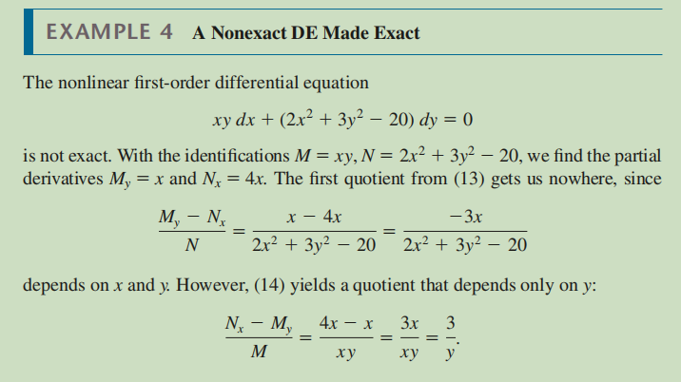
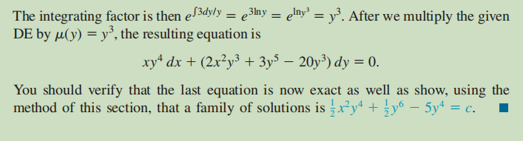
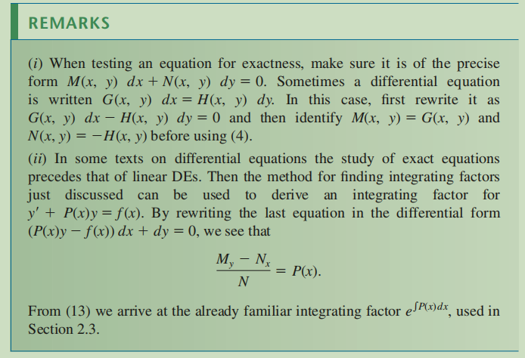
WATCH:
Theory+Technique with example:
Exact differential equation (introduction & example)
EXACT Equations (how to check for exactness!) 3 examples
HOW TO CREATE YOUR OWN EXACT EQUATIONS?
Solved Problems:
Exact Differential Equation, (2.4#11)
Exact Differential Equation, 2.4#13
Exact Differential Equation, 2.4#19
Exact Differential Equation, 2.4#25
Exact Differential Equation, 2.4#27a
Exact Differential Equation, 2.4#28a
Theory+Technique with example:
Almost Exact Differential equation & special integrating factor (introduction & example)
Special integrating factor for almost exact equation, mu(y)
Solved Problems:
Find a special integrating factor mu(y) for an almost-exact differential equation
Almost-exact differential equation with integrating factor
special integrating factor in y, sect2.5#7
special integrating factor of the form x^n*y^m, sect2.5#13
special integrating factor of the form x^n*y^m, sect2.5#14
Use the following online solver:
Exact DE Solver – GeoGebra
PRACTISE: DENNIS G. ZILL: 2.4: Exact Equations: 1-20, 21-26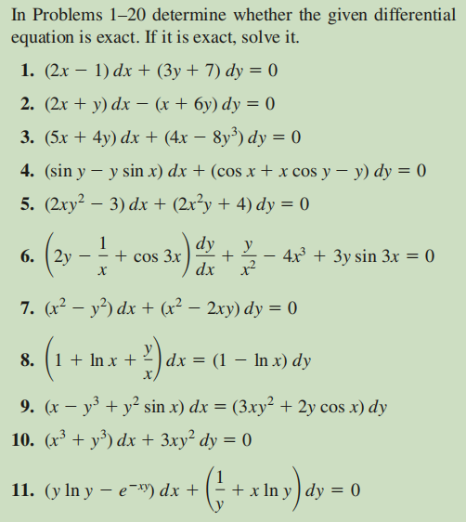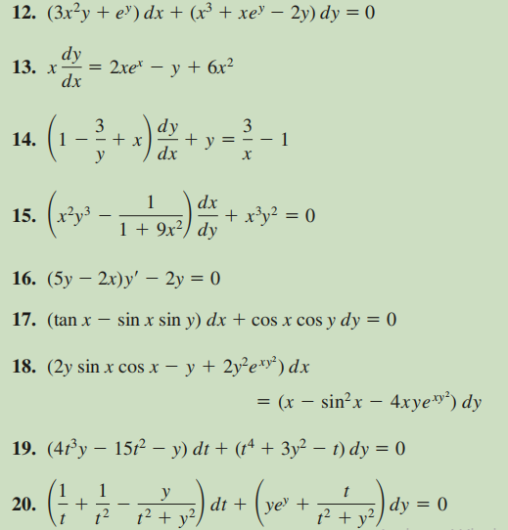
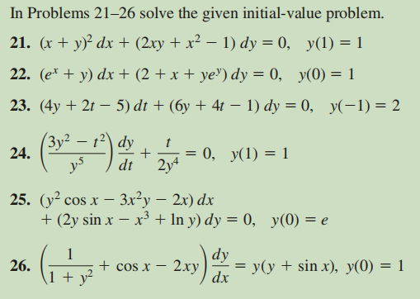

Higher order DE, homogeneous and inhomogeneous cases.

Homogeneous linear equations with constant coefficients
READ:
Second Order Differential Equations
READ: DENNIS G. ZILL: 4.3: Homogeneous linear equations with constant coefficients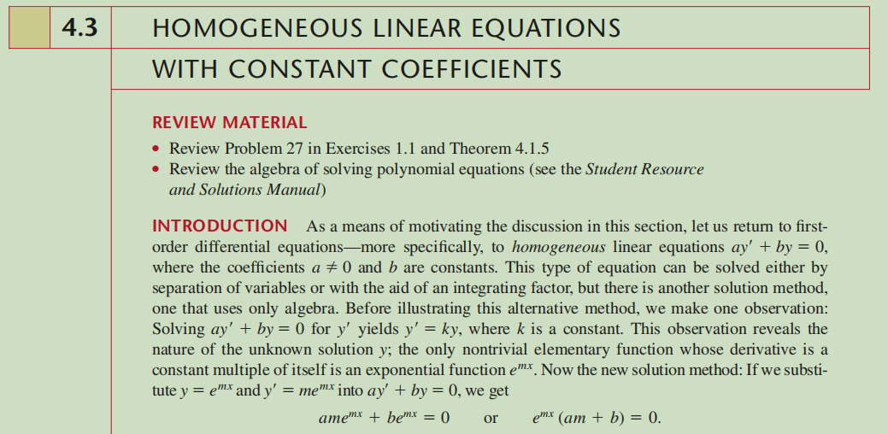
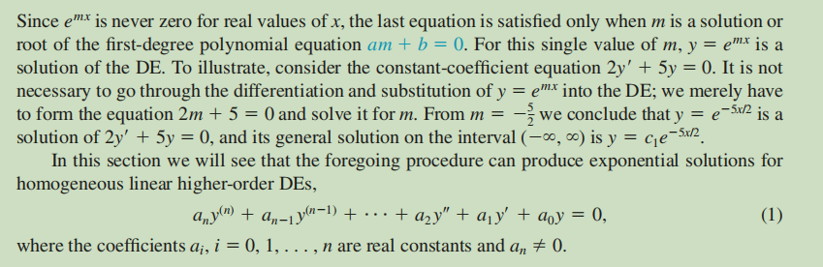
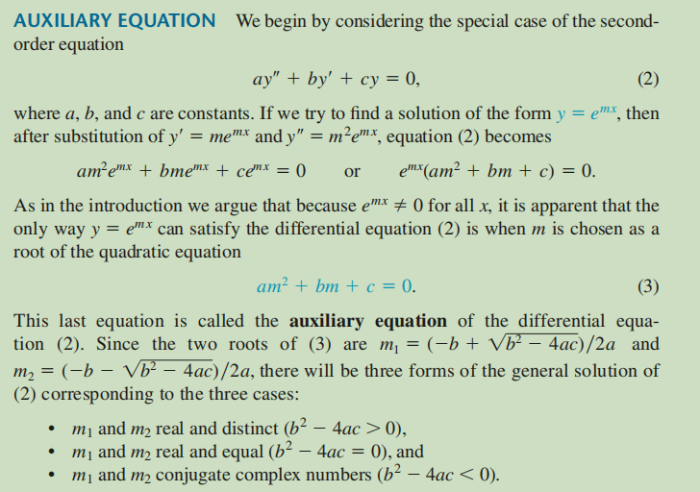
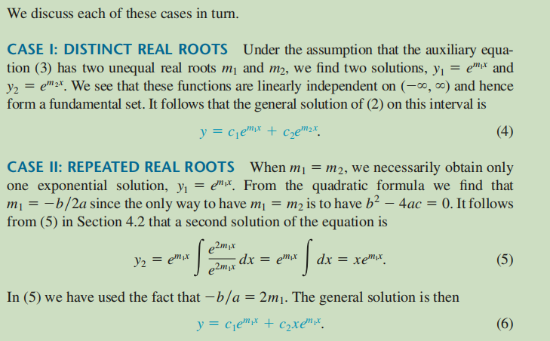
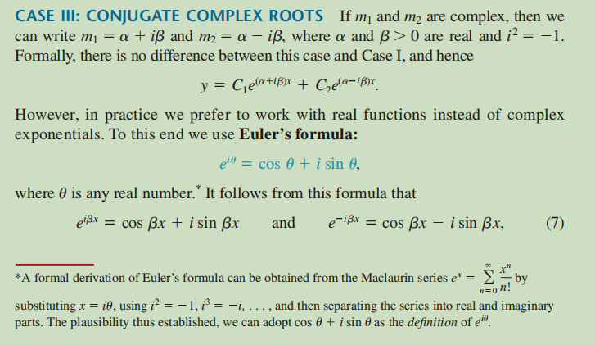
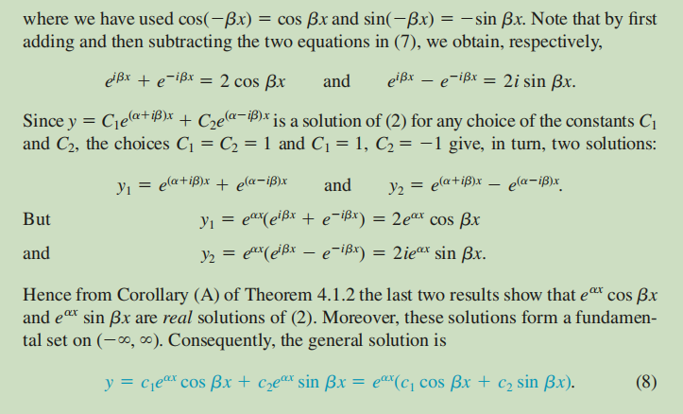
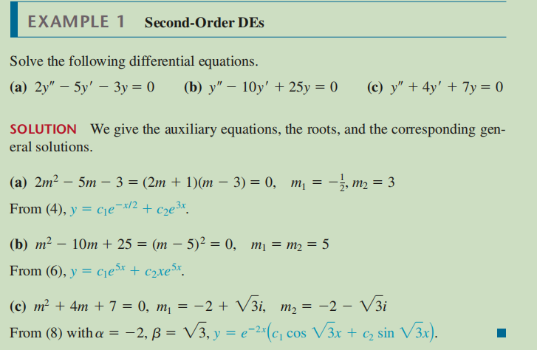
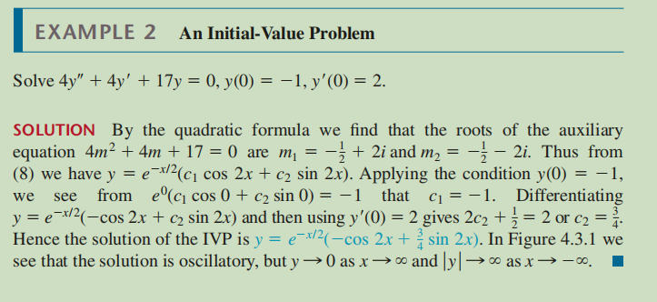
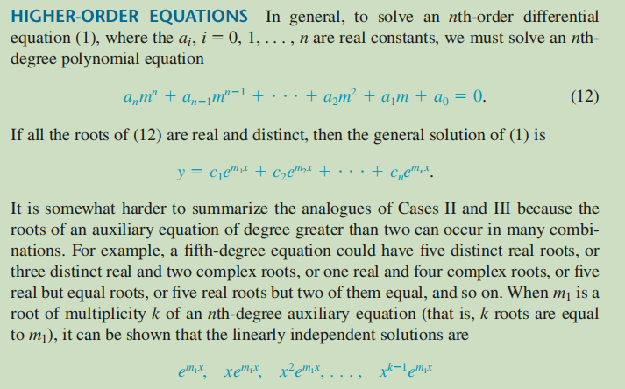
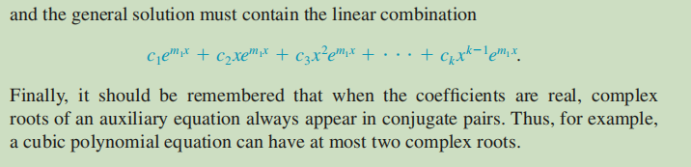
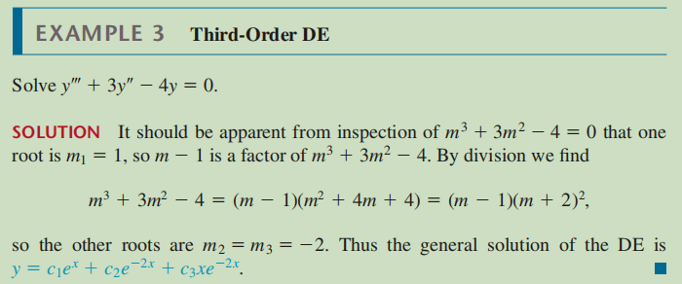
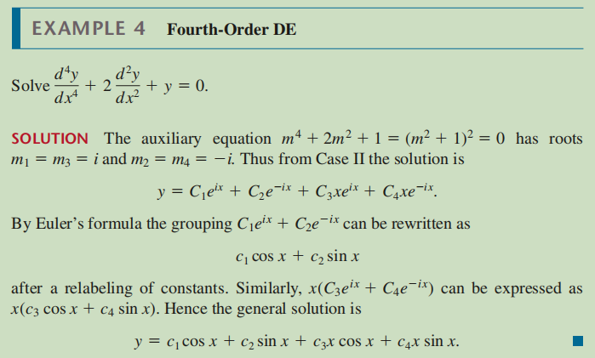
WATCH:
The Theory of 2nd Order ODEs // Existence & Uniqueness, Superposition, & Linear Independence
How to Solve Constant Coefficient Homogeneous Differential Equations
Constant Coefficient ODEs: Real & Distinct vs Real & Repeated vs Complex Pair
Higher Order Constant Coefficient Differential Equations: y'''+y'=0 and y''''-3y'''+3y''-y'=0
Use the following online solver:
Calculator Ordinary Differential Equations (ODE) and Systems of ODEs
Solve differential equations online
Differential Equation Calculator - eMathHelp
Function Calculator - eMathHelp
PRACTISE: DENNIS G. ZILL: 4.3: Homogeneous linear equations with constant coefficients:
1-23, 25, 29-34, 35, 37, 39
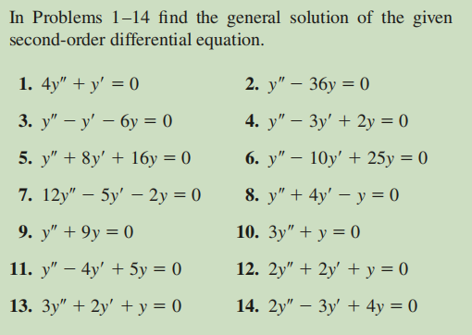
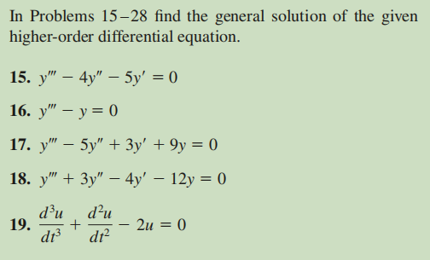
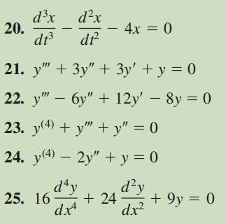
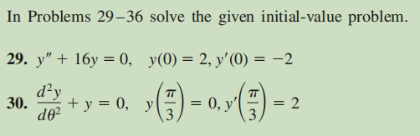

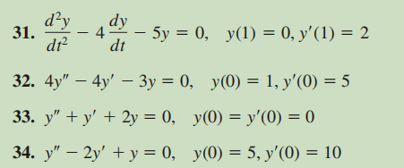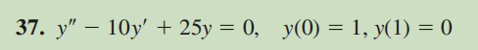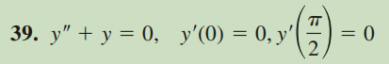

Undetermined Coefficients-Superposition Approach
READ:
Method of Undetermined Coefficients
READ: DENNIS G. ZILL: 4.4: Undetermined Coefficients-Superposition Approach
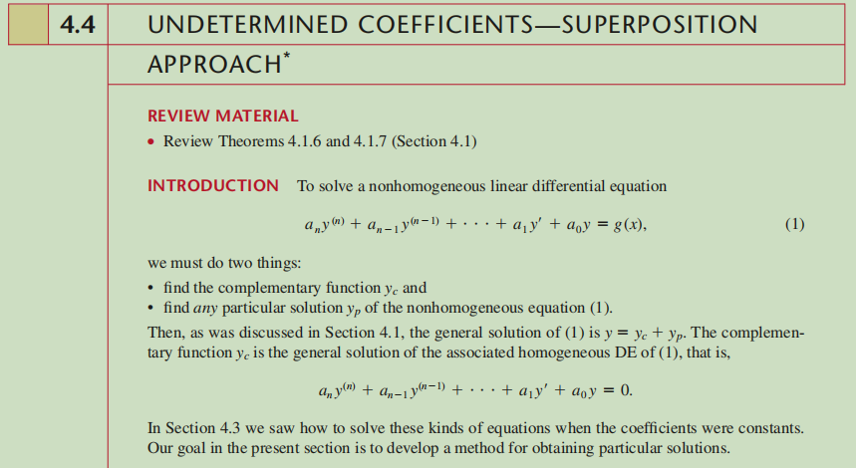
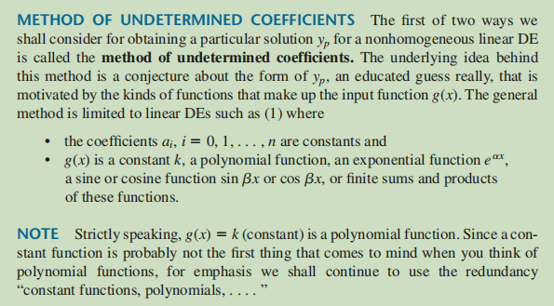
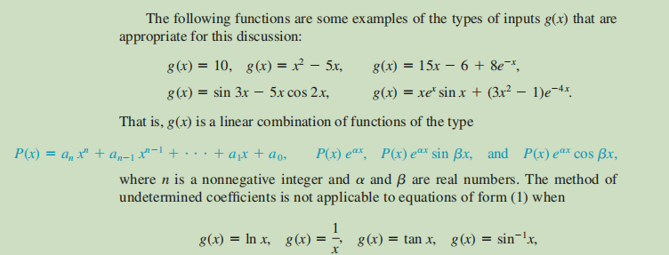
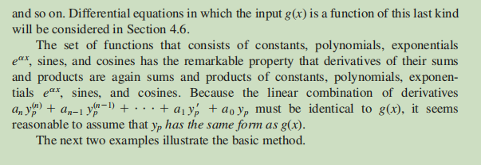
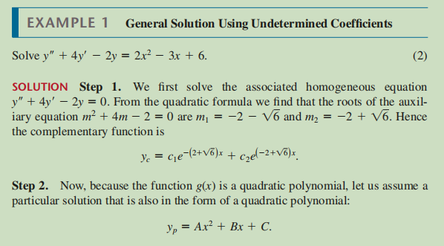
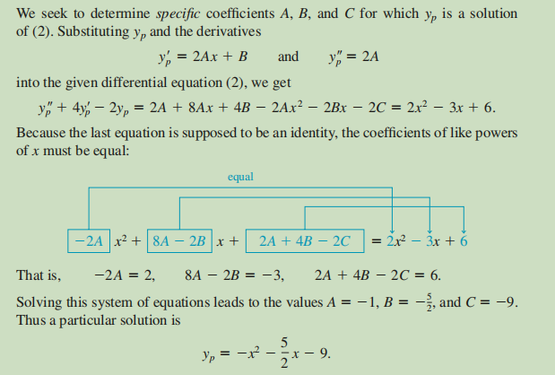
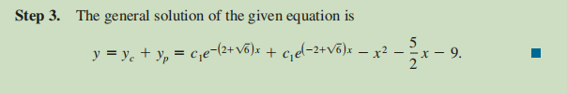
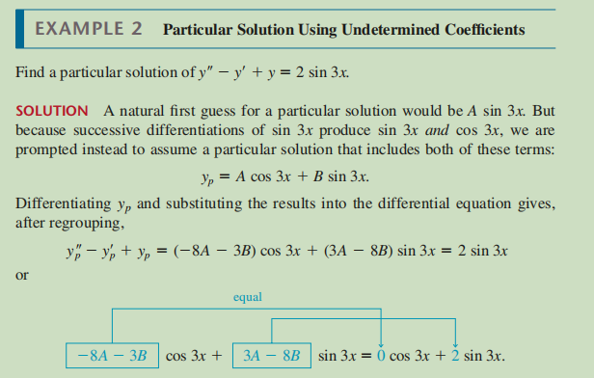
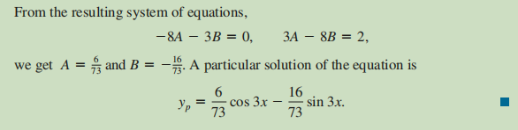
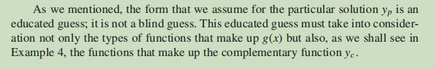
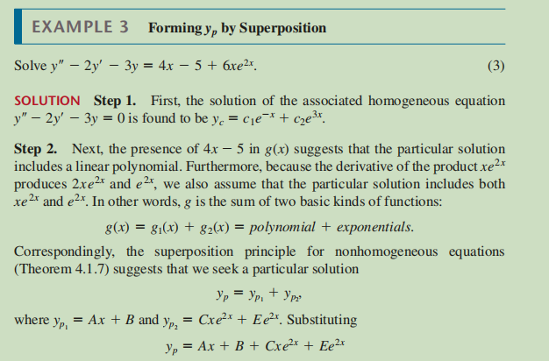
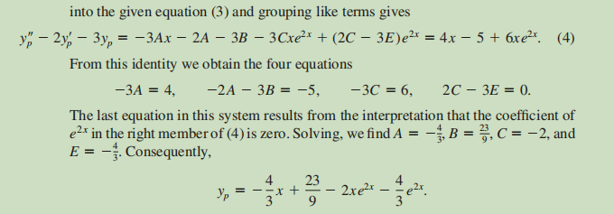

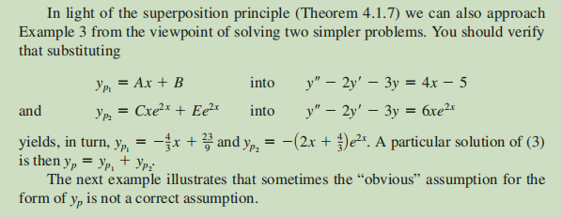
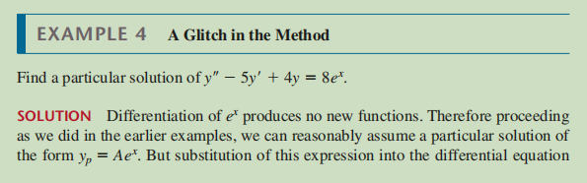
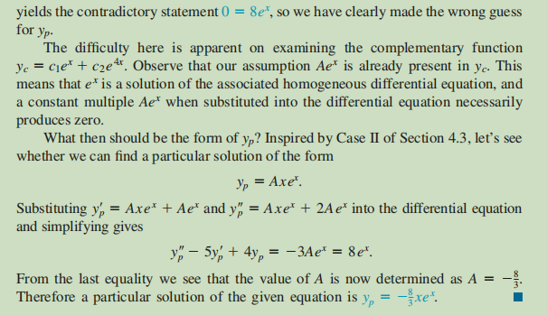
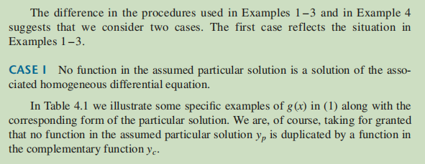
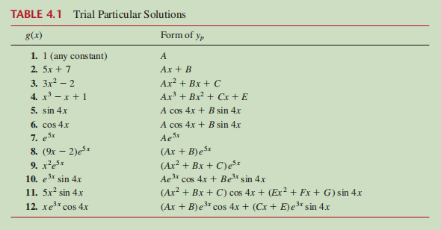
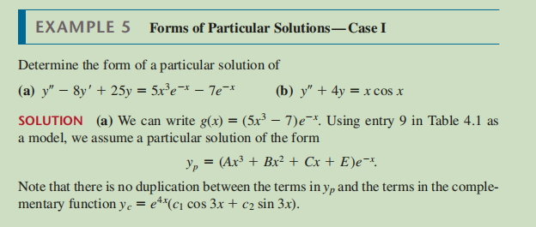
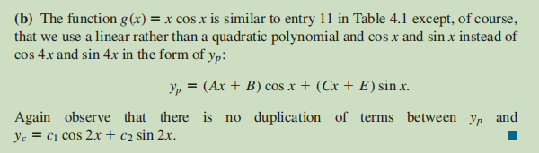
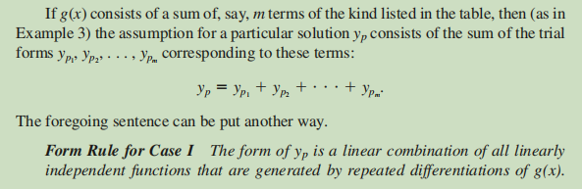
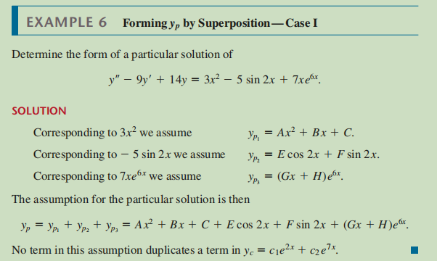
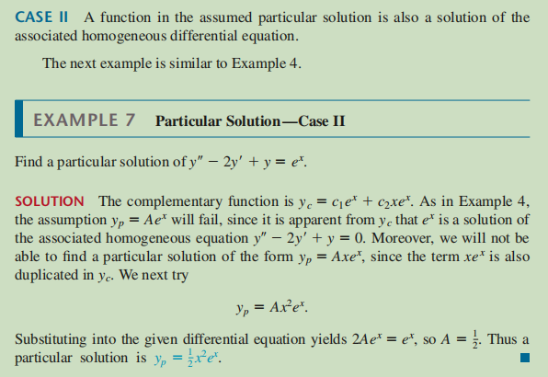
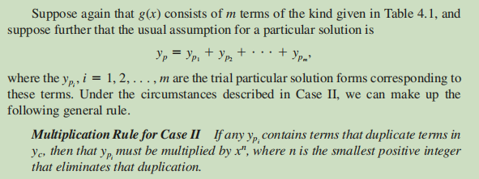
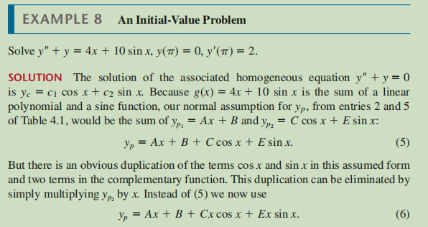
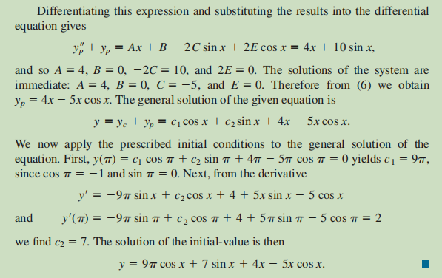
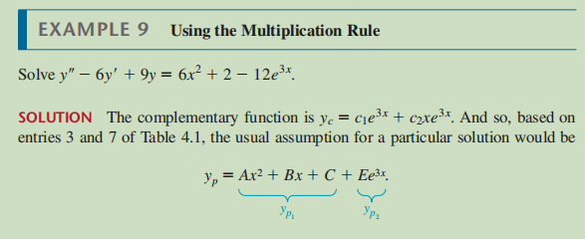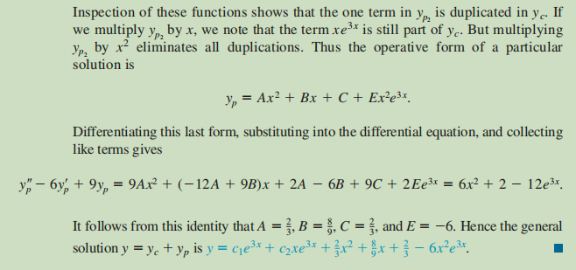
WATCH:
Undetermined Coefficients: Solving non-homogeneous ODEs
Use the following online solver:
Calculator Ordinary Differential Equations (ODE) and Systems of ODEs
Solve differential equations online
Differential Equation Calculator - eMathHelp
Function Calculator - eMathHelp
PRACTISE: DENNIS G. ZILL: 4.4: Undetermined Coefficients-Superposition Approach:
1-15, 17, 27-31
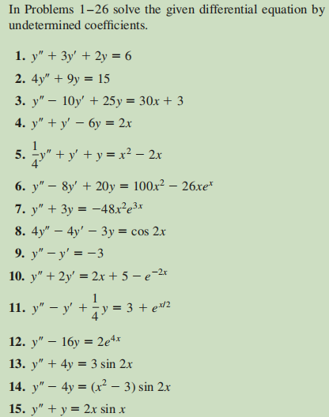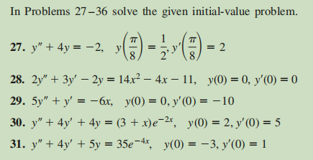
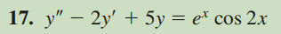

Modeling with 1st and 2nd order DE

Linear Models
READ:
Differential Equations - Introduction
Differential Equations Solution Guide
Solution of First Order Linear Differential Equations

READ:
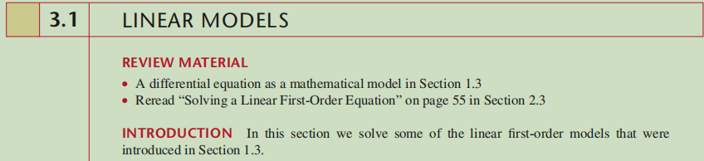
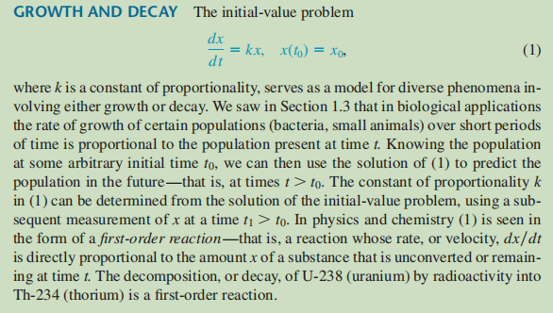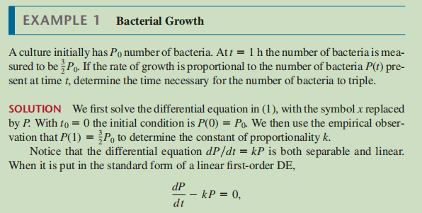
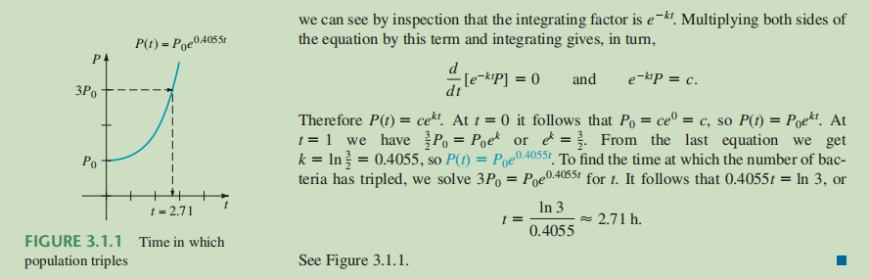
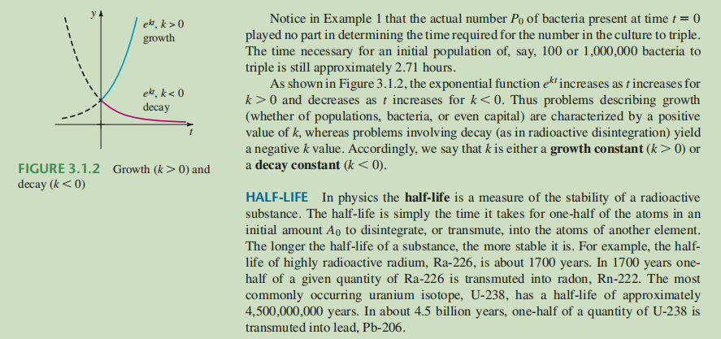
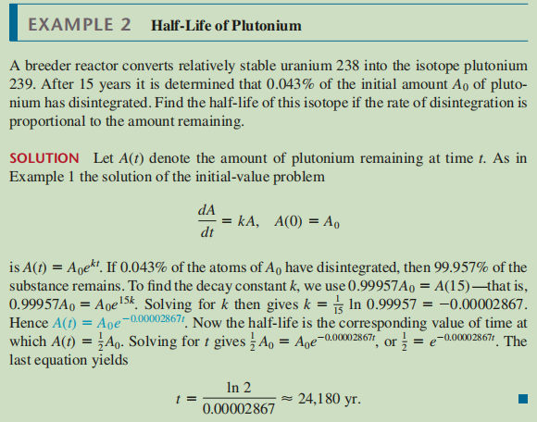
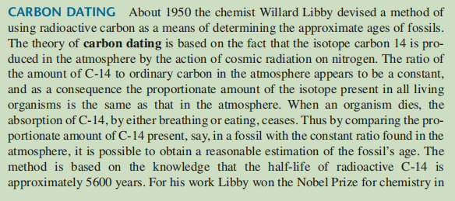
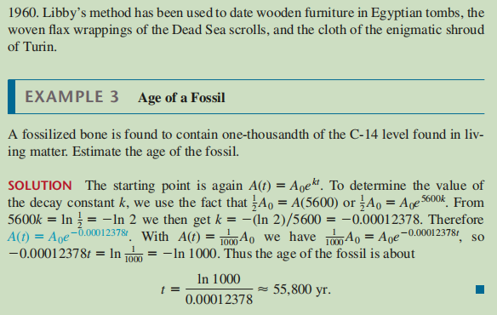
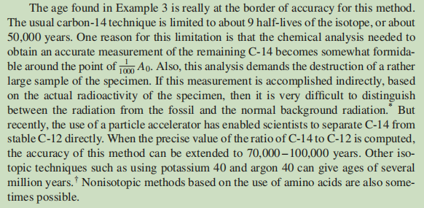
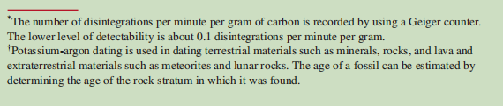
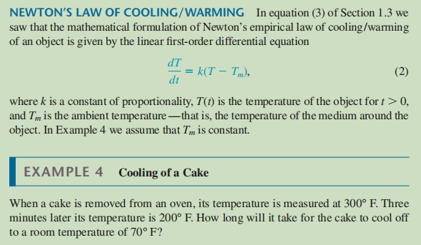
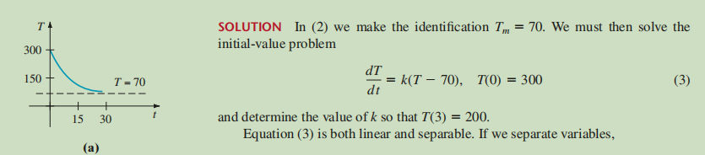
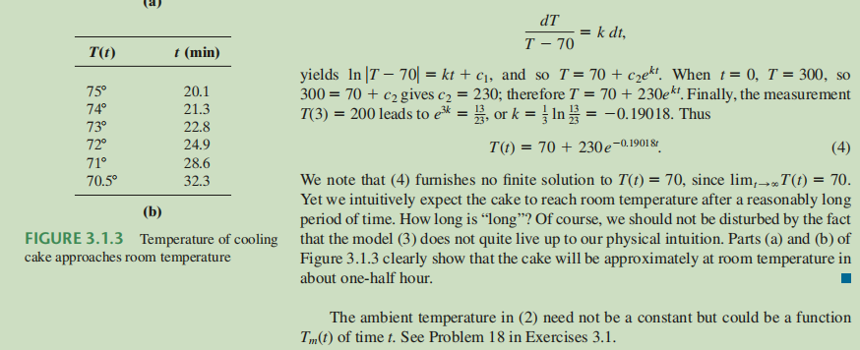
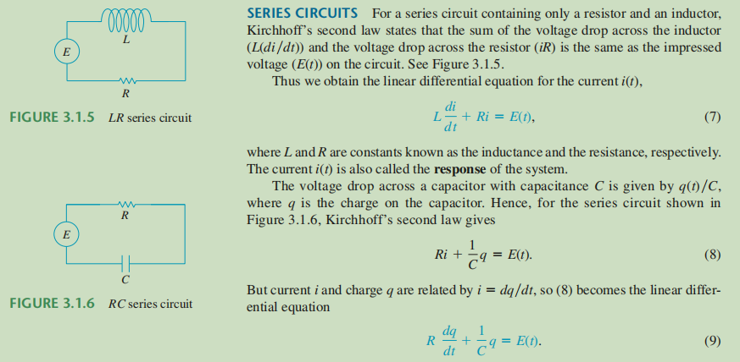
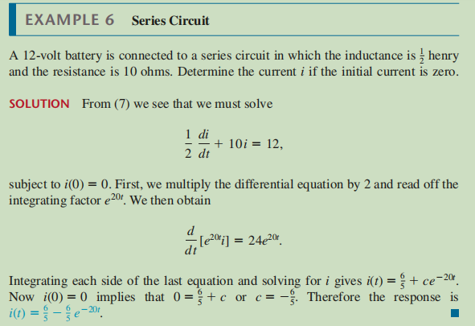
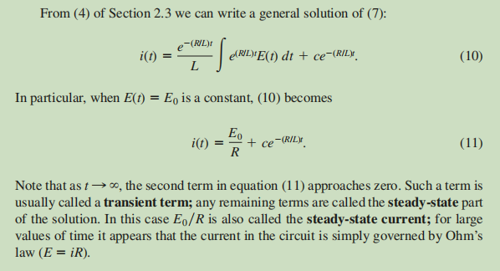
WATCH:
CalcGREEN 2 : Ch. 3.3 : Affine ODEs in Practice
Newton's Law of Cooling // Separable ODE Example
The Logistic Growth Differential Equation
CalcGREEN 2 : Ch. 4.4 : So Many ODEs

PRACTISE: DENNIS G. ZILL: 3.1: Linear Models: Example 1-4, 7(supposed to be 6) and exercise 1-7, 13-17, 29
